

Requirement & Design Specification
MOTO RENTAL - MOTORCYCLE RENTAL MANAGEMENT PLATFORM
Version: 3.0

– Da Nang, May 2025–

Record of Changes
Version | Date | A*  M, D | In charge | Change Description
*A - Added M - Modified D - Deleted

Contents
Record of Changes 1
Contents 3
I. Overview 7
1. User Requirements 7
1.1 Actors 7
1.2 Use Cases 8
2. Overall Functionalities 21
2.1 Screens Flow 21
2.2 Screen Descriptions 23
2.3 Screen Authorization 27
2.4 Non-UI Functions 29
3. System High Level Design 30
3.1 Database Design 30
3.2 Code Packages 32
II. Requirement Specifications 33
1. Authentication 33
1.1 UC-01_Create an account 33
1.2 UC-02_OTP screen 34
1.3 UC-03_Login credentials 34
1.4 UC-04_Login with Google 35
1.5 UC-05_Logout 36
1.6 UC-06_Forgot password 36
2. Account 37
2.1 UC-07_Change password 37
2.2 UC-08_View and update profile 38
2.3 UC-20_View Booking History 38
3. General Features 39
3.1 UC-09_View All Motorcycles 39
3.2 UC-10_View Motorcycle Detail 40
3.3 UC-11_View Tourism Location 40
3.4 UC-12_View FAQs 41
3.5 UC-13_View Price List 42
3.6 UC-14_View Policies 42
3.7 UC-15_Give Contact 43
3.8 UC-16_View Event/Sales 44
3.9 UC-17_Search Motorcycles 45
3.10 UC-18_Get Motorcycle Suggestions by Demand 45
3.11 UC-19_Contact by Chatbot 46
4. Customer Management 47
4.1 UC-33_View customer list 47
4.2 UC-34_Disable customer account 48
4.3 UC-35_View overdue rentals 49
4.4 UC-36_Provide customer consultation 50
5. Rental Booking 51
5.1 UC-21_Choose pick up/return date/location 51
5.2 UC-22_Choose motorcycles 52
5.3 UC-23_Choose accessories 53
5.4 UC-24_Confirm personal information 53
5.5 UC-25_Confirm booking 54
5.6 UC-26_Make payment 55
5.7 UC-27_Apply voucher code 56
5.8 UC-28_Cancel booking 57
5.9 UC-29_Extend booking 58
5.10 UC-30_Give rating and feedback 59
5.11 UC-31_Add to favorites 60
5.12 UC-32_Get motorcycle suggestions by tourism location 61
6. Rental Management 62
6.1 UC-37_Confirm booking 62
6.2 UC-38_Update booking status 62
6.3 UC-39_Cancel booking by staff 64
6.4 UC-40_Handle extension request 65
6.5 UC-41_Handle cancellation request 66
7. Administration 67
7.1 UC-42_CRUD Motorcycle 67
7.2 UC-43_CRUD price list 68
7.3 UC-44_CRUD FAQs 68
7.4 UC-45_CRUD Tourism Location 69
7.5 UC-46_CRUD Sales/Events 70
7.6 UC-47_CRUD Accessories 71
7.7 UC-48_View Customer Feedback and Contact Requests 72
7.8 UC-49_Track rental motorcycle GPS location 73
7.9 UC-50_View Staff List 73
7.10 UC-51_Disable Staff Account 74
7.11 UC-52_Manage Staff Roles and Permissions 75
7.12 UC-53_View Dashboard 76
7.13 UC-54_View Rental Analytics Report 77
III. Design Specifications 78
1. Authentication 78
1.1 Register 78
1.2 Login 81
1.3 Logout 83
1.4 Change Password 84
1.5 Forgot Password 85
2. Account 87
2.1 View Profile 87
2.2. Update Profile 90
3. Motorcycle Information 93
3.1. View All Motorcycles 93
3.2. View Motorcycle Detail 95
3.3. View Price List 97
4. Tourism Information 99
4.1. View Tourism Location 99
4.2. View Tourism Location Detail 102
5. Rental Booking 104
5.1 Create Booking 104
5.2 View Booking History 116
5.3 Cancel Booking 118
5.4 Extend Booking 120
5.5 Rating & Feedback 120
6. Customer Support 123
6.1 View FAQ 123
6.2 View Rental Policy 124
6.3 Contact Us 127
6.4 AI Chatbot Support 128
7. Rental Management 131
7.1 View Booking List 131
7.2 Confirm Booking 134
7.3 Update Booking Status 134
7.4 Handle Cancellation Request 136
7.5 Handle Extension Request 138
7.6 View Customer Information 140
8. Administration 142
8.1 Motorcycle Management 142
8.2 Tourism Location Management 144
8.3 Promotion Management 146
8.4 FAQ Management 147
8.5 Price Management 149
8.6 Accessory Management 151
8.7 User Management 153

I. Overview

1. User Requirements

1.1 Actors

# | Actor | Description
1 | Admin | The highest priority manager (Staff Manager) with full system access. Can manage staff accounts, view analytics dashboard, oversee all rentals  - Configure system settings and monitor all operations  - Manage roles and permissions for staff members
2 | Motorbike Renter | Customers are users who have registered an account and can browse motorcycles, make bookings, track rental history, and manage their profile.
3 | Staff | Staff are employees who manage day-to-day operations including bookings, motorcycles, customers, and content management.
4 | Guest | A guest is a visitor who browses the platform without logging in. They can view motorcycles, pricing, tourism locations, FAQs, and contact the support team.

1.2 Use Cases

a. Diagram(s)
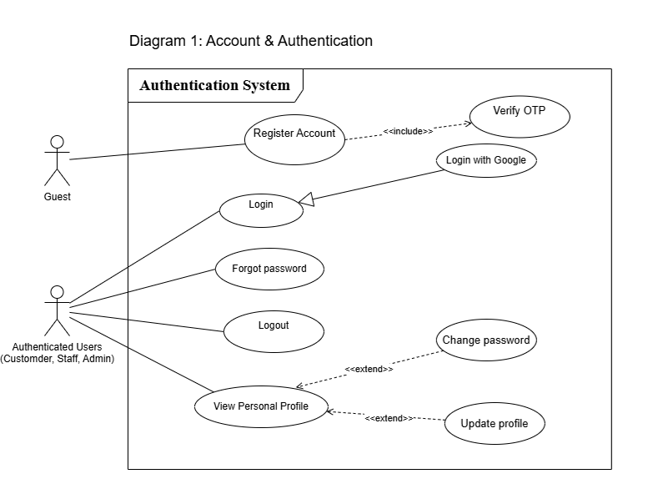
Figure 1. Authentication use case diagram
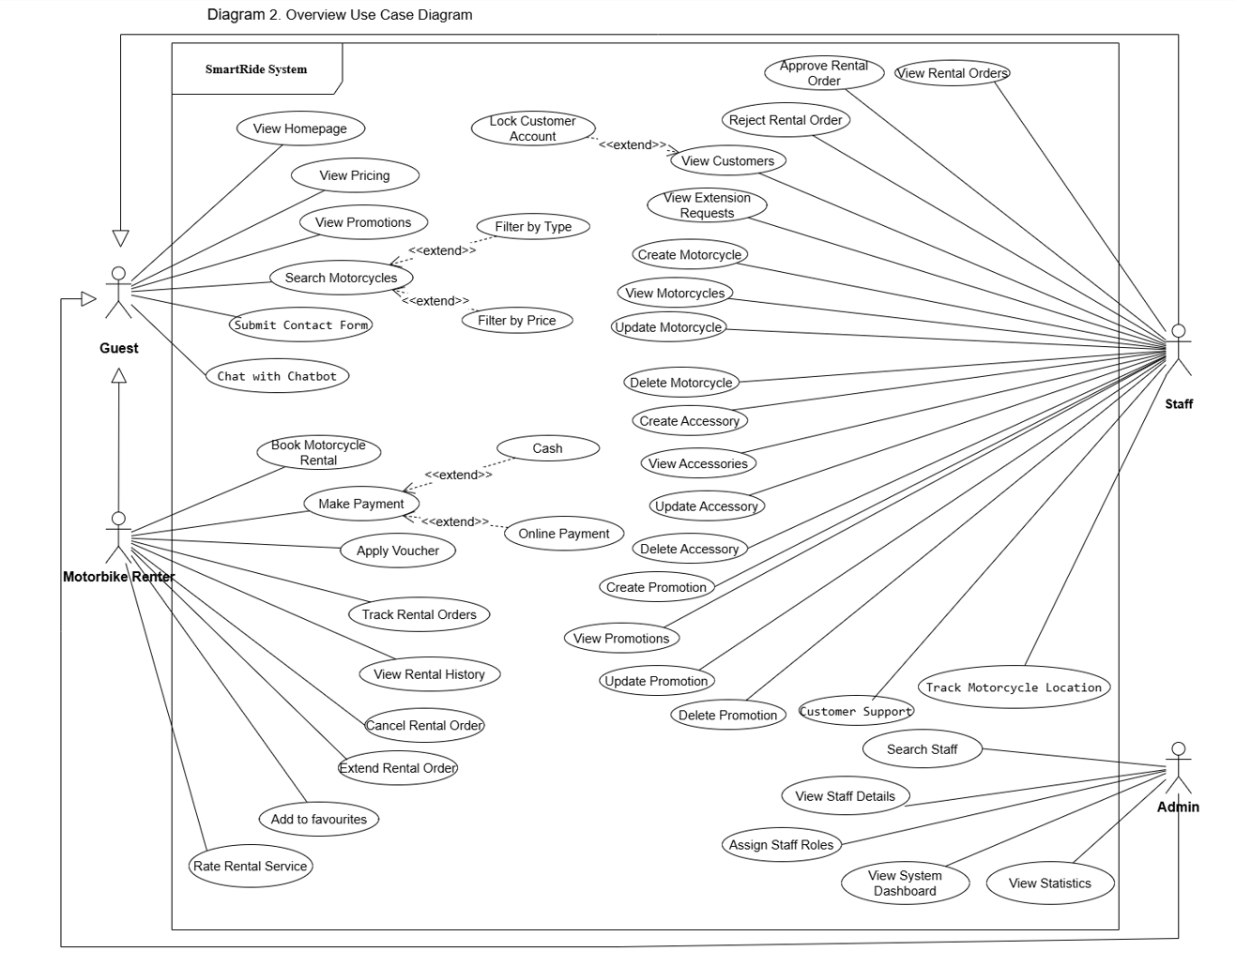
Figure 2. Overview use case diagram
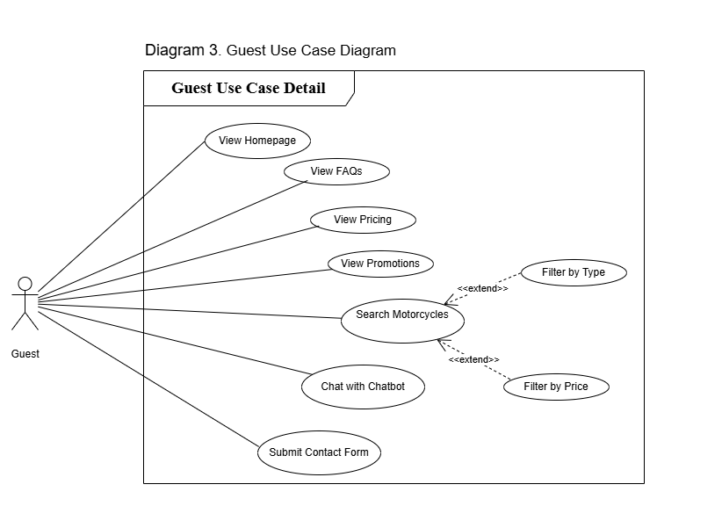
Figure 3. Guest use case diagram
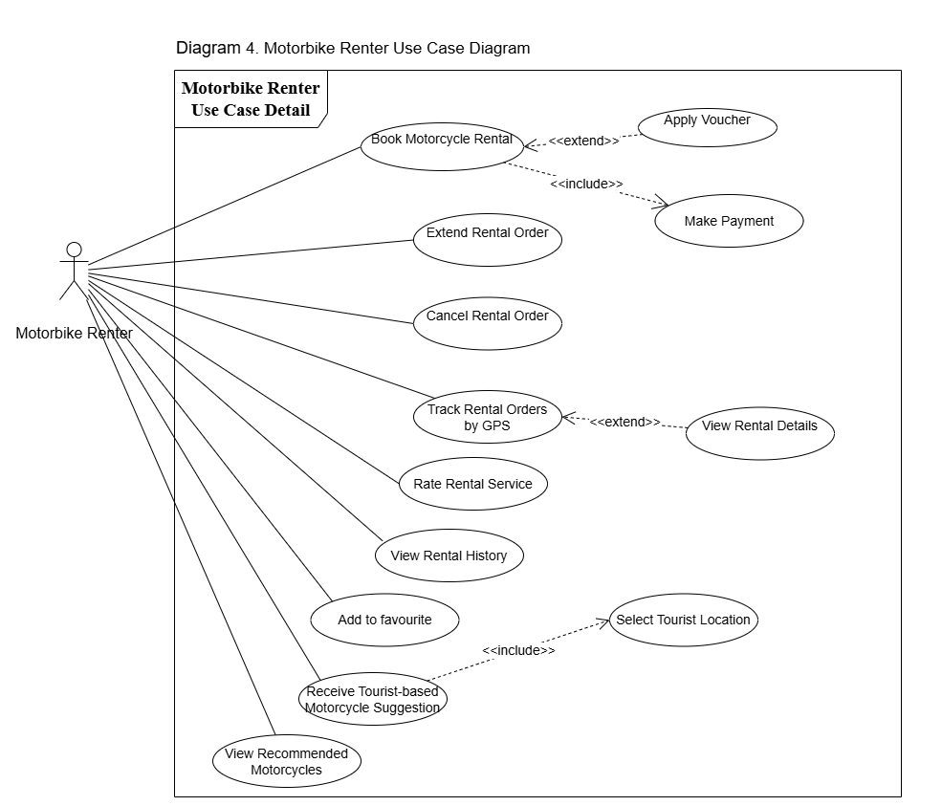
Figure 4. Motorbike Renter use case diagram
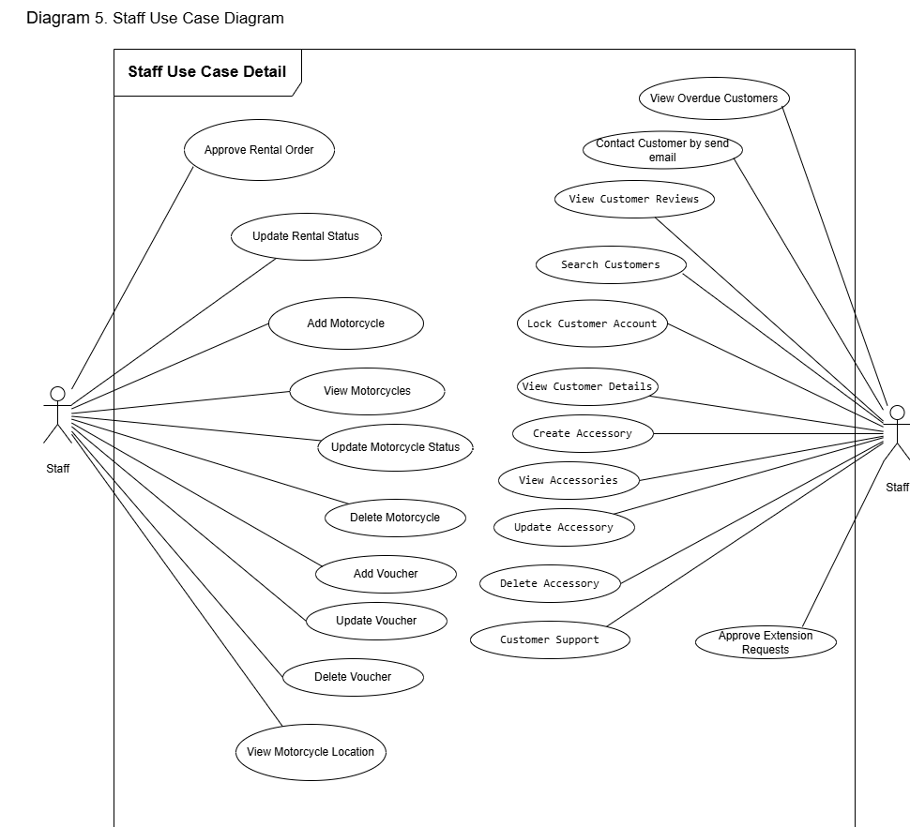
Figure 5. Staff use case diagram
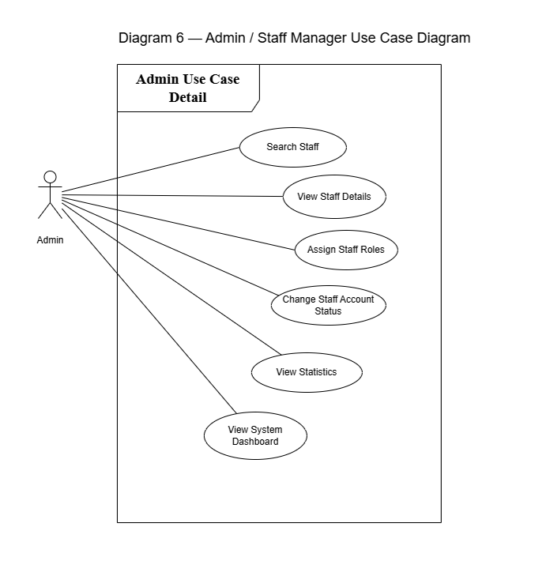
Figure 6. Admin use case diagram

b. Descriptions
ID | Feature | Use case | Description
UC-01 | Authentication | Create an account | New users can register an account by providing their name, email, and password to access the platform.
UC-02 | Authentication | OTP screen | Users enter a one-time code sent to their email to verify their identity during registration.
UC-03 | Authentication | Login/Logout | Users can log in using registered credentials and log out to end their session.
UC-04 | Authentication | Login with Google | Users can log in quickly using their existing Google account.
UC-05 | Authentication | Forgot password | Users can request a password reset by entering their registered email to receive a reset link or OTP.
UC-06 | Account | Change password | Users can change their account password by verifying the current one and setting a new one.
UC-07 | Account | View and Update Profile | Users can view and update personal information, contact details, address, and profile photo (avatar).
UC-08 | General | View Homepage | Guests and customers can view the homepage to get an overview of the website services and features.
UC-09 | General | View all motorcycles | Guests and customers can view a list of all available motorcycles, including photos, rental prices, and basic information.
UC-10 | General | View a motorcycle in detail | Guests and customers can view detailed information about a specific motorcycle, including images, specs, price, and included accessories.
UC-11 | Tourism Management | View tourism location | Guests and customers can browse suggested tourism destinations with photos, descriptions, and reference links.
UC-12 | FAQ Management | View FAQs | Guests and customers can read frequently asked questions and their answers to better understand the service.
UC-13 | Pricing Management | View price list | Guests and customers can view the current rental price list for all motorcycle types and rental durations.
UC-14 | Policy Management | View policies | Guests and customers can read the platform rental terms and conditions before making a reservation.
UC-15 | Contact Management | Give contact | Users can submit a contact form to send questions or requests to the support team.
UC-16 | Promotion Management | View event/sales | Guests and customers can view current promotions, discount events, and upcoming campaigns.
UC-17 | Search & Recommendation | Search motorcycles | Guests and customers can search and filter motorcycles by brand, category, travel purpose, displacement, or price range.
UC-18 | Search & Recommendation | Get motorcycle suggestions by demand | Guests and customers can enter their travel needs such as touring, city riding, or fuel saving to receive suitable motorcycle suggestions from the system.
UC-19 | Chatbot | Contact by chatbot | Guests and customers can chat with the system chatbot to get information and rental recommendations from the website.
UC-20 | Account | View booking history | Customers can view a list of all past and current rental bookings and open any booking to see its full details.
UC-21 | Rental Booking | Choose pick up/return date/location | Customers can select their preferred pickup and return dates and locations for the motorcycle rental.
UC-22 | Rental Booking | Choose motorcycles | Customers can browse and select an available motorcycle for their chosen rental period.
UC-23 | Rental Booking | Choose accessories | Customers can add optional accessories such as helmets or rain gear to their rental order.
UC-24 | Rental Booking | Confirm personal information | Customers can review and confirm their personal details before proceeding with the booking.
UC-25 | Rental Booking | Confirm booking | Customers can review the complete booking summary including motorcycle, accessories, dates, and total cost before finalizing.
UC-26 | Rental Booking | Make payment | Customers can complete payment for their rental booking through available payment methods.
UC-27 | Rental Booking | Apply voucher code | Customers can enter a voucher or promo code at checkout to receive a discount on their rental.
UC-28 | Rental Booking | Cancel booking | Customers can submit a cancellation request for an active booking and track the processing status.
UC-29 | Rental Booking | Extend booking | Customers can request to extend their current rental period by selecting a new return date.
UC-30 | Rental Booking | Give rating and feedback | Customers can rate the motorcycle and overall service quality after completing a rental.
UC-31 | Favorite | Add to favorites | Customers can save motorcycles they are interested in to a personal favorites list for easy access when planning a rental.
UC-32 | Tourism Management | Get motorcycle suggestions by tourism location | Customers can select a tourism destination to receive motorcycle recommendations suitable for that route or terrain.
UC-33 | Customer Management | View customer list | Staff can view, search, and access detailed profiles of all registered customers.
UC-34 | Customer Management | Disable customer account | Staff can deactivate a customer account that has violated the platform rules.
UC-35 | Customer Management | View overdue rentals | Staff can view a list of customers who have not returned their motorcycle by the agreed return date.
UC-36 | Customer Management | Provide customer consultation | Staff can provide consultation to customers regarding motorcycle options, rental pricing, accessories, policies, and active promotions.
UC-37 | Rental Management | Confirm booking | Staff can review and approve pending booking requests submitted by customers.
UC-38 | Rental Management | Update booking status | Staff can update the booking status through each rental stage: confirmed → picked up → active → completed.
UC-39 | Rental Management | Cancel booking by staff | Staff can cancel a booking on behalf of the customer, including providing a reason and processing any applicable refund.
UC-40 | Extension Management | Handle extension request | Staff can view extension requests submitted by customers and approve or reject them after checking motorcycle availability.
UC-41 | Cancellation Management | Handle cancellation request | Staff can view cancellation requests submitted by customers and approve or reject them.
UC-42 | Motorcycle Management | CRUD Motorcycle | Staff can add, update, delete motorcycles and manage their availability status (available, rented, under maintenance, decommissioned).
UC-43 | Pricing Management | CRUD price list | Staff can add new pricing entries, update existing rental rates, and remove outdated price records.
UC-44 | FAQ Management | CRUD FAQs | Staff can add new FAQ entries, update existing questions and answers, and remove FAQs that are no longer relevant.
UC-45 | Tourism Management | CRUD Tourism Location | Staff can add new tourism destinations with photos and descriptions, update existing ones, and remove outdated entries.
UC-46 | Promotion Management | CRUD sales/events | Staff can create new promotions or events with voucher codes, update active campaigns, and remove expired ones.
UC-47 | Accessory Management | CRUD accessories | Staff can add new accessories, update stock and pricing information, and remove accessories that are no longer available.
UC-48 | Feedback Management | View customer feedback and contact requests | Staff can view ratings and reviews from customers after completed rentals, and read contact form submissions sent by customers.
UC-49 | Rental Management | Track rental motorcycle GPS location | Staff can view the real-time GPS location of motorcycles currently being rented on an interactive map.
UC-50 | Staff Management | View staff list | The manager can view, search, and access detailed profiles of all staff accounts along with their roles and permissions.
UC-51 | Staff Management | Disable staff account | The manager can deactivate a staff account to revoke system access when needed.
UC-52 | Staff Management | Manage staff roles and permissions | The manager can assign or update roles and access permissions for staff members in the system.
UC-53 | Dashboard & Analytics | View dashboard | The manager can view a dashboard showing key metrics such as active rentals, revenue, motorcycle availability, and booking statistics.
UC-54 | Dashboard & Analytics | View rental analytics report | The manager can view reports on motorcycle rental performance, including most and least rented vehicles, demand trends, and discount recommendations.

2. Overall Functionalities

2.1 Screens Flow
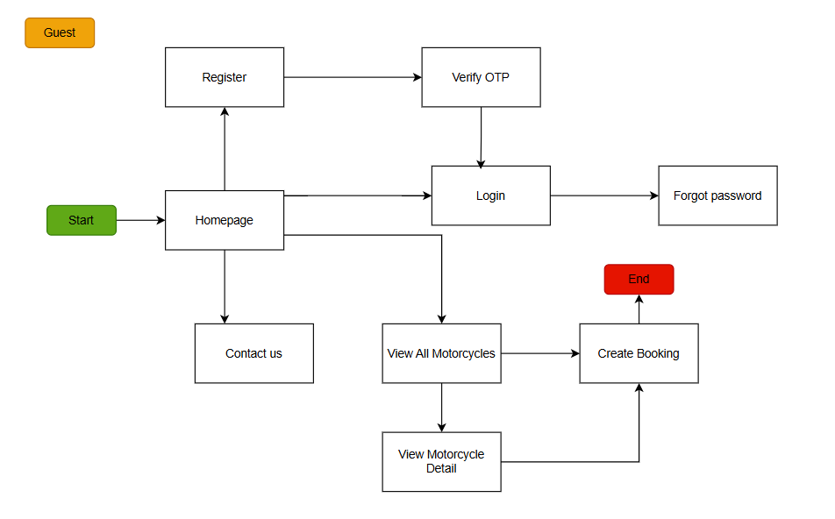
Figure 7. Screen flow Diagram – Guest

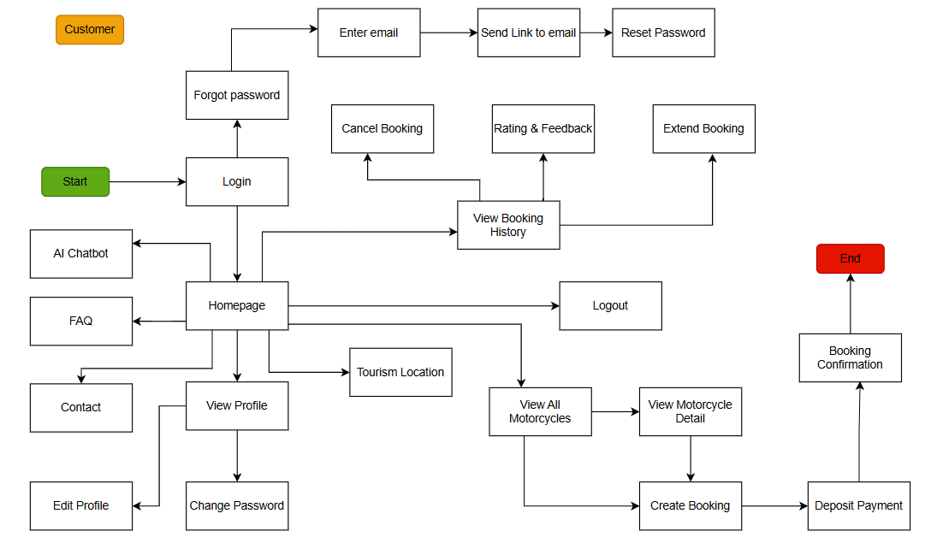
Figure 8. Screen flow Diagram – Customer
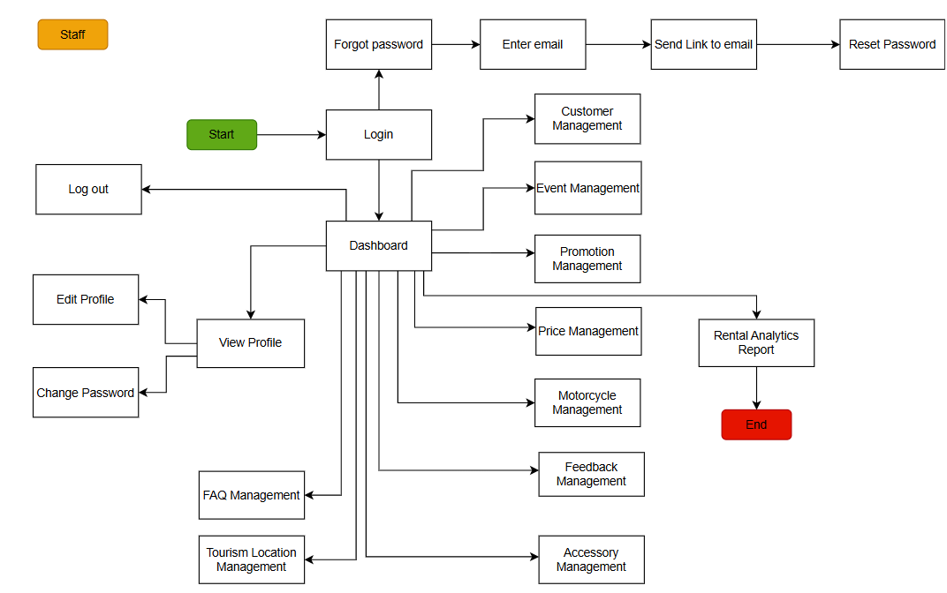
Figure 9. Screen Flow Diagram – Staff
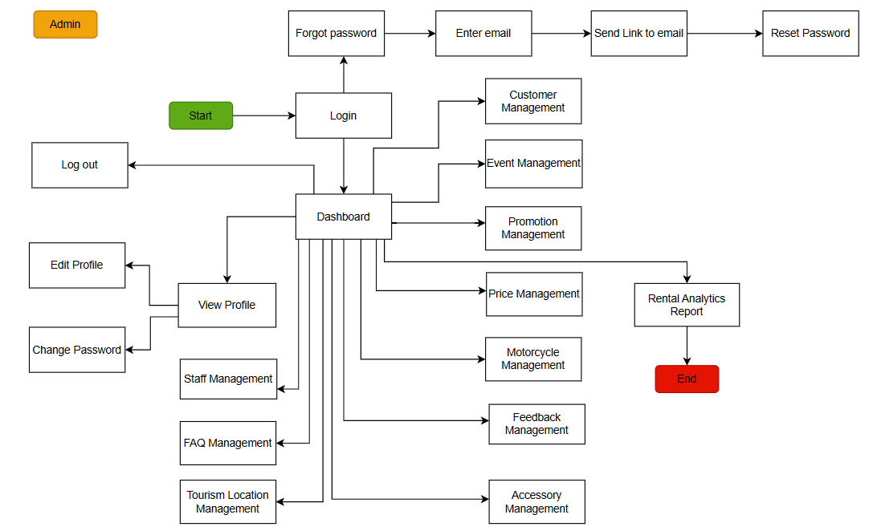
Figure 10. Screen Flow Diagram – Admin (Manager)

2.2 Screen Descriptions
ID | Feature | Screen | Description
1 | Create an account | Register | Allows guests to register a new account by providing name, email, and password.
2 | OTP verification | Verify OTP | Allows users to verify their identity using a one-time code sent to their email.
3 | Login / Logout | Login | Allows users to log in to the system using registered credentials, or log out to end the session.
4 | Login with Google | Login | Allows users to log in quickly using their existing Google account.
5 | Forgot password | Forgot Password | Allows users to recover their password via Enter Email -> Send Link to Email -> Reset Password.
6 | Change password | Change Password | Allows users to change their current password after verification.
7 | View and update profile | View Profile / Edit Profile | Allows users to view and edit personal information, contact details, and avatar.
8 | View homepage | Homepage | Displays an overview of services, promotions, and featured motorcycles.
9 | View all motorcycles | View All Motorcycles | Displays a list of all available motorcycles with photos, prices, and basic info.
10 | View a motorcycle in detail | View Motorcycle Detail | Displays detailed information about a specific motorcycle, including specs and accessories.
11 | View tourism location | Tourism Location | Displays suggested tourism destinations with photos and descriptions.
12 | View FAQs | FAQ | Displays frequently asked questions and their answers.
13 | View price list | Price List | Displays the current rental price list for all motorcycle types.
14 | View policies | Policies | Displays the platform's rental terms and conditions.
15 | Give contact | Contact Us | Allows users to submit a contact form to the support team.
16 | View event/sales | Event/Sales | Displays current promotions, discount events, and campaigns.
17 | Search motorcycles | View All Motorcycles | Allows users to search and filter motorcycles by brand, category, or price.
18 | Get motorcycle suggestions by demand | Motorcycle Suggestion | Suggests suitable motorcycles based on the user's travel needs.
19 | Contact by chatbot | AI Chatbot | Allows users to chat with the system chatbot for information and recommendations.
20 | View booking history | View Booking History | Displays a list of past and current rental bookings.
21 | Choose pick up/return date/location | Create Booking | Allows customers to select pickup/return dates and locations.
22 | Choose motorcycles | Create Booking | Allows customers to select an available motorcycle for the rental period.
23 | Choose accessories | Create Booking | Allows customers to add optional accessories to the booking.
24 | Confirm personal information | Create Booking | Allows customers to review and confirm personal details before booking.
25 | Confirm booking | Booking Confirmation | Displays the complete booking summary before payment.
26 | Make payment | Deposit Payment | Allows customers to complete payment for their rental booking.
27 | Apply voucher code | Deposit Payment | Allows customers to enter a voucher/promo code to receive a discount at payment.
28 | Cancel booking | Cancel Booking | Allows customers to submit a cancellation request for an active booking.
29 | Extend booking | Extend Booking | Allows customers to request an extension of the rental period.
30 | Give rating and feedback | Rating & Feedback | Allows customers to rate the motorcycle and service after rental completion.
31 | Add to favorites | View Motorcycle Detail | Allows customers to save motorcycles to a personal favorites list.
32 | Get motorcycle suggestions by tourism location | Tourism Location | Suggests motorcycles suitable for a selected tourism destination/route.
33 | View customer list | Customer Management | Allows staff to view, search, and access profiles of registered customers.
34 | Disable customer account | Customer Management | Allows staff to deactivate a customer account that violated platform rules.
35 | View overdue rentals | Customer Management | Displays customers who have not returned motorcycles by the agreed date.
36 | Provide customer consultation | Customer Management | Allows staff to provide consultation on motorcycles, pricing, and policies.
37 | Confirm booking (staff) | Booking Management | Allows staff to review and approve pending booking requests.
38 | Update booking status | Booking Management | Allows staff to update booking status through each rental stage.
39 | Cancel booking by staff | Booking Management | Allows staff to cancel a booking on behalf of the customer and process refunds.
40 | Handle extension request | Booking Management | Allows staff to approve or reject customer extension requests.
41 | Handle cancellation request | Booking Management | Allows staff to approve or reject customer cancellation requests.
42 | CRUD motorcycle | Motorcycle Management | Allows staff to add, update, delete motorcycles and manage availability status.
43 | CRUD price list | Price Management | Allows staff to add, update, and remove rental price entries.
44 | CRUD FAQs | FAQ Management | Allows staff to add, update, and remove FAQ entries.
45 | CRUD tourism location | Tourism Location Management | Allows staff to add, update, and remove tourism destinations.
46 | CRUD sales/events | Event Management / Promotion Management | Allows staff to create, update, and remove events, promotions, and voucher campaigns.
47 | CRUD accessories | Accessory Management | Allows staff to add, update, and remove accessories.
48 | View customer feedback and contact requests | Feedback Management | Allows staff to view customer ratings, reviews, and contact submissions.
49 | Track rental motorcycle GPS location | GPS Tracking Map | Displays the real-time GPS location of motorcycles currently being rented.
50 | View staff list | Staff Management | Allows the manager to view and search profiles of staff accounts.
51 | Disable staff account | Staff Management | Allows the manager to deactivate a staff account.
52 | Manage staff roles and permissions | Staff Management | Allows the manager to assign or update roles and access permissions for staff.
53 | View dashboard | Dashboard | Displays key metrics such as active rentals, revenue, and booking statistics.
54 | View rental analytics report | Rental Analytics Report | Displays reports on rental performance, demand trends, and recommendations.

2.3 Screen Authorization
Screen | Guest | Customer | Staff | Admin
Homepage | X | X
Register | X
Verify OTP | X
Login | X | X | X | X
Forgot Password | X | X | X | X
Enter Email | X | X | X | X
Send Link to Email | X | X | X | X
Reset Password | X | X | X | X
Logout |  | X | X | X
Dashboard |  |  | X | X
View Profile |  | X | X | X
Edit Profile |  | X | X | X
Change Password |  | X | X | X
Contact Us | X | X
FAQ | X | X
Price List | X | X
Policies | X | X
Event/Sales | X | X
Tourism Location | X | X
View All Motorcycles | X | X
View Motorcycle Detail | X | X
Motorcycle Suggestion | X | X
AI Chatbot |  | X
Create Booking | X | X
Booking Confirmation |  | X
Deposit Payment |  | X
View Booking History |  | X
Cancel Booking |  | X
Extend Booking |  | X
Rating & Feedback |  | X
Customer Management |  |  | X | X
Booking Management |  |  | X | X
Motorcycle Management |  |  | X | X
Price Management |  |  | X | X
FAQ Management |  |  | X | X
Tourism Location Management |  |  | X | X
Event Management |  |  | X | X
Promotion Management |  |  | X | X
Accessory Management |  |  | X | X
Feedback Management |  |  | X | X
GPS Tracking Map |  |  | X | X
Rental Analytics Report |  |  | X | X
Staff Management |  |  |  | X

2.4 Non-UI Functions
ID | Feature | System Function | Description
1 | Account Verification | Send OTP Email | Automatically sends a one-time code to the user's email for registration or password reset verification.
2 | Booking Notification | Send Booking Confirmation Email | Automatically sends an email/notification confirming booking details after a booking is placed or updated.
3 | Payment Processing | Payment Gateway Integration | Connects to a third-party payment gateway (e.g., VNPay, Momo) to process online rental payments securely.
4 | Voucher Application | Voucher Code Validation | Validates voucher/promo codes against conditions such as expiry date, usage limit, and minimum order value.
5 | Motorcycle Tracking | GPS Data Synchronization | Periodically receives and updates GPS coordinates from motorcycle tracking devices for live map display.
6 | Overdue Detection | Overdue Rental Alert | Automatically scans active bookings and flags/notifies staff of rentals that have passed the agreed return date.
7 | Chatbot Support | Chatbot NLP Processing | Processes user messages using natural language processing to return relevant information or suggestions.
8 | Motorcycle Recommendation | Suggestion Engine | Analyzes travel demand/tourism location input and returns a ranked list of suitable motorcycles.
9 | Reporting | Rental Analytics Calculation | Periodically aggregates booking and revenue data to generate dashboard metrics and analytics reports.
10 | Account Security | Password Encryption | Encrypts and securely stores user passwords using a one-way hashing algorithm.

3. System High Level Design

3.1 Database Design

a. Database Schema
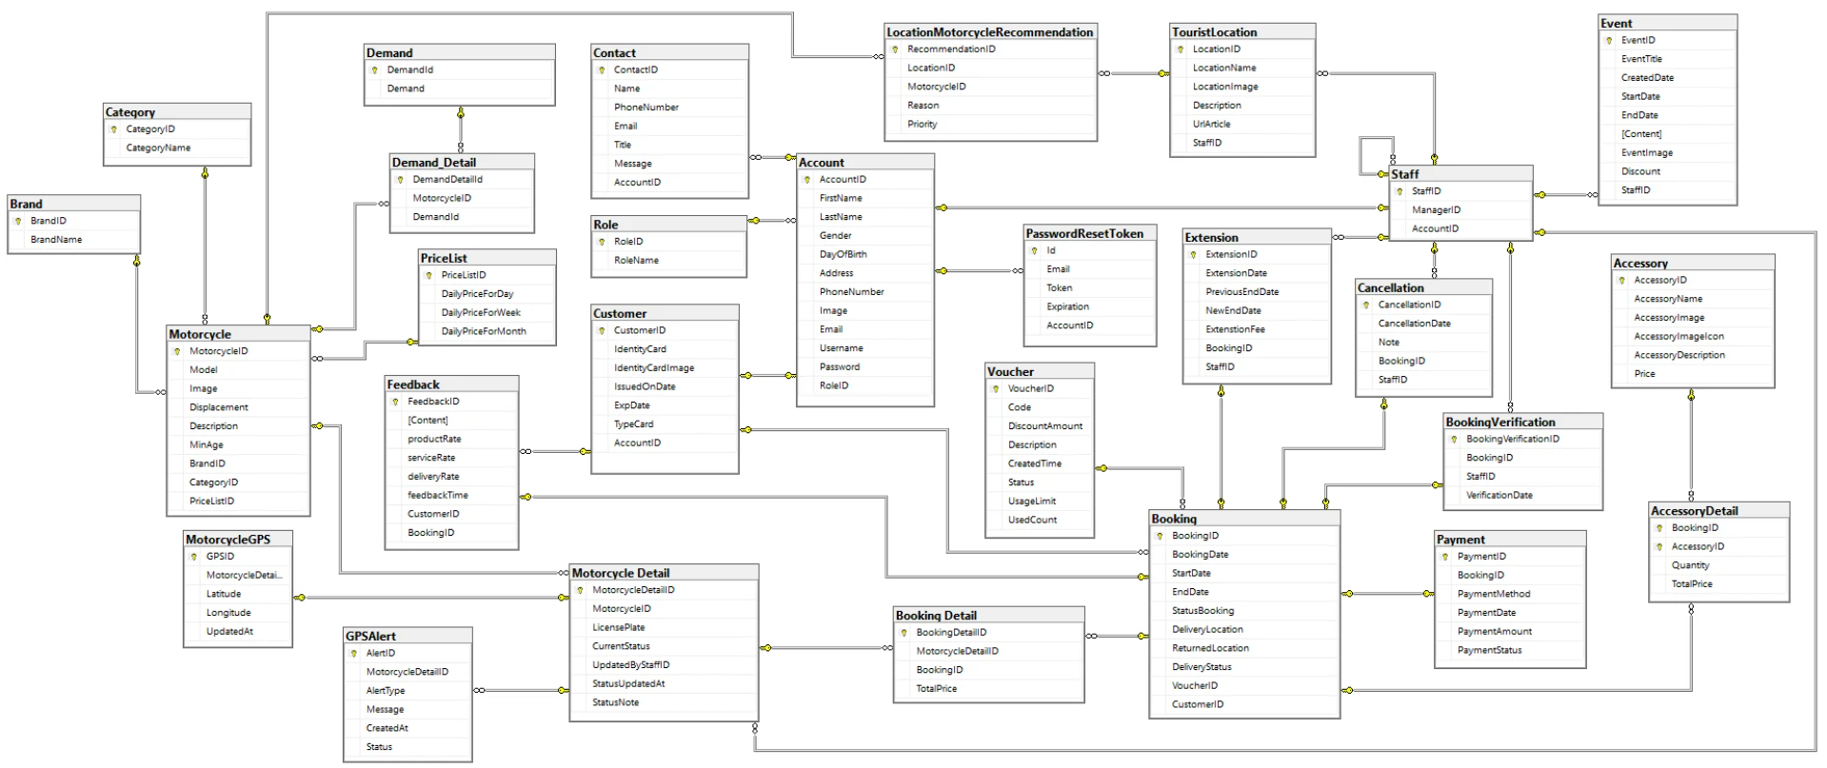

b. Table Descriptions
No | Table | Description
1 | Account | Stores user account information including personal details, credentials, and role assignment.
2 | Role | Defines system roles (Customer, Staff, Admin) used to control access permissions across the platform.
3 | Customer | Stores customer identity verification details linked to an Account, such as identity card number, image, and expiry date.
4 | Staff | Stores staff records with manager hierarchy and a reference to the associated Account.
5 | PasswordResetToken | Manages password reset requests by storing a unique token, associated email, and expiration time. Used by the Forgot Password feature.
6 | Motorcycle | Contains motorcycle inventory details such as model, image, displacement, minimum age requirement, and references to brand, category, and price list.
7 | Brand | Stores motorcycle brand information used to categorize motorcycles by manufacturer.
8 | Category | Defines motorcycle categories (e.g., sport, scooter, touring) to help customers filter rentals.
9 | PriceList | Contains rental pricing tiers (daily, weekly, monthly) to support flexible rental durations.
10 | MotorcycleDetail | Tracks individual motorcycle unit status, license plate, and status update history for fleet management.
11 | MotorcycleGPS | Records real-time GPS coordinates linked to a motorcycle unit for live tracking during active rentals.
12 | GPSAlert | Stores GPS alert events for motorcycle units, including alert type, message, and status, to notify staff of abnormal location activity.
13 | Booking | Records rental booking transactions including booking date, rental period, delivery/return locations, status, and applied voucher.
14 | BookingDetail | Links a booking to a specific motorcycle unit with the total price for that rental line.
15 | BookingVerification | Tracks staff verification of bookings, recording which staff member confirmed the rental handover and when.
16 | Payment | Records payment transactions for bookings, including payment method, date, amount, and status.
17 | AccessoryDetail | Links accessories to a booking with quantity and total price for each accessory rented.
18 | Accessory | Stores available rental accessories (e.g., helmets, rain gear) with name, image, description, and price.
19 | Voucher | Manages promotional voucher codes with discount amount, usage limit, and usage count for discount tracking.
20 | Extension | Handles booking extension requests, storing previous and new end dates, extension fee, and the staff member who approved the request.
21 | Cancellation | Records booking cancellation events with cancellation date, note, and the staff member who processed it.
22 | Feedback | Stores post-rental customer feedback including ratings for product, service, and delivery, linked to a customer and booking.
23 | Contact | Stores customer contact and support form submissions with name, phone, email, title, and message for staff follow-up.
24 | Demand | Defines rental demand types (e.g., tourism, city commuting) used to match customers with suitable motorcycles.
25 | Demand_Detail | Links motorcycles to demand types to power the motorcycle recommendation feature by travel purpose.
26 | TouristLocation | Stores tourism destination entries including name, image, description, and a reference article URL.
27 | LocationMotorcycleRecommendation | Maps motorcycles to tourist locations with a reason and priority to support location-based motorcycle suggestions.
28 | Event | Stores promotional events and campaigns with title, date range, content, discount value, and the staff member who created it.
29 | FAQ | Stores frequently asked questions and their answers managed by Staff to support customers

3.2 Code Packages
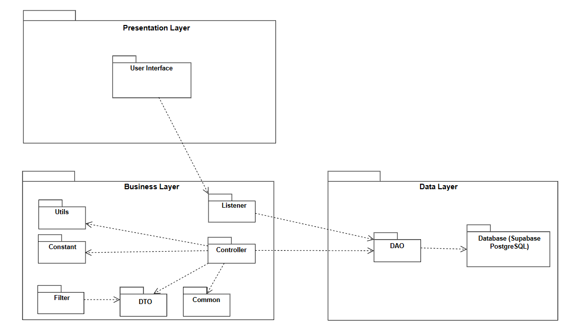
Figure 11. Code Packages Diagram
Package descriptions
No | Package | Description
1 | Presentation Layer | Contains the User Interface, responsible for rendering screens and capturing user interactions.
2 | Business Layer | Contains the Listener and Controller, along with supporting Utils, Constant, Filter, DTO, and Common packages that implement the core business logic.
3 | Data Layer | Contains the DAO package, which interacts directly with the Database (Supabase PostgreSQL) to perform data persistence operations.
4 | User Interface | Renders screens and captures user interactions within the Presentation Layer.
5 | Listener | Receives requests from the Presentation Layer and forwards them to the Controller.
6 | Controller | Implements business logic and coordinates the flow of data between layers.
7 | Utils | Provides utility functions and common services used across the application.
8 | Constant | Stores fixed values and configuration parameters used throughout the system.
9 | Filter | Contains filters for data validation, authentication, and request processing.
10 | DTO | Represents Data Transfer Objects used to exchange data between layers.
11 | Common | Provides shared classes and helper components used across modules.
12 | DAO | Handles database operations, interacting directly with the Database (Supabase PostgreSQL) for data persistence.

II. Requirement Specifications

1. Authentication

1.1 UC-01_Create an account

a. Functionalities
UC ID and Name: | UC-01_Create an account
Created By: | Hồng Nguyên | Date Created: | 01/Jul/2026
Primary Actor: | Customer | Secondary Actors: | None
Trigger: | Customer wants to create an account.
Description: | New users can register an account by providing their name, email, and password to access the platform.
Preconditions: | User accesses the authentication page.
Postconditions: | The create an account process is completed successfully.
Normal Flow | 1. Customer accesses the create an account feature.  2. Customer provides required credentials or information.  3. System validates the provided information.  4. System processes the request (e.g., creates session, updates record).  5. System redirects Customer to the appropriate screen with a success message.
Alternative Flows: | None
Exceptions: | 3a. Validation failed: System displays an error message ('Invalid credentials' or 'Email already exists').
Priority: | Medium
Frequency of Use: | High
Business Rules: | BR-01, BR-02, BR-03, BR-04, BR-05, BR-06
Other Information:
Assumptions:

b. Business Rules
ID | Business Rule | Business Rule Description
BR-01 | Unique email rule | Email must not already exist in the system. System displays an error if duplicate.
BR-02 | Unique username rule | Username must not already exist in the system. System displays an error if duplicate.
BR-03 | Unique phone rule | Phone number must not already exist in the system. System displays an error if duplicate.
BR-04 | Password strength rule | Password must be at least 8 characters, including at least 1 uppercase letter and 1 digit.
BR-05 | Password confirmation rule | Password and confirm password fields must match.
BR-06 | Required fields rule | All fields (firstname, lastname, gender, phone, email, username) must not be left empty.

1.2 UC-02_OTP screen

a. Functionalities
UC ID and Name: | UC-02_OTP screen
Created By: | Hồng Nguyên | Date Created: | 01/Jul/2026
Primary Actor: | Customer | Secondary Actors: | None
Trigger: | Customer wants to otp screen.
Description: | Users enter a one-time code sent to their email to verify their identity during registration or password recovery.
Preconditions: | User accesses the authentication page.
Postconditions: | The otp screen process is completed successfully.
Normal Flow | 1. Customer accesses the otp screen feature.  2. Customer provides required credentials or information.  3. System validates the provided information.  4. System processes the request (e.g., creates session, updates record).  5. System redirects Customer to the appropriate screen with a success message.
Alternative Flows: | None
Exceptions: | 3a. Validation failed: System displays an error message ('Invalid credentials' or 'Email already exists') and halts.
Priority: | Medium
Frequency of Use: | High
Business Rules: | BR-07, BR-08, BR-09
Other Information:
Assumptions:

b. Business Rules
ID | Business Rule | Business Rule Description
BR-07 | OTP format rule | OTP is a 6-digit numeric code generated and sent to the registered email.
BR-08 | OTP validation rule | The entered OTP must match the code stored in the current session.
BR-09 | OTP single-use rule | OTP is single-use and expires when the session ends or a new OTP is requested.

1.3 UC-03_Login credentials

a. Functionalities
UC ID and Name: | UC-03_Login credentials
Created By: | Hoàng Minh | Date Created: | 01/Jul/2026
Primary Actor: | Customer | Secondary Actors: | None
Trigger: | Customer wants to login credentials.
Description: | Users can log in to their account using their registered username and password.
Preconditions: | User accesses the authentication page.
Postconditions: | The login credentials process is completed successfully.
Normal Flow | 1. Customer accesses the login credentials feature.  2. Customer provides required credentials or information.  3. System validates the provided information.  4. System processes the request (e.g., creates session, updates record).  5. System redirects Customer to the appropriate screen with a success message.
Alternative Flows: | None
Exceptions: | 3a. Validation failed: System displays an error message ('Invalid credentials' or 'Email already exists') and halts.
Priority: | Medium
Frequency of Use: | High
Business Rules: | BR-10, BR-11, BR-12, BR-13
Other Information:
Assumptions:

b. Business Rules
ID | Business Rule | Business Rule Description
BR-10 | Required fields rule | Both username and password fields are required to attempt login.
BR-11 | Password verification rule | Password is verified against the stored BCrypt hash.
BR-12 | Role-based redirect rule | RoleID 1 (Customer) is redirected to Home page; RoleID 2 or 3 (Staff/Admin) is redirected to Staff Home page.
BR-13 | Disabled account rule | Accounts with any RoleID other than 1, 2, or 3 are treated as disabled and access is denied.

1.4 UC-04_Login with Google

a. Functionalities
UC ID and Name: | UC-04_Login with Google
Created By: | Quang Minh | Date Created: | 01/Jul/2026
Primary Actor: | Customer | Secondary Actors: | None
Trigger: | Customer wants to login with google.
Description: | Users can log in quickly using their existing Google account.
Preconditions: | User accesses the authentication page.
Postconditions: | The login with google process is completed successfully.
Normal Flow | 1. Customer accesses the login with google feature.  2. Customer provides required credentials or information.  3. System validates the provided information.  4. System processes the request (e.g., creates session, updates record).  5. System redirects Customer to the appropriate screen with a success message.
Alternative Flows: | None
Exceptions: | 3a. Validation failed: System displays an error message ('Invalid credentials' or 'Email already exists') and halts.
Priority: | Medium
Frequency of Use: | High
Business Rules: | BR-14, BR-15, BR-16
Other Information:
Assumptions:

b. Business Rules
ID | Business Rule | Business Rule Description
BR-14 | OAuth authentication rule | Authentication is handled via Google OAuth 2.0 to retrieve the user's email.
BR-15 | Auto-create account rule | If the Google email is not registered in the system, a new account is automatically created with RoleID = 1.
BR-16 | Existing account rule | If the Google email already exists in the system, the user is logged in directly to that account.

1.5 UC-05_Logout

a. Functionalities
UC ID and Name: | UC-05_Logout
Created By: | Hoàng Minh | Date Created: | 01/Jul/2026
Primary Actor: | Customer | Secondary Actors: | None
Trigger: | Customer wants to logout.
Description: | Users can log out of their account to end the current session.
Preconditions: | Customer is currently logged in.
Postconditions: | The logout process is completed successfully.
Normal Flow | 1. Customer clicks the Logout button.  2. System removes the current session (account and email attributes).  3. System redirects Customer to the Home page.
Alternative Flows: | None
Exceptions: | 3a. Validation failed: System displays an error message (e.g., 'Invalid credentials' or 'Email already exists') and halts.
Priority: | Medium
Frequency of Use: | High
Business Rules: | None
Other Information:
Assumptions:

b. Business Rules
None

1.6 UC-06_Forgot password

a. Functionalities
UC ID and Name: | UC-06_Forgot password
Created By: | Phong Quyền | Date Created: | 01/Jul/2026
Primary Actor: | Customer | Secondary Actors: | None
Trigger: | Customer wants to forgot password.
Description: | Users can request a password reset by entering their registered email to receive a reset link or OTP.
Preconditions: | User accesses the authentication page.
Postconditions: | The forgot password process is completed successfully.
Normal Flow | 1. Customer accesses the forgot password feature.  2. Customer provides required credentials or information.  3. System validates the provided information.  4. System processes the request (e.g., creates session, updates record).  5. System redirects Customer to the appropriate screen with a success message.
Alternative Flows: | None
Exceptions: | 3a. Validation failed: System displays an error message ('Invalid credentials' or 'Email already exists') and halts.
Priority: | Medium
Frequency of Use: | High
Business Rules: | BR-17, BR-18, BR-19
Other Information:
Assumptions:

b. Business Rules
ID | Business Rule | Business Rule Description
BR-17 | Email existence rule | The provided email must exist in the system; otherwise the reset request is rejected.
BR-18 | Token generation rule | A password reset link containing a unique UUID token is generated and sent to the registered email.
BR-19 | Token expiry rule | The reset link expires after 5 minutes and is valid for single use only.

2. Account

2.1 UC-07_Change password

a. Functionalities
UC ID and Name: | UC-07_Change password
Created By: | Công Minh | Date Created: | 01/Jul/2026
Primary Actor: | Customer | Secondary Actors: | None
Trigger: | Customer wants to change password.
Description: | Users can change their account password by verifying the current one and setting a new one.
Preconditions: | User accesses the authentication page.
Postconditions: | The change password process is completed successfully.
Normal Flow | 1. Customer accesses the change password feature.  2. Customer provides required credentials or information.  3. System validates the provided information.  4. System processes the request (e.g., creates session, updates record).  5. System redirects Customer to the appropriate screen with a success message.
Alternative Flows: | None
Exceptions: | 3a. Validation failed: System displays an error message ('Invalid credentials' or 'Email already exists') and halts.
Priority: | Medium
Frequency of Use: | High
Business Rules: | BR-20, BR-21, BR-22, BR-23, BR-24
Other Information:
Assumptions:

b. Business Rules
ID | Business Rule | Business Rule Description
BR-20 | Authentication rule | Customer must be logged in to access this feature.
BR-21 | Current password rule | The current password must be verified correctly via BCrypt before allowing any change.
BR-22 | New password differs rule | The new password must not be the same as the current password.
BR-23 | Confirmation match rule | The new password and confirmation password must match.
BR-24 | Password strength rule | New password must be at least 8 characters, including at least 1 uppercase letter and 1 digit.

2.2 UC-08_View and update profile

a. Functionalities
UC ID and Name: | UC-08_View and update profile
Created By: | Quang Minh | Date Created: | 01/Jul/2026
Primary Actor: | Customer | Secondary Actors: | None
Trigger: | Customer wants to view and update profile.
Description: | Users can view and update their personal information, including name, contact details, address, and profile photo.
Preconditions: | Customer is logged in with appropriate permissions.
Postconditions: | The and update profile information is successfully updated/managed in the system.
Normal Flow | 1. Customer accesses the and update profile management section.  2. System retrieves and displays the current list/data.  3. Customer selects an item and performs the desired action (Add/Edit/Delete/Update).  4. Customer fills in any required details and submits.  5. System validates the inputs.  6. System updates the database and displays a success message.
Alternative Flows: | 3a. If deleting, the system prompts for confirmation before proceeding.
Exceptions: | 5a. Invalid input data: System shows an error message and asks Customer to re-enter.
Priority: | Medium
Frequency of Use: | High
Business Rules: | BR-25, BR-26, BR-27, BR-28, BR-29, BR-30
Other Information:
Assumptions:

b. Business Rules
ID | Business Rule | Business Rule Description
BR-25 | Authentication rule | Customer must be logged in to access this feature.
BR-26 | Email format rule | Email is required and must follow a valid format (contain @ and domain).
BR-27 | Phone format rule | Phone number must be exactly 10 digits and begin with 0.
BR-28 | Date of birth rule | Date of birth must not be a future date.
BR-29 | Unique email rule | Email must not already belong to another account in the system.
BR-30 | Unique phone rule | Phone number must not already belong to another account in the system.

2.3 UC-20_View Booking History

a. Functionalities
UC ID and Name: | UC-20_View Booking History
Created By: | Hoàng Minh | Date Created: | 01/Jul/2026
Primary Actor: | Guest, Customer | Secondary Actors: | None
Trigger: | Customer accesses Booking History page.
Description: | As a customer, I want to view my booking history so that I can track previous and current motorcycle rentals.
Preconditions: | Customer is logged into the system.
Postconditions: | Booking history is displayed successfully.
Normal Flow | 1. Customer accesses Booking History page.  2. System retrieves booking records.  3. System displays booking list.  4. Customer selects a booking.  5. System displays booking details.
Alternative Flows: | None
Exceptions: | No booking history available.  System displays notification message.
Priority: | Should Have
Frequency of Use: | High
Business Rules: | BR-53, BR-54, BR-55
Other Information:
Assumptions:

b. Business Rules

ID | Business Rule | Business Rule Description
BR-53 | Ownership rule | Customers can only view their own bookings.
BR-54 | History sorting rule | Booking history is sorted by booking date in descending order.
BR-55 | Detail viewing rule | Customers can open any booking record to view full booking details.

3. General Features

3.1 UC-09_View All Motorcycles

a. Functionalities
UC ID and Name: | UC-09_View All Motorcycles
Created By: | Lê Quang Minh | Date Created: | 01/Jul/2026
Primary Actor: | Guest, Customer | Secondary Actors: | None
Trigger: | User accesses the motorcycle page.  User wants to browse available motorcycles.
Description: | As a guest or customer, I want to view all available motorcycles so that I can choose a suitable motorcycle for rental.
Preconditions: | Motorcycles exist in the system.
Postconditions: | A list of motorcycles is displayed successfully.
Normal Flow | 1.User accesses the motorcycle listing page.  2.System retrieves all available motorcycles.  3.System displays motorcycle images, names, categories, and rental prices.  4.User browses the motorcycle list.  5.User may select a motorcycle to view details.
Alternative Flows: | None
Exceptions: | 1.System displays a notification message.  2.User returns to the homepage.
Priority: | Must Have
Frequency of Use: | Very High
Business Rules: | BR-31, BR-32
Other Information:
Assumptions:

b. Business Rules

ID | Business Rule | Business Rule Description
BR-31 | Available motorcycle rule | Only motorcycles with Available status are displayed to users.
BR-32 | Display information rule | Each motorcycle must display image, name, category, and rental price.

3.2 UC-10_View Motorcycle Detail

a. Functionalities
UC ID and Name: | UC-10_View Motorcycle Detail
Created By: | Lê Quang Minh | Date Created: | 01/Jul/2026
Primary Actor: | Guest, Customer | Secondary Actors: | None
Trigger: | User selects a motorcycle.
Description: | As a guest or customer, I want to view motorcycle details so that I can decide whether to rent it.
Preconditions: | Motorcycle exists
Postconditions: | Motorcycle details are displayed successfully.
Normal Flow | 1. User selects a motorcycle.  2. System retrieves motorcycle information.  3. System displays images, specifications and rental price.  4. System displays included accessories.  5. User reviews details.
Alternative Flows: | None
Exceptions: | Selected motorcycle not found. e.
Priority: | Must Have
Frequency of Use: | High
Business Rules: | BR-33, BR-34
Other Information:
Assumptions:

b. Business Rules

ID | Business Rule | Business Rule Description
BR-33 | Existing motorcycle rule | Selected motorcycle must exist.
BR-34 | Accessory display rule | Included accessories must be displayed together with motorcycle details.

3.3 UC-11_View Tourism Location

a. Functionalities
UC ID and Name: | UC-11_View Tourism Location
Created By: | Hồng Nguyên | Date Created: | 01/Jul/2026
Primary Actor: | Guest, Customer | Secondary Actors: | None
Trigger: | User accesses Tourism page.
Description: | As a user, I want to view tourism destinations so that I can plan my trip.
Preconditions: | Tourism destinations exist.
Postconditions: | Tourism information is displayed.
Normal Flow | 1. User accesses Tourism page.  2. System retrieves destination information.  3. System displays images, descriptions and reference links.  4. User reviews destinations.
Alternative Flows: | None
Exceptions: | No destination found.
Priority: | Medium
Frequency of Use: | High
Business Rules: | BR-35, BR-36
Other Information:
Assumptions:

b. Business Rules

ID | Business Rule | Business Rule Description
BR-35 | Active destination rule | Only active destinations are displayed.
BR-36 | Reference link rule | Destination may contain external reference links.

3.4 UC-12_View FAQs

a. Functionalities
UC ID and Name: | UC-12_View FAQs
Created By: | Phong Quyền | Date Created: | 01/Jul/2026
Primary Actor: | Guest, Customer | Secondary Actors: | None
Trigger: | User accesses FAQ page.
Description: | As a user, I want to view FAQs so that I can understand the service.
Preconditions: | FAQ records exist.
Postconditions: | FAQs are displayed.
Normal Flow | 1. User accesses FAQ page.  2. System retrieves FAQs.  3. System displays questions and answers.  4. User reviews FAQ information.
Alternative Flows: | None
Exceptions: | No FAQs available.
Priority: | Should Have
Frequency of Use: | High
Business Rules: | BR-37, BR-38
Other Information:
Assumptions:

b. Business Rules

ID | Business Rule | Business Rule Description
BR-37 | Active FAQ rule | Only active FAQs are displayed.
BR-38 | Visibility rule | FAQs are visible to all users.

3.5 UC-13_View Price List

a. Functionalities
UC ID and Name: | UC-13_View Price List
Created By: | Công Minh | Date Created: | 01/Jul/2026
Primary Actor: | Guest, Customer | Secondary Actors: | None
Trigger: | User accesses Price List page.
Description: | As a user, I want to view rental prices so that I can estimate rental costs.
Preconditions: | Price list exists.
Postconditions: | Rental prices are displayed.
Normal Flow | 1. User accesses FAQ page.  2. System retrieves FAQs.  3. System displays questions and answers.  4. User reviews FAQ information.
Alternative Flows: | None
Exceptions: | Pricing data unavailable.
Priority: | Must Have
Frequency of Use: | High
Business Rules: | BR-39, BR-40
Other Information:
Assumptions:

b. Business Rules

ID | Business Rule | Business Rule Description
BR-39 | Valid price rule | Rental price must be greater than zero.
BR-40 | Current pricing rule | Only active prices are displayed.

3.6 UC-14_View Policies

a. Functionalities
UC ID and Name: | UC-14_View Policies
Created By: | Hồng Nguyên | Date Created: | 01/Jul/2026
Primary Actor: | Guest, Customer | Secondary Actors: | None
Trigger: | User accesses Policy page.
Description: | As a user, I want to read rental policies before making a reservation.
Preconditions: | Policies exist.
Postconditions: | Policies are displayed.
Normal Flow | 1. User accesses Policy page.  2. System retrieves policy information.  3. System displays policy content.  4. User reviews policies.
Alternative Flows: | None
Exceptions: | Policy data unavailable.
Priority: | MustHave
Frequency of Use: | High
Business Rules: | BR-41, BR-42
Other Information:
Assumptions:

b. Business Rules

ID | Business Rule | Business Rule Description
BR-41 | Active policy rule | Only active policies are displayed.
BR-42 | Latest version rule | Only the latest approved version can be viewed.

3.7 UC-15_Give Contact

a. Functionalities
UC ID and Name: | UC-15_Give Contact
Created By: | Hoàng Minh | Date Created: | 01/Jul/2026
Primary Actor: | Guest, Customer | Secondary Actors: | None
Trigger: | User accesses Contact page
Description: | As a user, I want to send contact information so that I can receive support.
Preconditions: | Contact page is available.
Postconditions: | Contact request is submitted successfully.
Normal Flow | 1. User accesses Contact page.  2. User enters contact information.  3. User enters message.  4. User clicks Submit.  5. System validates data.  6. System stores request.  7. System displays success notification.
Alternative Flows: | None
Exceptions: | Required fields missing or invalid email format.
Priority: | Should Have
Frequency of Use: | High
Business Rules: | BR-43, BR-44
Other Information:
Assumptions:

b. Business Rules

ID | Business Rule | Business Rule Description
BR-43 | Required field rule | Name, Email, Subject and Message are required.
BR-44 | Email validation rule | Email must follow a valid format.

3.8 UC-16_View Event/Sales

a. Functionalities
UC ID and Name: | UC-16_View Event/Sales
Created By: | Lê Quang Minh | Date Created: | 01/Jul/2026
Primary Actor: | Guest, Customer | Secondary Actors: | None
Trigger: | User accesses Promotion page.
Description: | As a user, I want to view current promotions and discount campaigns so that I can save money when renting motorcycles.
Preconditions: | Promotion information exists in the system.
Postconditions: | Promotions are displayed successfully.
Normal Flow | 1. User accesses Promotion page.  2. System retrieves active promotions.  3. System displays promotion title, description, discount value, and validity period.  4. User reviews promotion information.
Alternative Flows: | None
Exceptions: | No promotions available.  System displays notification message.
Priority: | Should Have
Frequency of Use: | High
Business Rules: | BR-45, BR-46
Other Information:
Assumptions:

b. Business Rules

ID | Business Rule | Business Rule Description
BR-45 | Active promotion rule | Only active promotions can be displayed.
BR-46 | Promotion validity rule | Promotions must be within their effective date range.

3.9 UC-17_Search Motorcycles

a. Functionalities
UC ID and Name: | UC-17_Search Motorcycles
Created By: | Phong Quyền | Date Created: | 01/Jul/2026
Primary Actor: | Guest, Customer | Secondary Actors: | None
Trigger: | User enters search criteria and clicks Search.
Description: | As a user, I want to search motorcycles using filters so that I can quickly find suitable motorcycles.
Preconditions: | Motorcycle data exists in the system.
Postconditions: | Search results are displayed successfully.
Normal Flow | 1. User accesses Motorcycle Search page.  2. User enters search criteria.  3. User clicks Search button.  4. System validates search criteria.  5. System retrieves matching motorcycles.  6. System displays search results.
Alternative Flows: | User leaves filters blank.  System displays all available motorcycles.
Exceptions: | No matching motorcycles found.  System displays notification message.
Priority: | Must Have
Frequency of Use: | Very High
Business Rules: | BR-47, BR-48
Other Information:
Assumptions:

b. Business Rules

ID | Business Rule | Business Rule Description
BR-47 | Search filter rule | Search supports brand, category, displacement, price range, and travel purpose filters.
BR-48 | Availability rule | Only available motorcycles appear in search results.

3.10 UC-18_Get Motorcycle Suggestions by Demand

a. Functionalities
UC ID and Name: | UC-18_Get Motorcycle Suggestions by Demand
Created By: | Công Minh | Date Created: | 01/Jul/2026
Primary Actor: | Guest, Customer | Secondary Actors: | None
Trigger: | User selects a travel demand.
Description: | As a user, I want to receive motorcycle recommendations based on my travel needs so that I can choose the most suitable motorcycle.
Preconditions: | Recommendation data exists in the system.
Postconditions: | Recommended motorcycles are displayed successfully.
Normal Flow | 1. User accesses Recommendation page.  2. User selects travel demand.  3. System analyzes recommendation criteria.  4. System retrieves suitable motorcycles.  5. System ranks recommendations.  6. System displays recommended motorcycles.
Alternative Flows: | User selects multiple travel demands.  System combines recommendation criteria.
Exceptions: | No suitable recommendation found.  System displays default suggestions.
Priority: | Should Have
Frequency of Use: | Medium
Business Rules: | BR-49, BR-50
Other Information:
Assumptions: | Recommendation rules are predefined by administrators.

b. Business Rules

ID | Business Rule | Business Rule Description
BR-49 | Demand matching rule | Recommendations are generated based on selected travel demand.
BR-50 | Recommendation limit rule | Maximum 10 motorcycles are displayed per recommendation request.

3.11 UC-19_Contact by Chatbot

a. Functionalities
UC ID and Name: | UC-19_Contact by Chatbot
Created By: | Lê Quang Minh | Date Created: | 01/Jul/2026
Primary Actor: | Guest, Customer | Secondary Actors: | None
Trigger: | User opens chatbot window.
Description: | As a user, I want to communicate with the chatbot so that I can receive support and rental recommendations instantly.
Preconditions: | Chatbot service is available.
Postconditions: | Chatbot response is displayed successfully.
Normal Flow | 1. User opens chatbot.  2. User enters a question.  3. System processes the request.  4. Chatbot generates a response.  5. System displays the response.
Alternative Flows: | None
Exceptions: | Chatbot service unavailable.  System displays support contact information.
Priority: | Could Have
Frequency of Use: | Medium
Business Rules: | BR-51, BR-52
Other Information:
Assumptions:

b. Business Rules

ID | Business Rule | Business Rule Description
BR-51 | Question processing rule | Chatbot must analyze user input before generating a response.
BR-52 | Fallback rule | If chatbot cannot answer, support contact information is displayed.

4. Customer Management

4.1 UC-33_View customer list

a. Functionalities
UC ID and Name: | UC-33_View customer list
Created By: | Công Minh | Date Created: | 01/Jul/2026
Primary Actor: | Staff | Secondary Actors: | None
Trigger: | Staff clicks on the "Customer List" option in the navigation menu
Description: | As a Staff, I want to view, search, and access detailed profiles of all registered customers so that I can manage customer information and assist them with booking queries.
Preconditions: | Staff is logged in and authorized to access the management portal.
Postconditions: | The customer list and chosen customer profile details are displayed successfully.
Normal Flow | 1. User clicks on "Customer List" menu.  2. System retrieves the list of all registered customers from the database.  3. System displays the customer list page with a table showing: Customer ID, Full Name, Email, Phone Number, Status, and action buttons.  4. User enters a search query (name, email, or phone number) or filters by status. 5. System filters the database and displays the matching records.  6. User clicks on "View Detail" for a specific customer.  7. System retrieves and displays the customer's full profile (including identity details, address, and rental status).
Alternative Flows: | Alternative Flow 1: Search returns no results  1. At step 5, if no customers match the query, the System displays: "No customers found matching the search criteria.
Exceptions: | Exception 1: Database connection failure  1. At step 2 or 7, if the database connection fails, the System displays: "Error: Unable to load customer data. Please try again later.
Priority: | Must Have
Frequency of Use: | High
Business Rules: | BR-81, BR-82, BR-83
Other Information:
Assumptions:

b. Business Rules

ID | Business Rule | Business Rule Description
BR-81 | Authorized Access Only | Only accounts with roles 'Staff' or 'Staff Manager' are permitted to access this Use Case and view customer profiles.
BR-82 | Search Wildcard Matching | The search query must match partially (case-insensitive) against the customer's Full Name, Email, or Phone Number.
BR-83 | Credential Masking | Under no circumstances should customer passwords or security credentials be displayed or sent in the view customer response.

4.2 UC-34_Disable customer account

a. Functionalities
UC ID and Name: | UC-34_Disable customer account
Created By: | Hồng Nguyên | Date Created: | 01/Jul/2026
Primary Actor: | Staff | Secondary Actors: | None
Trigger: | Staff selects to lock/disable a customer account.
Description: | As a Staff, I want to disable a customer account so that I can prevent that customer from logging into the platform or using the system services.
Preconditions: | Staff is logged into the system. The target customer account is currently active.
Postconditions: | The customer account status is successfully updated to disabled in the system.
Normal Flow | 1. User accesses the customer management feature.  2. User selects the target customer record and requests to disable it.  3. System validates the request and displays a confirmation dialog.  4. User confirms the action.  5. System processes the request (updates customer account, changes status to disabled).  6. System redirects User to the appropriate screen with a success message.
Alternative Flows: | Alternative Flow 1: User cancels the disable action  1. At step 4, the User cancels the action.  2. System redirects User to the customer management screen without changing the status.
Exceptions: | Exception 1: System error occurs  1. At step 5, if the status cannot be updated due to a system error, System displays an error message to the User and retains the current status.
Priority: | Must Have
Frequency of Use: | Medium
Business Rules: | BR-84, BR-85, BR-86
Other Information:
Assumptions:

b. Business Rules

ID | Business Rule | Business Rule Description
BR-84 | Account Status States | The system must support two primary customer account states: Active and Disabled. A disabled account is barred from logging in or using platform services.
BR-85 | Search Wildcard Matching | The system must require confirmation from the Staff member before changing any customer account status to disabled.
BR-86 | Credential Masking | The customer list screen must only show accounts classified as customers (either Active or Disabled). Staff and Manager accounts must be excluded from this view.

4.3 UC-35_View overdue rentals

a. Functionalities
UC ID and Name: | UC-35_View overdue rentals
Created By: | Hoàng Minh | Date Created: | 01/Jul/2026
Primary Actor: | Staff | Secondary Actors: | None
Trigger: | Staff selects to view the overdue rentals list.
Description: | As a Staff, I want to view a list of customers who have not returned their motorcycles on time so that I can track overdue rentals and contact them for return procedures.
Preconditions: | Staff is logged into the system and authorized.
Postconditions: | The list of overdue rentals and corresponding customer details is displayed successfully.
Normal Flow | 1. User accesses the overdue rentals feature.  2. System processes the request (retrieves active rentals whose scheduled return deadlines have passed).  3. System redirects User to the appropriate screen with the list of overdue rentals, showing customer information, booking identifier, final deadline, and elapsed overdue duration.
Alternative Flows: | Alternative Flow 1: No overdue rentals exist  1. At step 2, if no rentals are overdue, System processes the request.  2. System redirects User to the overdue rentals screen with a message indicating that there are currently no overdue rentals.
Exceptions: | Exception 1: System error occurs  1. At step 2, if the data retrieval fails due to a system connection error, System displays a notification indicating that the system is temporarily unavailable.
Priority: | High
Frequency of Use: | High
Business Rules: | BR-87, BR-88, BR-89
Other Information:
Assumptions:

b. Business Rules

ID | Business Rule | Business Rule Description
BR-87 | Overdue Rental Classification | A rental is classified as overdue if the final scheduled return date and time (including any approved extensions) has passed, the booking is confirmed, and the motorcycle has not been marked as returned.
BR-88 | Overdue Duration Calculation | The system must calculate the overdue duration in days by determining the difference between the current system date/time and the final scheduled return date.
BR-89 | Overdue Sorting Priority | The list of overdue rentals must be sorted in descending order of their final return date, ensuring that the most recently overdue rentals are displayed at the top.

4.4 UC-36_Provide customer consultation

a. Functionalities
UC ID and Name: | UC-36_Provide customer consultation
Created By: | Lê Quang Minh | Date Created: | 01/Jul/2026
Primary Actor: | Staff | Secondary Actors: | None
Trigger: | Staff accesses the contact management feature.
Description: | As a Staff member, I want to view customer contact requests so that I can provide them with consultation regarding motorcycle options and rentals.
Preconditions: | Staff is logged in to the administration portal and has proper permission.
Postconditions: | The consultation request is processed, the status is updated, and the customer is notified of the response.
Normal Flow | 1. User accesses the customer consultation feature.  2. User selects the target consultation record.  3. System validates the input/request.  4. System processes the request (e.g., retrieves the detailed query and updates the consultation status).  5. System displays a success message.
Alternative Flows: | None
Exceptions: | 1. Database error occurs: System displays a connection error message.
Priority: | High
Frequency of Use: | High
Business Rules: | BR-90, BR-91
Other Information:
Assumptions:

b. Business Rules

ID | Business Rule | Business Rule Description
BR-90 | Guest Consultation Identification | The system must label consultation requests with a guest status if the submitting customer email does not match any registered account.
BR-91 | Consultation Status Update | The system must require the user to input resolution notes before updating the request status to resolved.

5. Rental Booking

5.1 UC-21_Choose pick up/return date/location

a. Functionalities
UC ID and Name: | UC-21_Choose pick up/return date/location
Created By: | Lê Quang Minh | Date Created: | 01/Jul/2026
Primary Actor: | Customer | Secondary Actors: | None
Trigger: | Customer wants to configure the rental timeframe and locations.
Description: | Customers can select their preferred pickup and return dates, times, and specific locations for the motorcycle rental.
Preconditions: | Customer is logged in with appropriate permissions.
Postconditions: | Rental dates and locations are successfully saved to the active booking session context.
Normal Flow | 1. Customer inputs the Ngày nhận xe (Pickup Date) and Giờ nhận xe (Pickup Time).  2. Customer inputs the Ngày trả xe (Return Date) and Giờ trả xe (Return Time).  3. Customer selects the Địa điểm nhận xe (Pickup Location) from the provided dropdown.  4. Customer selects the Địa điểm trả xe (Return Location) from the provided dropdown.  5. System validates that the selected timeframe complies with company operating hours.
Alternative Flows: | 3a. Quick Package Fill:  1. Customer clicks the [Thuê 1 Tuần] or [Thuê 1 Tháng] shortcut button.  2. System calculates and automatically populates the corresponding Ngày trả xe block.
Exceptions: | 5a. Out of operating hours: System displays an error message if the time is outside 07:00 - 23:00.  5b. Invalid date range: System displays an error message if the return date is earlier than the pickup date.
Priority: | High
Frequency of Use: | High
Business Rules: | BR-41, BR-42 , BR-43
Other Information:
Assumptions:

b. Business Rules
ID | Business Rule | Business Rule Description
BR-41 | Operational Hours | Both pickup and return times must fall strictly within the official operating window from 07:00 to 23:00.
BR-42 | Advance Notice | The Giờ nhận xe must be scheduled at least 30 minutes later than the current system timestamp.
BR-43 | Minimum Period | The total calculated duration between pickup and return must be a minimum of 1 hour.

5.2 UC-22_Choose motorcycles

a. Functionalities
UC ID and Name: | UC-22_Choose motorcycles
Created By: | Phong Quyền | Date Created: | 01/Jul/2026
Primary Actor: | Customer | Secondary Actors: | None
Trigger: | Customer wants to choose a specific vehicle for their trip.
Description: | Customers can browse and select an available motorcycle and define the rental count for their chosen rental period.
Preconditions: | Rental dates and times are already established in the session.
Postconditions: | Specific motorcycle models and their designated counts are linked to the order structure.
Normal Flow | 1. Customer reviews the available fleet catalog under the CHỌN XE MÁY header section.  2. Customer checks detailed engine specs and package rates (e.g., Yamaha NVX 155cc, Honda Air Blade 160cc).  3. Customer modifies the drop-down list counter from "0" to the desired quantity.  4. System dynamically registers the selection and updates the active allocation banner displaying "Đã chọn: X x [Tên xe]".
Alternative Flows: | None
Exceptions: | 3a. Out of stock allocation: System disables quantities exceeding real-time fleet availability for that specific timeframe.
Priority: | High
Frequency of Use: | High
Business Rules: | BR-44, BR-45
Other Information:
Assumptions:

b. Business Rules
ID | Business Rule | Business Rule Description
BR-44 | Real-time Inventory Check | Available quantities for each card must be calculated dynamically based on real-time database logs for that exact date range to prevent overbooking.
BR-45 | Selection Boundary | A customer must select at least 1 vehicle to proceed through the downstream booking steps.

5.3 UC-23_Choose accessories

a. Functionalities
UC ID and Name: | UC-23_Choose accessories
Created By: | Công Minh | Date Created: | 01/Jul/2026
Primary Actor: | Customer | Secondary Actors: | None
Trigger: | Customer wants to add extra gear items to their rental.
Description: | Customers can add optional accessories such as helmets, protective gloves, or rain gear to their current rental order.
Preconditions: | Customer scrolls to the PHỤ KIỆN ĐI KÈM module on the booking configuration page.
Postconditions: | Selected add-on gear parameters are appended to the checkout list array.
Normal Flow | 1. Customer browses available peripheral equipment lists (e.g., Mũ bảo hiểm 3/4, Găng tay, Giá đỡ điện thoại, Áo mưa rời).  2. Customer inputs chosen quantities or ticks the add-on options next to the item cards.  3. System registers price differentials (e.g., ₫20.000 for open-face vs Free items).  4. System maps accessories directly into the running checkout calculator.
Alternative Flows: | None
Exceptions: | None
Priority: | Medium
Frequency of Use: | High
Business Rules: | BR-46
Other Information:
Assumptions:

b. Business Rules
ID | Business Rule | Business Rule Description
BR-46 | Quantity Cap | The maximum quantity selected for any premium paid accessory cannot exceed the total count of rented motorcycles in the order.

5.4 UC-24_Confirm personal information

a. Functionalities
UC ID and Name: | UC-24_Confirm personal information
Created By: | Hồng Nguyên | Date Created: | 01/Jul/2026
Primary Actor: | Customer | Secondary Actors: | None
Trigger: | Customer reaches the identity verification portion of the workflow.
Description: | Customers can review, modify, and confirm their personal identity details and mandatory verification images before finalizing code execution.
Preconditions: | Customer reaches the THÔNG TIN CÁ NHÂN container block.
Postconditions: | Customer's demographic data and verified state registration cards are staged for transaction entry.
Normal Flow | 1. Customer populates primary fields: Họ, Tên, Email, Số điện thoại, and Địa chỉ.  2. Customer inputs official credentials including CCCD/CMND, Ngày cấp, and Ngày hết hạn.  3. Customer interacts with the media attachment links to upload crisp images of both the front and back layout profiles of their identity card.  4. System stores files securely in transient storage buckets.
Alternative Flows: | None
Exceptions: | 4a. Format Failure: System rejects uploaded document components failing to comply with image file formats (png, jpg).
Priority: | High
Frequency of Use: | High
Business Rules: | BR-47, BR-48
Other Information:
Assumptions:

b. Business Rules
ID | Business Rule | Business Rule Description
BR-47 | File Completeness | Both Mặt trước (Front) and Mặt sau (Back) images of the CCCD/CMND must be successfully uploaded before form submission is unlocked.
BR-48 | Legal Age Limit | Calculated age based on the Ngày sinh field must indicate that the customer is at least 18 years old on the pickup date.

5.5 UC-25_Confirm booking

a. Functionalities
UC ID and Name: | UC-25_Confirm booking
Created By: | Hoàng Minh | Date Created: | 01/Jul/2026
Primary Actor: | Customer | Secondary Actors: | None
Trigger: | Customer wishes to verify contract parameters prior to launching currency transfers.
Description: | Customers can review the complete booking summary including motorcycle details, added accessories, rental dates, and the final total cost breakdown before processing.
Preconditions: | Vehicle, parameters, tracking dates, and legal verification profiles are completed.
Postconditions: | Invoice profiles lock securely into a finalized state ready for deposit routing hooks.
Normal Flow | 1. Customer reviews compiled telemetry nodes nested inside the XÁC NHẬN ĐƠN ĐẶT XE dashboard.  2. Customer audits values inside THỜI GIAN THUÊ, THÔNG TIN KHÁCH HÀNG, and CHI TIẾT DỊCH VỤ & TỔNG TIỀN.  3. Customer accepts legal requirements by ticking the box: "Tôi đã đọc và đồng ý với Điều khoản & Chính sách của SmartRide".  4. System updates state tracking controls from invalid to authorized layout flags.
Alternative Flows: | None
Exceptions: | 3a. Agreement missing: System leaves downstream financial buttons locked if the terms confirmation box remains unticked.
Priority: | High
Frequency of Use: | High
Business Rules: | BR-49
Other Information:
Assumptions:

b. Business Rules

ID | Business Rule | Business Rule Description
BR-49 | Policy Lock out | The action triggers inside the final THANH TOÁN CỌC box must remain strictly disabled until the terms checkbox evaluates as checked = true.

5.6 UC-26_Make payment

a. Functionalities

UC ID and Name: | UC-26_Make payment
Created By: | Lê Quang Minh | Date Created: | 01/Jul/2026
Primary Actor: | Customer | Secondary Actors: | External Payment Gateway API
Trigger: | Customer clicks to pay the upfront security deposit.
Description: | Customers can complete payment for their specialized vehicle reservation securely utilizing integrated payment channels.
Preconditions: | Order summary details are confirmed and user validation states evaluate as true.
Postconditions: | The order state shifts to Paid/Reserved, and the vehicle inventory allocation safely updates.
Normal Flow | 1. Customer unlocks access to the final THANH TOÁN CỌC interactive wrapper.  2. Customer selects their preferred transaction channel gateway.  3. Customer commits the action to initialize the transaction processing logic.  4. System maps session reference codes and triggers secure redirection pathways to process the deposit transaction.
Alternative Flows: | None
Exceptions: | 4a. API Callback Drops: System cancels pending inventory locks if external gateway endpoints report communication failures.
Priority: | High
Frequency of Use: | High
Business Rules: | BR-50
Other Information:
Assumptions:

b. Business Rules

ID | Business Rule | Business Rule Description
BR-50 | Transaction Time out | Once the payment gateway redirect occurs, the selected fleet assets are locked on the database for a max window of 15 minutes awaiting successful confirmation.

5.7 UC-27_Apply voucher code

a. Functionalities

UC ID and Name: | UC-27_Apply voucher code
Created By: | Phong Quyền | Date Created: | 01/Jul/2026
Primary Actor: | Customer | Secondary Actors: | None
Trigger: | Customer desires to use a promotional code discount.
Description: | Customers can enter a voucher or promo code at checkout to receive an instant mathematical discount calculation on their active rental total balance.
Preconditions: | Customer is viewing the checkout summary overview grid elements.
Postconditions: | Total balances recalculate accurately based on the verified reduction rates of the active voucher campaign parameters.
Normal Flow | 1. Customer locates the text box element tracking the MÃ GIẢM GIÁ (VOUCHER) card wrapper.  2. Customer inputs an active voucher character code into the placeholder field "Nhập mã voucher...".  3. Customer interacts with the [Áp dụng] button control element.  4. System validates the code string constraints against configuration conditions stored in relational backend schemas.  5. System recalculates price summaries and subtracts the discount from the total price.
Alternative Flows: | None
Exceptions: | 4a. Invalid Promo: System leaves layout prices unchanged and displays an error warning message detailing code expiration or invalid parameters.
Priority: | Medium
Frequency of Use: | Medium
Business Rules: | BR-51
Other Information:
Assumptions:

b. Business Rules

ID | Business Rule | Business Rule Description
BR-50 | Validation Criteria | Each voucher code must pass structural checks confirming its expiration date, active campaign flag, and minimum order values (if applicable) before calculation.

5.8 UC-28_Cancel booking

a. Functionalities

UC ID and Name: | UC-28_Cancel booking
Created By: | Công Minh | Date Created: | 01/Jul/2026
Primary Actor: | Customer | Secondary Actors: | System Administrator
Trigger: | Customer wants to terminate an active contract assignment entry.
Description: | Customers can submit a cancellation request for an active booking session and monitor the backend processing status logs through completion.
Preconditions: | Customer has authenticated their session and is reviewing historical order tracking sheets.
Postconditions: | The order state shifts status indicators to Cancelled, and automated refund pipelines initialize according to corporate policy constraints.
Normal Flow | 1. Customer selects a valid target contract item inside the user dashboard module.  2. Customer fires the cancellation request trigger action widget.  3. System evaluates if timestamp constraints satisfy the cancellation timeline policy rules.  4. System sets order state tracking parameters to Pending Cancellation or flags immediate asset release vectors.
Alternative Flows: | 1a. In-Form Abandonment:  1. Customer clicks the [ HỦY ĐẶT XE] button at the top of the multi-step layout.  2. System clears data inputs immediately and returns the user to the marketplace layout.
Exceptions: | 3a. Deadline Breach: System blocks autonomous cancellation tasks if the current timeframe falls inside the 24-hour pickup window restriction threshold.
Priority: | High
Frequency of Use: | Low
Business Rules: | BR-52
Other Information:
Assumptions:

b. Business Rules

ID | Business Rule | Business Rule Description
BR-52 | Refund Timeline | To receive a 100% automated refund processing state, cancellation requests must execute at least 24 hours prior to the scheduled pickup time.

5.9 UC-29_Extend booking

a. Functionalities

UC ID and Name: | UC-29_Extend booking
Created By: | Hồng Nguyên | Date Created: | 01/Jul/2026
Primary Actor: | Customer | Secondary Actors: | Fleet Management Staff
Trigger: | Customer decides they require the rented vehicle for a longer duration.
Description: | Customers can request to extend their current active rental period online by defining an updated return timeframe limit.
Preconditions: | User records contain a currently active transaction entry marked with a lifecycle flag matching Renting.
Postconditions: | Tracking schedules change states to accommodate new end dates, and supplementary balance metrics post onto user invoice logs.
Normal Flow | 1. Customer enters their personal active booking log card profile details.  2. Customer activates the tracking interface configuration link labeled "Gia hạn thuê xe".  3. Customer provides an updated terminal target timeframe parameter via date elements.  4. System evaluates downstream inventory scheduling timelines to ensure no overlapping reservations occur.  5. System quotes the step-up pricing metrics required to cover the extension.
Alternative Flows: | None
Exceptions: | 3a. Deadline Breach: System blocks autonomous cancellation tasks if the current timeframe falls inside the 24-hour pickup window restriction threshold.
Priority: | Medium
Frequency of Use: | Medium
Business Rules: | BR-53
Other Information:
Assumptions:

b. Business Rules

ID | Business Rule | Business Rule Description
BR-53 | Schedule Precedence | Extension processing loops must confirm that the target asset identifier maintains a clean inventory schedule through the requested date extension.

5.10 UC-30_Give rating and feedback

a. Functionalities

UC ID and Name: | UC-30_Give rating and feedback
Created By: | Hoàng Minh | Date Created: | 01/Jul/2026
Primary Actor: | Customer | Secondary Actors: | None
Trigger: | Customer wishes to log their review scores on the marketplace index.
Description: | Customers can rate the performance parameters of the motorcycle model and evaluate overall customer service metrics after completing a rental contract lifecycle.
Preconditions: | The target transaction log reflects a finalized lifecycle state tracking flag matching Completed.
Postconditions: | Review objects link onto the product matrix, and global calculation variables update across catalog rows.
Normal Flow | 1. Customer locates the target completed transaction entry nested inside historical log arrays.  2. Customer applies a quantitative rating value by selecting the star interface indicators.  3. Customer inputs qualitative review commentary strings into the text layout space.  4. Customer clicks the submission element control button to post their feedback review to the platform.
Alternative Flows: | None
Exceptions: | 3a. Parameter Deficiency: System stops data writes if a numerical rating choice is absent.
Priority: | Low
Frequency of Use: | Low
Business Rules: | BR-54
Other Information:
Assumptions:

b. Business Rules

ID | Business Rule | Business Rule Description
BR-54 | Review Rights | Chấm điểm Star Rating and review input interfaces remain strictly hidden or disabled unless order workflow flags read Completed.

5.11 UC-31_Add to favorites

a. Functionalities

UC ID and Name: | UC-31_Add to favorites
Created By: | Hồng Nguyên | Date Created: | 01/Jul/2026
Primary Actor: | Customer | Secondary Actors: | None
Trigger: | Customer isolates a preferred motorcycle asset model for future reference.
Description: | Customers can save specific motorcycles they are interested in to a personal favorites listing array for expedited discovery when planning a rental.
Preconditions: | Customer account access session holds valid authorization tokens.
Postconditions: | Target product keys link directly to user record tracking fields across consecutive login lifecycles.
Normal Flow | 1. Customer explores individual motorcycle models inside the DANH MỤC XE MÁY display layout panels.  2. Customer interacts with the favorite bookmark link button layout shape asset [].  3. System captures properties matching the asset selection and updates profile preferences records.  4. System renders the visual state of the selected icon to confirm the product is successfully bookmarked.
Alternative Flows: | 1a. Remove Bookmark:  1. Customer re-clicks an active favorite icon template component.  2. System unlinks product identity indices from the array structure and resets component styling rules.
Exceptions: | None
Priority: | Low
Frequency of Use: | Medium
Business Rules: | BR-55
Other Information:
Assumptions:

b. Business Rules

ID | Business Rule | Business Rule Description
BR-55 | State Persistence | Bookmarked item matrices must cleanly persist within database relationship records across consecutive logins until manually untoggled by the customer.

5.12 UC-32_Get motorcycle suggestions by tourism location

a. Functionalities

UC ID and Name: | UC-32_Get motorcycle suggestions by tourism location
Created By: | Phong Quyền | Date Created: | 01/Jul/2026
Primary Actor: | Customer / Guest | Secondary Actors: | None
Trigger: | User seeks guidance choosing a vehicle suited to a specific destination's terrain characteristics.
Description: | Customers can select a tourism destination profile card to receive targeted motorcycle asset recommendations optimized for that specific path or terrain layout profile.
Preconditions: | User routes to the dedicated tourism management template view component
Postconditions: | The user interface filters current inventory catalogs down to display only targeted vehicle rows matching route conditions.
Normal Flow | 1. User reviews destination cards listed under ĐỊA ĐIỂM DU LỊCH (e.g., Bà Nà Hills, Đèo Hải Vân, Bán đảo Sơn Trà).  2. User selects an attraction by clicking its card container or clicking "Xem chi tiết".  3. System checks the destination terrain type configurations from thebackend parameters (e.g., steep hills require high-power or manual clutch vehicles).  4. System updates the display grid to spotlight matching recommended motorcycle rows (e.g., prioritizing Yamaha Sirius RC or Honda Future models for Đèo Hải Vân).
Alternative Flows: | 1a. Dropdown Trigger Workflow:  1. User interacts with the selector dropdown block labeled Trợ Lý SmartRide on the primary index page.  2. User selects a route list name and fires the [Tìm xe ] button tool control element.
Exceptions: | None
Priority: | Medium
Frequency of Use: | High
Business Rules: | BR-56
Other Information:
Assumptions:

b. Business Rules

ID | Business Rule | Business Rule Description
BR-56 | Terrain Filter Logic | Destined paths categorized with high-altitude inclines or steep mountain passes (such as Đèo Hải Vân or Bán đảo Sơn Trà) must automatically prioritize high-torque manual/semi-automatic vehicles and filter out low-power automatic electric configurations to ensure safety compliance.

6. Rental Management

6.1 UC-37_Confirm booking

a. Functionalities
UC ID and Name: | UC-37_Confirm booking
Created By: | Công Minh | Date Created: | 01/Jul/2026
Primary Actor: | Staff | Secondary Actors: | None
Trigger: | Staff accesses the booking management feature.
Description: | As a Staff, I want to confirm customer booking requests so that the reserved motorcycles are allocated and the delivery process can begin.
Preconditions: | Staff is logged in to the administration portal.
Postconditions: | System updates the booking status to confirmed and sets the delivery status.
Normal Flow | 1. User accesses the booking management feature.  2. User selects the pending booking record.  3. System validates the request.  4. System processes the request (e.g., updates the booking status to confirmed and sets the delivery status).  5. System displays a success message.
Alternative Flows: | None
Exceptions: | 1. Database error occurs: System displays a connection error message.
Priority: | High
Frequency of Use: | High
Business Rules: | BR-95, BR-96
Other Information:
Assumptions:

b. Business Rules

ID | Business Rule | Business Rule Description
BR-95 | Deposit Verification | A booking can only be confirmed if the deposit payment has been successfully processed or manually verified by the staff.
BR-96 | Motorcycle Allocation | Upon booking confirmation, the system must set the status of all associated motorcycles to reserved and schedule them for delivery preparation.

6.2 UC-38_Update booking status

a. Functionalities
UC ID and Name: | UC-38_Update booking status
Created By: | Hồng Nguyên | Date Created: | 01/Jul/2026
Primary Actor: | Staff | Secondary Actors: | None
Trigger: | Staff accesses the booking management feature.
Description: | As a Staff, I want to update the booking status so that the rental progress and payment status are kept accurate.
Preconditions: | Staff is logged in to the administration portal.
Postconditions: | System updates the status of the selected booking and saves the changes.
Normal Flow | 1. User accesses the booking management feature.  2. User provides required information / selects the target booking record.  3. System validates the input/request.  4. System processes the request (e.g., updates the booking status).  5. System displays a success message.
Alternative Flows: | 1a. Manual Payment Verification:  1. User selects the manual payment verification option.  2. System updates the booking status to paid and marks associated motorcycles as deposit paid.  2a. Staff-Initiated Cancellation:  1. User provides a cancellation reason and selects the cancel option.  2. System updates the booking status to cancelled and triggers an automated email notification to the customer.  3a. Customer Request Approval:  1. User selects the option to approve a customer-initiated cancellation or extension.  2. System processes the request and updates the approval record.  2. Email delivery error: System fails to dispatch the cancellation notification email to the customer and displays an error message.
Exceptions: | 1. Database error occurs: System displays a connection error message.  2. Email delivery error: System fails to dispatch the cancellation notification email to the customer and displays an error message.
Priority: | High
Frequency of Use: | High
Business Rules: | BR-97, BR-98
Other Information:
Assumptions:

b. Business Rules

ID | Business Rule | Business Rule Description
BR-97 | Status Transition Rules | The booking status can only transition from pending to confirmed, from confirmed to paid/active, and from active to completed. Cancelled status can only be applied to pending or confirmed bookings.
BR-98 | Active Status Dependency | A booking status cannot be set to active or paid until the motorcycle assignment is finalized and the delivery status is verified.

6.3 UC-39_Cancel booking by staff

a. Functionalities
UC ID and Name: | UC-39_Cancel booking by staff
Created By: | Hoàng Minh | Date Created: | 01/Jul/2026
Primary Actor: | Staff | Secondary Actors: | None
Trigger: | Staff accesses the booking cancellation feature.
Description: | As a Staff, I want to cancel an existing customer booking so that invalid or unfulfillable reservations are properly terminated and the customer is notified.
Preconditions: | Staff is logged in to the administration portal and a pending or confirmed booking exists.
Postconditions: | System updates the booking status to cancelled, records the cancellation reason, and notifies the customer.
Normal Flow | 1. User accesses the booking cancellation feature.  2. User provides required information (e.g., cancellation reason) and selects the target booking record.  3. System validates the input/request.  4. System processes the request (e.g., updates the booking status to cancelled and generates the notification email).  5. System displays a success message.
Alternative Flows: | None
Exceptions: | 1. Email delivery error: System fails to dispatch the cancellation notification email to the customer and displays an error message.  2. Database error: System encounters a failure while saving the cancellation record and displays an error message.
Priority: | High
Frequency of Use: | High
Business Rules: | BR-99, BR-100
Other Information:
Assumptions:

b. Business Rules

ID | Business Rule | Business Rule Description
BR-99 | Mandatory Reason Provision | A booking cannot be cancelled by the staff unless a descriptive cancellation reason is provided by the user.
BR-100 | Mandatory Customer Notification | Upon staff cancellation, the system must immediately dispatch an email to the customer detailing the specific reason for the cancellation to ensure transparency.

6.4 UC-40_Handle extension request

a. Functionalities
UC ID and Name: | UC-40_Handle extension request
Created By: | Lê Quang Minh | Date Created: | 01/Jul/2026
Primary Actor: | Staff | Secondary Actors: | None
Trigger: | Staff accesses the booking extension management feature.
Description: | As a Staff, I want to review and approve customer extension requests so that the rental duration and associated fees are properly updated.
Preconditions: | Staff is logged in to the administration portal and a pending extension request exists.
Postconditions: | System records the staff approval and finalizes the extension request.
Normal Flow | 1. User accesses the booking extension management feature.  2. User provides required information / selects the target extension record.  3. System validates the input/request.  4. System processes the request (e.g., updates the extension record with staff approval details).  5. System displays a success message.
Alternative Flows: | None
Exceptions: | 1. Database error: System encounters a failure while updating the extension record and displays a system error message.
Priority: | High
Frequency of Use: | High
Business Rules: | BR-101, BR-102
Other Information:
Assumptions:

b. Business Rules

ID | Business Rule | Business Rule Description
BR-101 | Staff Accountability Tracking | The system must automatically record the unique identifier of the staff member who approves the extension request to ensure operational accountability.
BR-102 | Extension Dependency | An extension request can only be processed and approved for bookings that are currently active and have not reached a completed or cancelled state.

6.5 UC-41_Handle cancellation request

a. Functionalities
UC ID and Name: | UC-41_Handle cancellation request
Created By: | Phong Quyền | Date Created: | 01/Jul/2026
Primary Actor: | Staff | Secondary Actors: | None
Trigger: | Staff accesses the cancellation management feature.
Description: | As a Staff, I want to review and approve customer cancellation requests so that the booking lifecycle is properly terminated and documented.
Preconditions: | Staff is logged in to the administration portal and a pending customer cancellation request exists.
Postconditions: | System records the staff approval and finalizes the cancellation process.
Normal Flow | 1. User accesses the cancellation management feature.  2. User provides required information / selects the target cancellation record.  3. System validates the input/request.  4. System processes the request (e.g., updates the cancellation record with staff approval details).  5. System displays a success message.
Alternative Flows: | None
Exceptions: | 1. Database error: System encounters a failure while updating the cancellation record and displays a system error message.
Priority: | High
Frequency of Use: | High
Business Rules: | BR-103, BR-104
Other Information:
Assumptions:

b. Business Rules

ID | Business Rule | Business Rule Description
BR-103 | Staff Accountability Tracking | The system must automatically record the unique identifier of the staff member who approves the cancellation request for operational accountability.
BR-104 | Cancellation Irreversibility | Once a cancellation request is approved and finalized by the staff, the associated booking status is permanently resolved and cannot be reverted to an active state.

7. Administration

7.1 UC-42_CRUD Motorcycle

a. Functionalities
UC ID and Name: | UC-42_CRUD Motorcycle
Created By: | Công Minh | Date Created: | 01/Jul/2026
Primary Actor: | Staff | Secondary Actors: | None
Trigger: | Staff accesses the motorcycle management feature.
Description: | As a Staff, I want to manage (create, read, update, delete) motorcycle records so that the fleet catalog remains accurate and up-to-date.
Preconditions: | Staff is logged in to the administration portal with fleet management privileges.
Postconditions: | System updates the motorcycle catalog and saves the changes to the database.
Normal Flow | 1. User accesses the motorcycle management feature.  2. User provides required information / selects the target record for modification.  3. System validates the input/request.  4. System processes the request (e.g., creates, updates, or deletes the motorcycle record).  5. System displays a success message.
Alternative Flows: | 1a. Auto-register New Brand:  1. User submits a motorcycle with a brand name that does not currently exist.  2. System validates the absence of the brand.  3. System automatically creates a new brand record before saving the motorcycle details.
Exceptions: | 1. Database error: System encounters a failure while executing the data operation and displays a system error message.  2. File upload failure: System fails to upload or process the motorcycle image and displays an upload error message.
Priority: | High
Frequency of Use: | High
Business Rules: | BR-105, BR-106
Other Information:
Assumptions:

b. Business Rules

ID | Business Rule | Business Rule Description
BR-105 | Dynamic Brand Registration | When adding or updating a motorcycle, if the submitted brand name is not currently registered in the system catalog, the system must automatically create a new brand entry before proceeding.
BR-106 | Image Reference Fallback | Each motorcycle record must be associated with an image file. If the remote image upload process fails, the system must gracefully fall back to storing the local filename reference to maintain structural data integrity.

7.2 UC-43_CRUD price list

a. Functionalities
UC ID and Name: | UC-43_CRUD price list
Created By: | Hồng Nguyên | Date Created: | 01/Jul/2026
Primary Actor: | Staff | Secondary Actors: | None
Trigger: | Staff accesses the pricing management feature.
Description: | As a Staff, I want to manage (create, read, update, delete) rental price lists so that the daily, weekly, and monthly rates are accurately maintained.
Preconditions: | Staff is logged in to the administration portal with pricing management privileges.
Postconditions: | System updates the pricing catalog and saves the rate changes to the database.
Normal Flow | 1. User accesses the pricing management feature.  2. User provides required information (e.g., daily, weekly, monthly rates) / selects the target record.  3. System validates the input/request (e.g., ensures numeric format and valid discounts).  4. System processes the request (e.g., updates the pricing record).  5. System displays a success message.
Alternative Flows: | None
Exceptions: | 1. Validation error: System detects invalid data (e.g., negative values or illogical duration discounts) and displays a validation error message.  2. Database error: System encounters a failure while saving the pricing data and displays a system error message.
Priority: | High
Frequency of Use: | High
Business Rules: | BR-107, BR-108
Other Information:
Assumptions:

b. Business Rules

ID | Business Rule | Business Rule Description
BR-107 | Mandatory Rate Structure | A complete price list entry must define all three rental duration rates: daily, weekly, and monthly prices. Partial rate structures are not permitted.
BR-106 | Logical Discount Validation | The system logically expects that longer rental durations offer better value; thus, weekly and monthly rates must be proportionately discounted compared to the base daily rate (e.g., evaluating the percentage ratio).

7.3 UC-44_CRUD FAQs

a. Functionalities
UC ID and Name: | UC-44_CRUD FAQs
Created By: | Hoàng Minh | Date Created: | 01/Jul/2026
Primary Actor: | Staff | Secondary Actors: | None
Trigger: | Staff wants to manage frequently asked questions (FAQs)
Description: | Staff can add new FAQ entries, update existing questions and answers, and remove FAQs that are no longer relevant
Preconditions: | Staff is logged in with appropriate permissions
Postconditions: | The FAQ information is successfully updated and managed in the system.
Normal Flow | 1. Staff accesses the FAQ management section  2. System retrieves and displays the current list of FAQs  3. Staff selects an action (Add/Edit/Delete)  4. Staff fills in the required details (Question, Answer) and submits  5. System validates the inputs  6. System update the database and display a success message
Alternative Flows: | 3a. If deleting, the system prompts for confirmation before proceeding
Exceptions: | 5a. Invalid input data (empty fields): System shows an error message and asks Staff to re-enter
Priority: | Medium
Frequency of Use: | Low
Business Rules: | BR-31, BR-32
Other Information:
Assumptions:

b. Business Rules

ID | Business Rule | Business Rule Description
BR-31 | Required fields rule | Both Question and Answer fields must not to be left empty
BR-32 | Staff tracking rule | The system must to automatically record the StaffID of the staff member who performed the CRUD action

7.4 UC-45_CRUD Tourism Location

a. Functionalities
UC ID and Name: | UC-45_CRUD Tourism Location
Created By: | Hồng Nguyên | Date Created: | 01/Jul/2026
Primary Actor: | Staff | Secondary Actors: | None
Trigger: | Staff wants to manage tourism destinations.
Description: | Staff can add new tourism destinations with photos and descriptions, update existing ones, and remove outdated entries.
Preconditions: | Staff is logged in with appropriate permissions.
Postconditions: | The tourism location data is successfully updated in the system.
Normal Flow | 1. Staff accesses the Tourism Management section.  2. System retrieves and displays the list of tourism locations.  3. Staff selects an action (Add / Edit / Delete).  4. Staff inputs data (Location Name, Description, Upload Photo) and submits.  5. System validates the input data and uploaded file format.  6. System updates the database and displays a success message.
Alternative Flows: | 3a. If deleting, the system prompts for confirmation before proceeding.
Exceptions: | 5a. Invalid file format or missing required fields: System displays an error message.
Priority: | Medium
Frequency of Use: | Low
Business Rules: | BR-33, BR-34
Other Information:
Assumptions:

b. Business Rules

ID | Business Rule | Business Rule Description
BR-33 | Image Format Rule | Uploaded photos must be in JPG, JPEG, or PNG format and cannot exceed 5MB.
BR-34 | Required Data | Location Name and Description cannot be left empty.

7.5 UC-46_CRUD Sales/Events

a. Functionalities
UC ID and Name: | UC-46_CRUD Sales/Events
Created By: | Phong Quyền | Date Created: | 01/Jul/2026
Primary Actor: | Staff | Secondary Actors: | None
Trigger: | Staff wants to manage promotional campaigns or events.
Description: | Staff can create new promotions or events with voucher codes, update active campaigns, and remove expired ones.
Preconditions: | Staff is logged in with appropriate permissions.
Postconditions: | Promotions and voucher codes are successfully updated in the system.
Normal Flow | 1. Staff accesses the Promotion Management section.  2. System retrieves and displays active and past promotions.  3. Staff selects an action (Add / Edit / Delete).  4. Staff inputs campaign details (Voucher Code, Discount Percentage, Start Date, End Date) and submits.  5. System validates that the end date is after the start date and the voucher code is unique.  6. System saves changes and displays a success message.
Alternative Flows: | 3a. If deleting, the system prompts for confirmation before proceeding.
Exceptions: | 5a. Duplicate voucher code or invalid date range: System displays an error message.
Priority: | Medium
Frequency of Use: | Medium
Business Rules: | BR-35, BR-36
Other Information:
Assumptions:

b. Business Rules

ID | Business Rule | Business Rule Description
BR-33 | Voucher Uniqueness | Each voucher code must be completely unique within the system.
BR-34 | Timeline Validation | The End Date of a promotion must be greater than or equal to its Start Date.

7.6 UC-47_CRUD Accessories

a. Functionalities
UC ID and Name: | UC-47_CRUD Accessories
Created By: | Công Minh | Date Created: | 01/Jul/2026
Primary Actor: | Staff | Secondary Actors: | None
Trigger: | Staff needs to update the accessory inventory.
Description: | Staff can add new accessories, update stock and pricing information, and remove accessories that are no longer available.
Preconditions: | Staff is logged in with appropriate permissions.
Postconditions: | Accessory catalog and inventory values are modified accurately.
Normal Flow | 1. Staff navigates to the Accessory Management view.  2. System pulls and populates the existing stock lists.  3. Staff triggers an action (Add / Update Stock / Delete).  4. Staff inputs data (Accessory Name, Price, Quantity in Stock) and executes.  5. System checks that numbers are positive and valid.  6. System commits modifications to inventory tables and displays a confirmation.
Alternative Flows: | 3a. Confirm pop-up dialog renders before complete product record extraction.
Exceptions: | 5a. Negative numeric entries supplied for pricing/stock fields: Reject operation.
Priority: | High
Frequency of Use: | Medium
Business Rules: | BR-37, BR-38
Other Information:
Assumptions:

b. Business Rules

ID | Business Rule | Business Rule Description
BR-37 | Positive Stock Value | The total remaining inventory quantity value must be greater than or equal to 0.
BR-38 | Non-Negative Price | The base operational rental fee price attribute calculated must always stand above 0. .

7.7 UC-48_View Customer Feedback and Contact Requests

a. Functionalities
UC ID and Name: | UC-48_View Customer Feedback and Contact Requests
Created By: | Hồng Nguyên | Date Created: | 01/Jul/2026
Primary Actor: | Staff | Secondary Actors: | None
Trigger: | Staff checks submitted incoming reviews or contact forms.
Description: | Staff can view ratings and reviews from customers after completed rentals, and read contact form submissions sent by customers.
Preconditions: | Staff is authenticated into administration view panels.
Postconditions: | Entries can be marked as read/reviewed by processing staff.
Normal Flow | 1. Staff targets Feedback and Contact Submissions panel areas.  2. System compiles lists split between system transaction reviews and standard web contact messages.  3. Staff selects any target message line row to open detailed field blocks.  4. System renders the target client name, rating values, explicit message texts, and transaction timestamp markers.  5. Staff checks off structural compliance flags or marks action rows as resolved.
Alternative Flows: | None
Exceptions: | None
Priority: | Medium
Frequency of Use: | High
Business Rules: | BR-39
Other Information:
Assumptions:

b. Business Rules

ID | Business Rule | Business Rule Description
BR-39 | Read-Only Feedback | Staff can only view ratings and cannot alter or modify user text reviews submitted directly by clients.

7.8 UC-49_Track rental motorcycle GPS location

a. Functionalities

UC ID and Name: | UC-49_Track rental motorcycle GPS location
Created By: | Lê Quang Minh | Date Created: | 01/Jul/2026
Primary Actor: | Staff | Secondary Actors: | None
Trigger: | Staff wants to check the current location of a motorcycle that is currently being rented.
Description: | Staff can view the real-time GPS location of motorcycles currently being rented on an interactive map.
Preconditions: | Staff is logged in with appropriate permissions; the rented motorcycle is equipped with a GPS tracking device.
Postconditions: | The current GPS location of the selected motorcycle is displayed on the map.
Normal Flow | 1. Staff navigates to the Rental Management view and selects an active rental.  2. Staff clicks on "Track Location" for the selected motorcycle.  3. System retrieves the latest GPS coordinates from the tracking device.  4. System displays the motorcycle's current location on an interactive map.  5. Staff can refresh the map to get updated coordinates.
Alternative Flows: | None
Exceptions: | 3a. GPS signal unavailable: System displays the last known location along with the timestamp of the last update.
Priority: | Medium
Frequency of Use: | Low
Business Rules: | BR-109
Other Information:
Assumptions:

b. Business Rules

ID | Business Rule | Business Rule Description
BR-109 | GPS Data Access Limit | GPS location data is only accessible to staff during an active rental period and is not retained after the rental is completed.

7.9 UC-50_View Staff List

a. Functionalities

UC ID and Name: | UC-50_View Staff List
Created By: | Hoàng Minh | Date Created: | 01/Jul/2026
Primary Actor: | Manager | Secondary Actors: | None
Trigger: | Manager wants to view or search for staff members.
Description: | The manager can view, search, and access detailed profiles of all staff accounts along with their roles and permissions.
Preconditions: | Manager is logged into the system administration panel.
Postconditions: | The comprehensive staff listing and filtered profile records are presented accurately.
Normal Flow | 1. Manager accesses the Staff Management workspace section.  2. System fetches all records from the internal personnel directory.  3. Manager types a keyword into the Search bar (e.g., Name, Email, or Role).  4.System dynamically filters rows based on the text string constraint.  5. Manager clicks on a specific staff record row to toggle a detailed view modal containing full assignment permissions. .
Alternative Flows: | None
Exceptions: | None
Priority: | Medium
Frequency of Use: | Medium
Business Rules: | BR-40
Other Information:
Assumptions:

b. Business Rules

ID | Business Rule | Business Rule Description
BR-40 | Directory Visibility | Only accounts associated with structural staff and administrators are returned; customer account parameters are isolated entirely.

7.10 UC-51_Disable Staff Account

a. Functionalities

UC ID and Name: | UC-51_Disable Staff Account
Created By: | Phong Quyền | Date Created: | 01/Jul/2026
Primary Actor: | Manager | Secondary Actors: | None
Trigger: | Manager determines a staff profile must be blocked or deactivated.
Description: | The manager can deactivate a staff account to revoke system access when needed.
Preconditions: | The manager must successfully log into the system and exercise administrative privileges in the human resources management section.
Postconditions: | The status of the assigned employee account will change to 'Inactive/Disabled', and all active sessions for that account will be terminated immediately.
Normal Flow | 1. Manager focuses on a target record row inside the Staff Management workspace table view.  2. Manager triggers the 'Disable Account' button interface control item.  3. System shows an analytical popup warning stating security implications.  4. Manager confirms the administrative deactivation request pipeline.  5. System modifies the status variable field to disabled state lines.  6. System terminates any open security authorization tokens assigned to that staff ID.
Alternative Flows: | 3a. Manager can abort the administrative action pipeline before confirming the warning dialog.
Exceptions: | 5a. Manager tries to disable their own currently active logged-in profile: System blocks the instruction and renders an error notification.
Priority: | High
Frequency of Use: | Low
Business Rules: | BR-40, BR-41
Other Information:
Assumptions:

b. Business Rules

ID | Business Rule | Business Rule Description
BR-40 | Self-Target Protection | An administrative actor cannot alter or flag their own profile status variable field to an inactive state configuration.
BR-41 | Session Invalidation Rule | Changing a personnel state flag to 'Disabled' must instantly drop active session cookies or API session authorization tokens inside cache databases.

7.11 UC-52_Manage Staff Roles and Permissions

a. Functionalities

UC ID and Name: | UC-52_Manage Staff Roles and Permissions
Created By: | Công Minh | Date Created: | 01/Jul/2026
Primary Actor: | Manager | Secondary Actors: | None
Trigger: | Manager needs to change functional authority mappings or group assignments.
Description: | The manager can assign or update roles and access permissions for staff members in the system
Preconditions: | Manager is logged in with master configuration rights
Postconditions: | The modified roles and discrete permission structural bits are committed securely
Normal Flow | 1. Manager navigates into the Authorization Setup matrix dashboard view.  2. System loads all baseline system structural roles alongside active personnel names.  3. Manager selects a specific staff member and clicks 'Modify Access Permissions'.  4. Manager checks or unchecks checkboxes linked to target operational areas (e.g., Order Approval, Inventory CRUD, Fleet Records).  5. Manager submits changes via the 'Save Authority Schema' trigger element.  6. System checks compliance rules, updates mapping tables, and forces permission stack reloading.
Alternative Flows: | None
Exceptions: | 5a. Selected modification parameters leave the system with zero valid master administrator accounts: System terminates the updates and errors out.
Priority: | High
Frequency of Use: | Low
Business Rules: | BR-43
Other Information:
Assumptions:

b. Business Rules

ID | Business Rule | Business Rule Description
BR-43 | Master Account Minimum Rule | The system must always enforce a lower-bound structural minimum of at least one active account containing full Administrator privileges.

7.12 UC-53_View Dashboard

a. Functionalities

UC ID and Name: | UC-53_View Dashboard
Created By: | Lê Quang Minh | Date Created: | 01/Jul/2026
Primary Actor: | Manager | Secondary Actors: | None
Trigger: | Manager accesses the primary system executive home screen dashboard view.
Description: | The manager can view a dashboard showing key metrics such as active rentals, revenue, motorcycle availability, and booking statistics.
Preconditions: | Manager is authenticated and verified within executive dashboard analytics access layers.
Postconditions: | Real-time key performance indicators and operations summary data items load onto screen layouts.
Normal Flow | 1. Manager chooses the main Operations Dashboard panel index item.  2. Manager chooses the main Operations Dashboard panel index item.  3. System aggregates real-time indicators split between multiple key performance tiles.  4. System processes graphical widgets showcasing bike status breakdowns (In-Use, In-Store, Maintenance).  5. System renders values onto high-level dashboard metrics cards.
Alternative Flows: | None
Exceptions: | None
Priority: | High
Frequency of Use: | High
Business Rules: | BR-44
Other Information:
Assumptions:

b. Business Rules

ID | Business Rule | Business Rule Description
BR-44 | Real-Time Metric Freshness | The high-level operational counts (Active Rentals, Bike Availability) must dynamically calculate or pull from cache states updated at maximum 5-minute intervals .

7.13 UC-54_View Rental Analytics Report

a. Functionalities

UC ID and Name: | UC-54_View Rental Analytics Report
Created By: | Lê Quang Minh | Date Created: | 01/Jul/2026
Primary Actor: | Manager | Secondary Actors: | None
Trigger: | Manager requests long-term tactical optimization reports or demand forecasts.
Description: | The manager can view reports on motorcycle rental performance, including most and least rented vehicles, demand trends, and discount recommendations.
Preconditions: | Manager is authorized to pull statistical optimization and business intelligence reports.
Postconditions: | Deep historical performance analytics and automated data-driven markdown suggestions compile visually.
Normal Flow | 1. Manager selects the 'Rental Performance Analytics Reports' module path.  2. System provides historical date parameter boundaries selectors (Quarterly, Annual, Custom range).  3. Manager specifies options and submits the generation processing command.  4. System groups rental transaction statistics across models, calculating usage percentages.  5. System executes analytical algorithms to label lowest-utilization fleets and generate algorithmic discount recommendation rows.  6. System renders descriptive lists, tabular trends, and export buttons.
Alternative Flows: | 5a. Manager can hit an 'Export CSV/PDF' command item to save raw analytic table streams outside the browser sandbox.
Exceptions: | None
Priority: | Medium
Frequency of Use: | Medium
Business Rules: | BR-45, BR-46
Other Information:
Assumptions:

b. Business Rules

ID | Business Rule | Business Rule Description
BR-45 | Utilization Baseline Index | Vehicles with utilization metrics rolling under 15% across a 45-day evaluation baseline are automatically flagged for discount recommendation logic pipelines.
BR-46 | Data Integrity Guardrail | Analytical reports utilize aggregate read mirrors and cannot introduce database write locks onto the live core order transaction tables.

III. Design Specifications

1. Authentication

1.1 Register
Users enter registration details and click "TẠO TÀI KHOẢN" to automatically trigger and send a verification OTP code to their registered email.
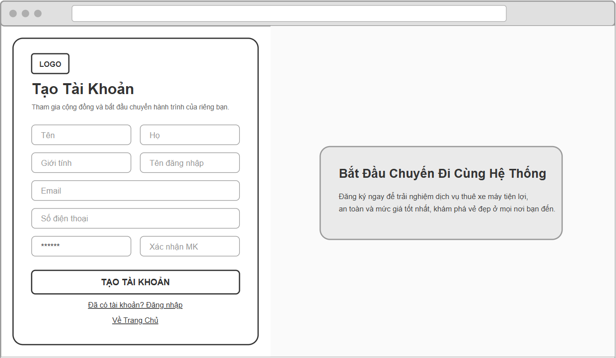

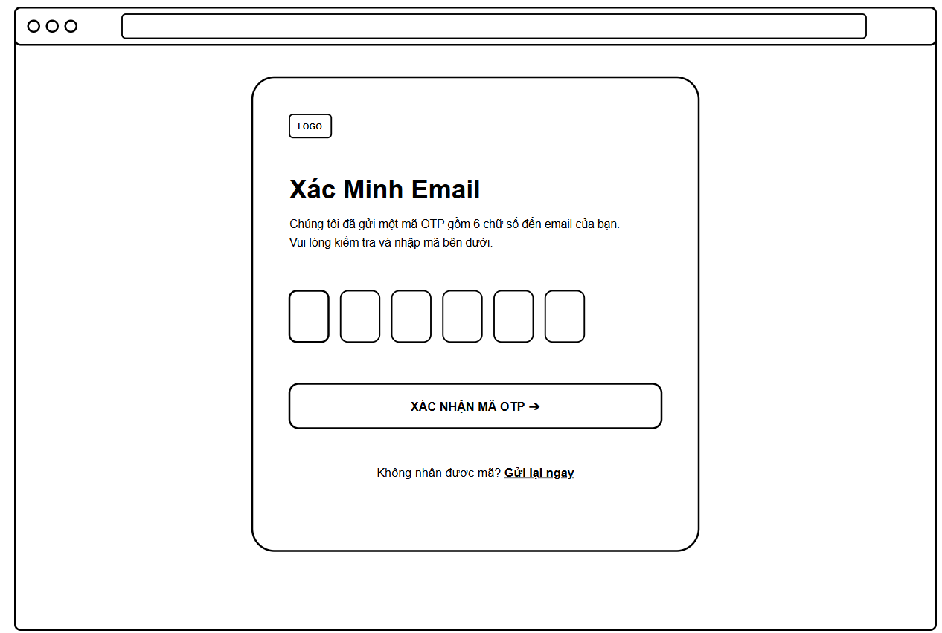
Field Name | Field Type | Description
Title | Heading | This field display "Tạo Tài Khoản".
Tên đăng nhập | Input field | Field to input a valid username.
Email | Input field | Field to input a valid email address. Must follow email format.
Số điện thoại | Input field | Field to input a valid phone number.
Mật khẩu | Password field | This field to input password.
Xác nhận MK | Password field | Field to re-enter password for confirmation.
TẠO TÀI KHOẢN | Button | Button to submit the registration form.
Error Message | Text | Displays error messages "Tên đăng nhập đã tồn tại", "Email không hợp lệ" hoặc "Mật khẩu không trùng khớp".
Success Message | Text | Allows users to navigate to the OTP verification page.
TẠO TÀI KHOẢN | Heading | Button Button to submit the registration form and trigger sending the OTP.

Database Access

Table | CRUD | Description
Account | C | Inserting required fields into a table Account in the database.
PasswordResetToken | C | Insert the generated OTP code and expiration time for the email.
Account | R | Check if Username, Email, or PhoneNumber already exists in the database.

SQL Commands
1. Check duplicate fields
SELECT * FROM "Account" WHERE "Username" = ? OR "Email" = ? OR "PhoneNumber" = ?;
2. Insert OTP code upon registration submission
INSERT INTO "PasswordResetToken" ("Email", "Token", "Expiration")
VALUES (?, ?, NOW() + INTERVAL '5 MINUTE');
3. Verify OTP code
SELECT * FROM "PasswordResetToken"
WHERE "Email" = ? AND "Token" = ? AND "Expiration" > NOW();
4. Inserting required fields into a table Account in the database
INSERT INTO "Account" ("Username", "Email", "PhoneNumber", "Password", "RoleID")
VALUES (?, ?, ?, ?, 1);

1.2 Login
Login to the platform to access user account features.

UI Design
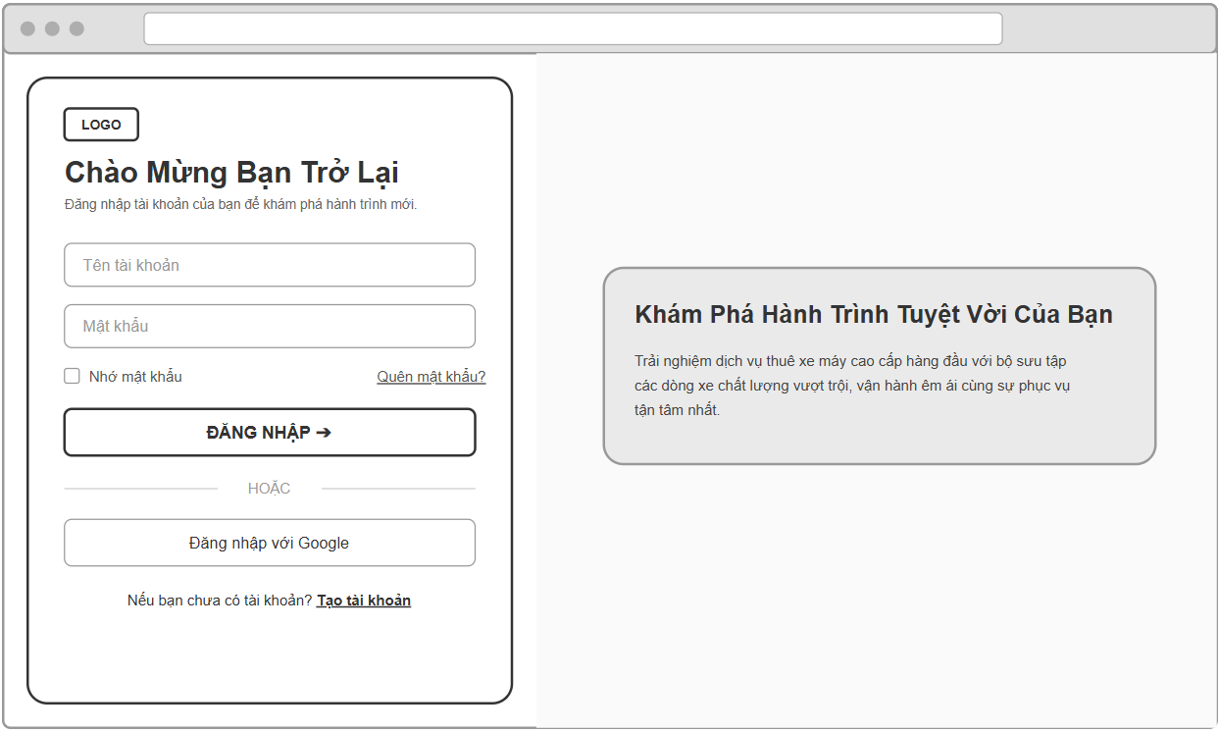

Field Name | Field Type | Description
Title | Heading | This field display "Chào Mừng Bạn Trở Lại"
Tên tài khoản | Input field | Field to input a valid username.
Mật khẩu | Input field | Field to input a valid password.
Đăng nhập | Button | Button to submit the login form.
Error Message | Text | Displays an error message "Tên đăng nhập hoặc Mật khẩu không đúng! Vui lòng nhập lại" when wrong credentials detected.
Success Message | Text | Allows users to navigate to Home page when login is successful.
Ghi nhớ mật khẩu | Check mark | Allows users to stay logged until the session expires.
Quên mật khẩu | Hyperlink | Allows users to recover their password
Đăng nhập bằng Google | Hyperlink | Allows user to login with his/her Google account

Database Access

Table | CRUD | Description
Account | R | Verify Username and Password information.
Account | R | Check exist account before authentication.
Account | C | Add user to database by login Google.
SQL Commands
1. Verify Username, Password or check exist account
SELECT * FROM "Account" WHERE "Username" = ? AND "Password" = ?;

2. Check exist email or username before login/register
SELECT * FROM "Account" WHERE "Username" = ? OR "Email" = ?;

3. Add user by login Google
INSERT INTO "Account" ("Username", "Email", "RoleID")
VALUES (?, ?, 1)
ON CONFLICT ("Email") DO UPDATE SET "Username" = EXCLUDED."Username";

1.3 Logout
Log out of the platform and terminate the current user session.

UI Design
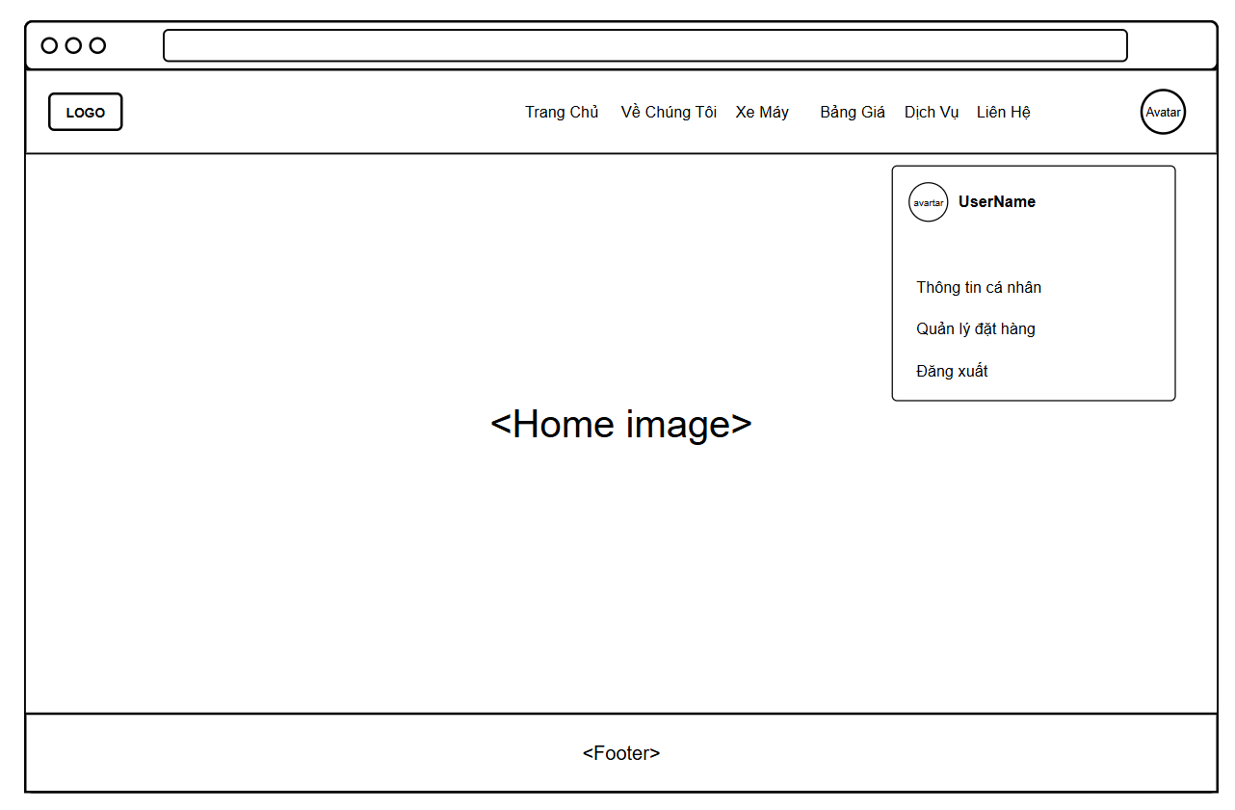
Field Name | Field Type | Description
Đăng xuất | Button | Button to submit the logout.

Database Access
None

1.4 Change Password
Allow users to change their account password to secure their information.

UI Design
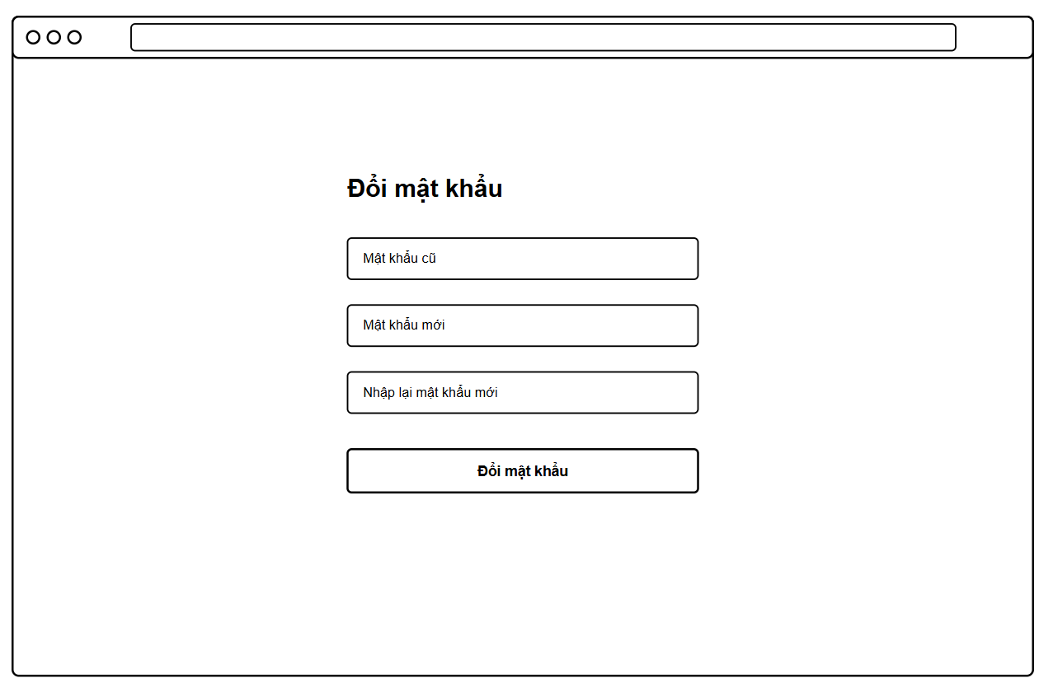
Quyền đang làm

Field Name | Field Type | Description
Title | Heading | This field displays "Đổi mật khẩu".
Mật khẩu cũ | Input field | Field to input current password.
Mật khẩu mới | Input field | Field to input a new password.
Nhập lại mật khẩu mới | Input field | Field to confirm the new password.
Đổi mật khẩu | Button | Button to submit the password change request.
Error Message | Text | Displays an error message when the current password is incorrect or the confirmation password does not match.
Success Message | Text | Displays a success message when the password is changed successfully.

Database Access

Table | CRUD | Description
Customer | R | Verify current password before updating.
Customer | U | Update new password in database.
SQL Commands
1. Verify current password
SELECT *
FROM Customer
WHERE CustomerID = ?
AND Password = ?;
2. Update new password
UPDATE Customer
SET Password = ?
WHERE CustomerID = ?;
3. Validate customer account
SELECT *
FROM Customer
WHERE CustomerID = ?;

1.5 Forgot Password
Users enter their registered email address to receive a password reset link containing a secure token.

UI Design

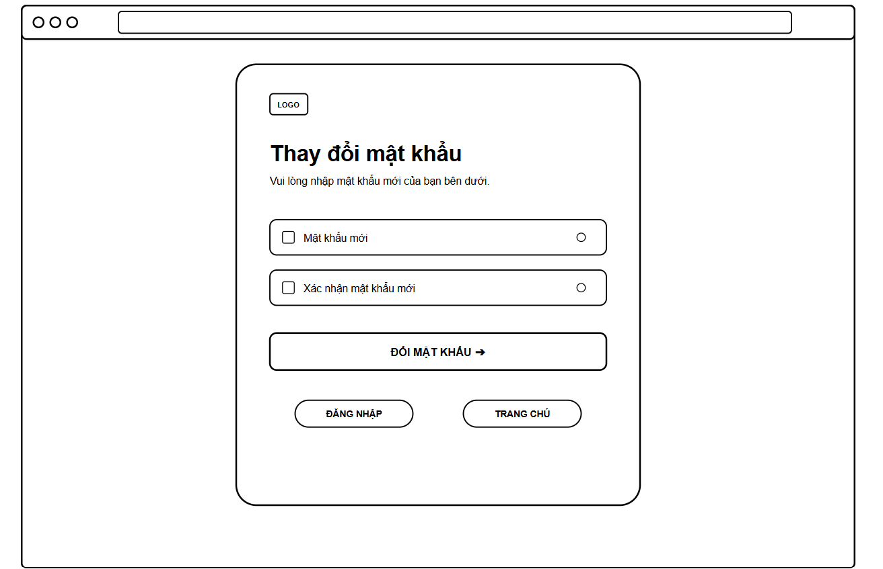

Field Name | Field Type | Description
Title | Heading | This field displays "Thay đổi mật khẩu".
Mật khẩu mới | Input field | Field to input a new password.
Xác nhận mật khẩu mới | Input field | Field to re-enter the new password for confirmation.
Đổi mật khẩu | Button | Button to submit the password reset request.
Đăng nhập | Button | Redirect users to the Login page.
Trang chủ | Button | Redirect users to the Home page.
Error Message | Text | Displays an error message when passwords do not match or validation fails.
Success Message | Text | Displays a success message when the password is changed successfully.

Table | CRUD | Description
Customer | R | Verify customer account using reset token.
Customer | U | Update new password in database.
Customer | C | Remove reset token after successful password reset.
SQL Commands
1. Verify reset token
SELECT *
FROM Customer
WHERE ResetToken = ?;
2. Update new password
UPDATE Customer
SET Password = ?
WHERE ResetToken = ?;
3. Remove reset token
UPDATE Customer
SET ResetToken = NULL
WHERE ResetToken = ?;
4. Check password confirmation (Business Validation)
New Password = Confirm Password

2. Account

2.1 View Profile
Allow logged-in users to view their complete personal profile and account registration details.

UI Design
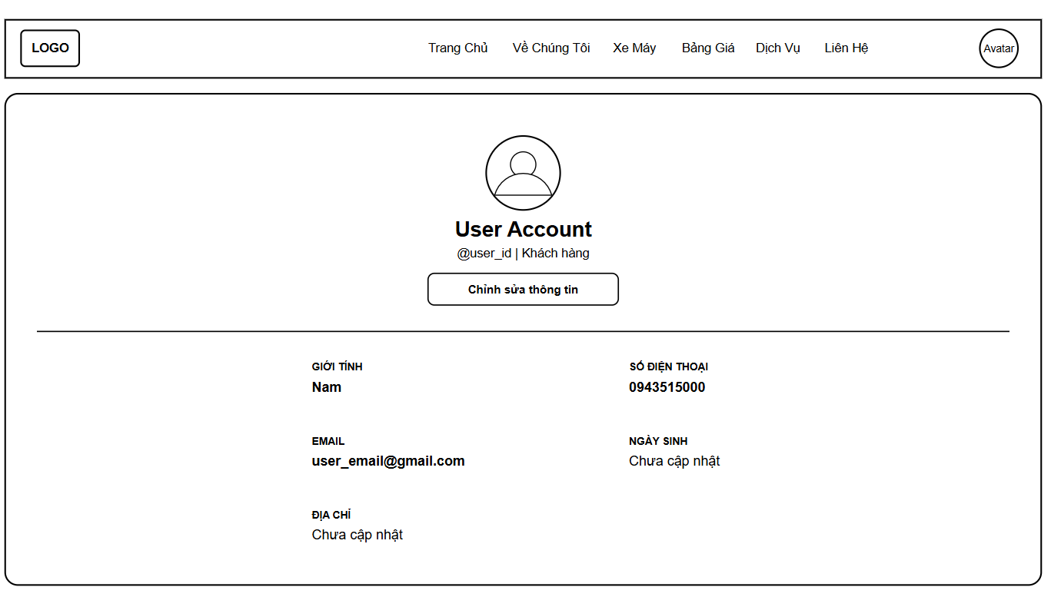

Field Name | Field Type | Description
Logo | Image | Displays the website logo.
Navigation Menu | Navigation Bar | Allows users to navigate to Home, About Us, Cars, Blog, Services, and Contact pages.
User Avatar | Image | Displays user's profile picture.
User Account | Heading | Displays user account information.
User ID | Text | Displays the user's unique identifier.
Customer Name | Text | Displays the customer's full name.
Edit Profile | Button | Redirects users to the Edit Profile page.
Gender | Text | Displays user's gender information.
Phone Number | Text | Displays user's phone number.
Date of Birth | Text | Displays user's date of birth.
Address | Text | Displays user's address information.
Account Menu | Hyperlink | Allows users to access account-related functions.

Table | CRUD | Description
Customer | R | Retrieve customer profile information.
Account | R | Retrieve account information.

SQL Commands
1. Get customer profile information
SELECT *
FROM Customer
WHERE CustomerID = ?;
2. Get account information
SELECT a.AccountID,
a.AccountName,
c.CustomerName,
c.Email,
c.Mobile,
c.Birthday,
c.Address
FROM Account a
JOIN Customer c
ON a.AccountID = c.AccountID
WHERE c.CustomerID = ?;
3. Load customer profile
SELECT CustomerName,
Gender,
Mobile,
Email,
Birthday,
Address
FROM Customer
WHERE CustomerID = ?;

2.2. Update Profile
Allows users to modify and update their personal profile details, including name, email, address, gender, phone number, and date of birth.

UI Design
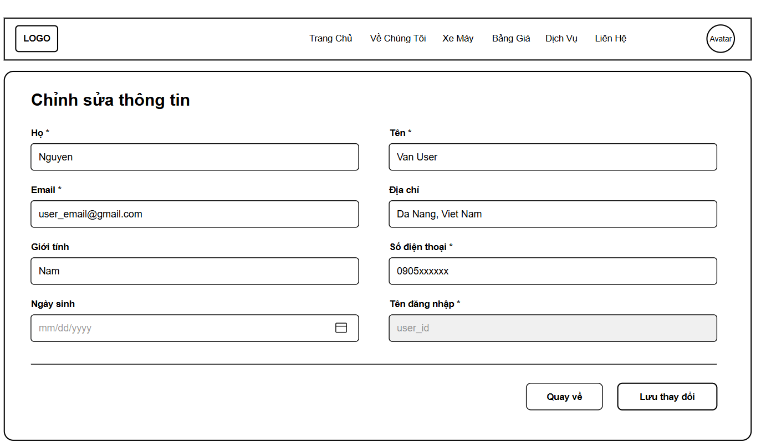

Field Name | Field Type | Description
Logo | Image | Displays the website logo.
Navigation Menu | Navigation Bar | Allows users to navigate to Home, About Us, Cars, Blog, Services, and Contact pages.
Title | Heading | Displays "Edit Profile".
First Name | Input Field | Allows users to enter or update their first name.
Last Name | Input Field | Allows users to enter or update their last name.
Email | Input Field | Allows users to enter or update their email address.
Address | Input Field | Allows users to enter or update their address.
Gender | Dropdown List | Allows users to select their gender.
Phone Number | Input Field | Allows users to enter or update their phone number.
Date of Birth | Date Picker | Allows users to select their date of birth.
Username | Input Field | Displays and allows users to update their username.
Back | Button | Returns users to the Profile page without saving changes.
Save Changes | Button | Saves updated profile information.
Error Message | Text | Displays validation errors when input data is invalid.
Success Message | Text | Displays a notification when profile information is updated successfully.

Table | CRUD | Description
Customer | R | Retrieve current customer information.
Account | R | Retrieve account information.
Customer | U | Update customer profile information.
Account | U | Update username or account-related information.

SQL Commands
1. Retrieve customer information
SELECT *
FROM Customer
WHERE CustomerID = ?;
2. Retrieve account information
SELECT *
FROM Account
WHERE AccountID = ?;
3. Update customer profile
UPDATE Customer
SET CustomerName = ?,
Mobile = ?,
Birthday = ?,
Email = ?,
Address = ?,
Gender = ?
WHERE CustomerID = ?;
4. Update account information
UPDATE Account
SET AccountName = ?
WHERE AccountID = ?;
5. Validate email uniqueness
SELECT *
FROM Customer
WHERE Email = ?
AND CustomerID <> ?;

3. Motorcycle Information

3.1. View All Motorcycles
Allows guests and registered customers to browse the list of available motorcycles, search by keywords, and filter vehicles to select for rental bookings.

UI Design
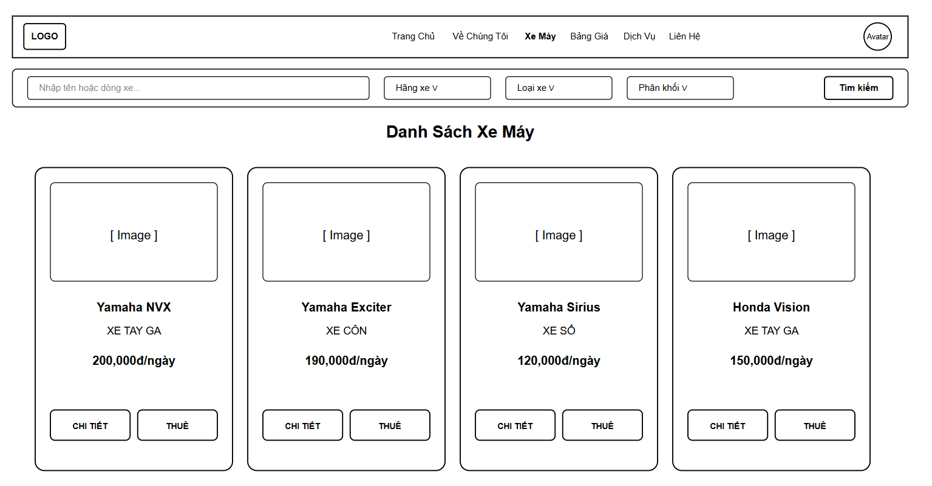

Field Name | Field Type | Description
Logo | Image | Displays the website logo.
Navigation Menu | Navigation Bar | Allows users to navigate to Home, About Us, Motorbikes, Blog, Services, and Contact pages.
Search Box | Input Field | Allows users to enter motorbike name or keyword.
Category Filter | Dropdown List | Allows users to filter motorbikes by category.
Price Filter | Dropdown List | Allows users to filter motorbikes by rental price.
Brand Filter | Dropdown List | Allows users to filter motorbikes by brand.
Search Button | Button | Executes the search function.
Title | Heading | Displays 'Danh Sách Xe Máy'.
Motorbike Image | Image | Displays motorbike image.
Motorbike Name | Text | Displays motorbike name.
Motorbike Type | Text | Displays motorbike category.
Rental Price | Text | Displays rental price per day.
View Detail | Button | Displays detailed motorbike information.
Rent Now | Button | Allows users to rent the selected motorbike.
User Account | Hyperlink | Allows users to access account-related functions.

Database Access
Table | CRUD | Description
Motorbike | R | Retrieve motorbike list.
Motorbike | R | Search motorbikes by keyword.
Category | R | Retrieve category information.
Brand | R | Retrieve brand information.
SQL Commands
1. Retrieve all motorbikes
SELECT * FROM Motorbike;
2. Search motorbike by keyword
SELECT * FROM Motorbike
WHERE MotorbikeName LIKE ?;
3. Filter motorbike by category
SELECT * FROM Motorbike
WHERE CategoryID = ?;
4. Filter motorbike by brand
SELECT * FROM Motorbike
WHERE BrandID = ?;

3.2. View Motorcycle Detail
Allows users to view comprehensive information about a selected motorcycle, including its rental pricing plans for different durations

UI Design
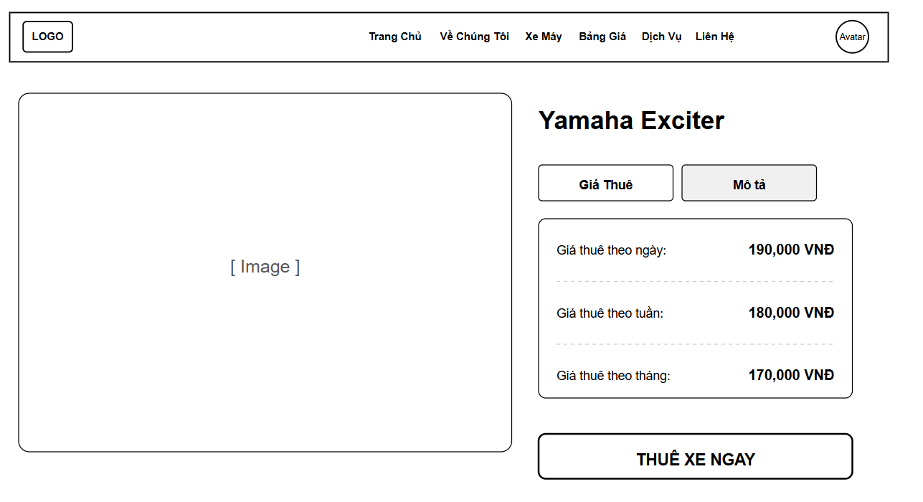

Field Name | Field Type | Description
Logo | Image | Displays the website logo.
Navigation Menu | Navigation Bar | Allows users to navigate through the website.
User Account | Hyperlink | Allows users to access account-related functions.
Motorbike Image | Image | Displays the selected motorbike image.
Motorbike Name | Heading | Displays the selected motorbike name.
Rental Price Tab | Button | Displays rental price information.
Description Tab | Button | Displays motorbike description information.
Daily Price | Text | Displays rental price per day.
Weekly Price | Text | Displays rental price per week.
Monthly Price | Text | Displays rental price per month.
Rent Now | Button | Allows users to rent the selected motorbike.

Database Access
Table | CRUD | Description
Motorbike | R | Retrieve detailed motorbike information.
Category | R | Retrieve motorbike category information.
RentalPrice | R | Retrieve rental pricing information.
SQL Commands
1. Retrieve motorbike details
SELECT *
FROM Motorbike
WHERE MotorbikeID = ?;
2. Retrieve rental prices
SELECT DailyPrice, WeeklyPrice, MonthlyPrice
FROM RentalPrice
WHERE MotorbikeID = ?;
3. Retrieve category information
SELECT m.*, c.CategoryName
FROM Motorbike m
JOIN Category c ON m.CategoryID = c.CategoryID
WHERE m.MotorbikeID = ?;

3.3. View Price List
This page displays rental rates for all motorcycles. Users can compare daily, weekly, and monthly prices to choose the most cost-effective rental plan.

UI Design
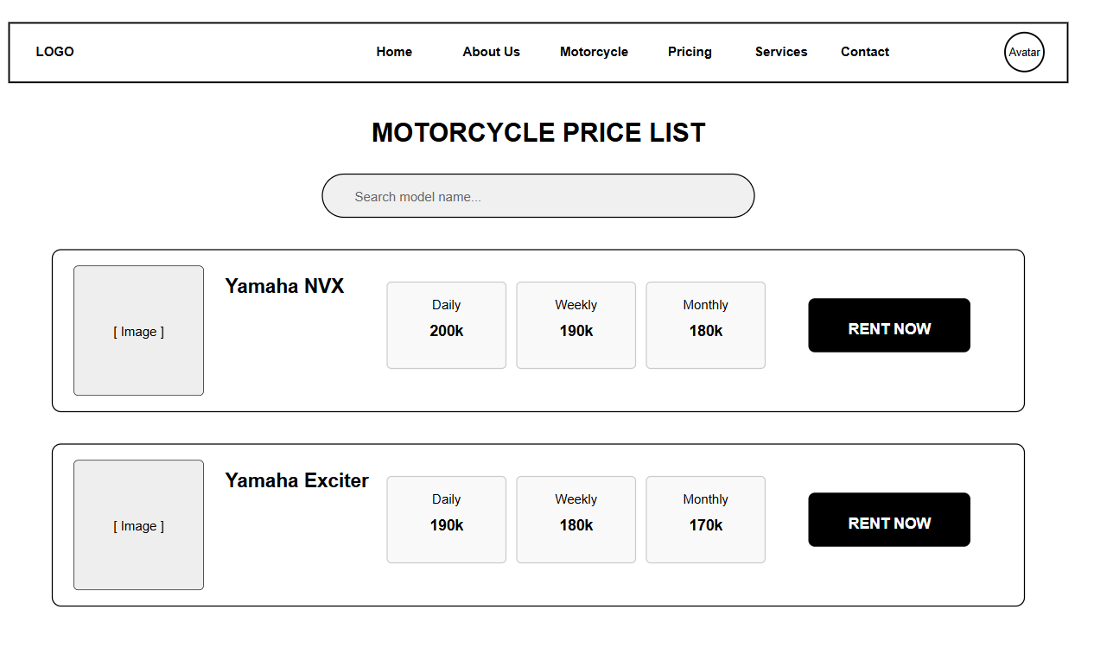

Field Name | Field Type | Description
Logo | Image | Displays the website logo.
Navigation Menu | Navigation Bar | Allows users to navigate to Home, About Us, Motorcycle, Pricing, Services, and Contact pages.
User Account | Hyperlink | Allows users to access account-related functions.
Title | Heading | Displays 'Motorcycle Price List'.
Search Box | Input Field | Allows users to search motorcycles by model name.
Motorcycle Image | Image | Displays motorcycle image.
Motorcycle Name | Text | Displays motorcycle model name.
Daily Price | Text | Displays rental price per day.
Weekly Price | Text | Displays rental price per week.
Monthly Price | Text | Displays rental price per month.
Rent Now | Button | Allows users to rent the selected motorcycle.

Database Access
Table | CRUD | Description
Motorcycle | R | Retrieve motorcycle list and pricing information.
RentalPrice | R | Retrieve daily, weekly and monthly rental prices.
Category | R | Retrieve motorcycle category information.
SQL Commands
1. Retrieve motorcycle list
SELECT * FROM Motorcycle;
2. Search motorcycle by model name
SELECT *
FROM Motorcycle
WHERE MotorcycleName LIKE ?;
3. Retrieve rental prices
SELECT DailyPrice, WeeklyPrice, MonthlyPrice
FROM RentalPrice
WHERE MotorcycleID = ?;
4. Retrieve motorcycle details
SELECT m.*, c.CategoryName
FROM Motorcycle m
JOIN Category c ON m.CategoryID = c.CategoryID;

4. Tourism Information

4.1. View Tourism Location
Provides users with a curated list of tourist attractions in Da Nang, along with recommendations for suitable motorcycles to visit each location.

UI Design

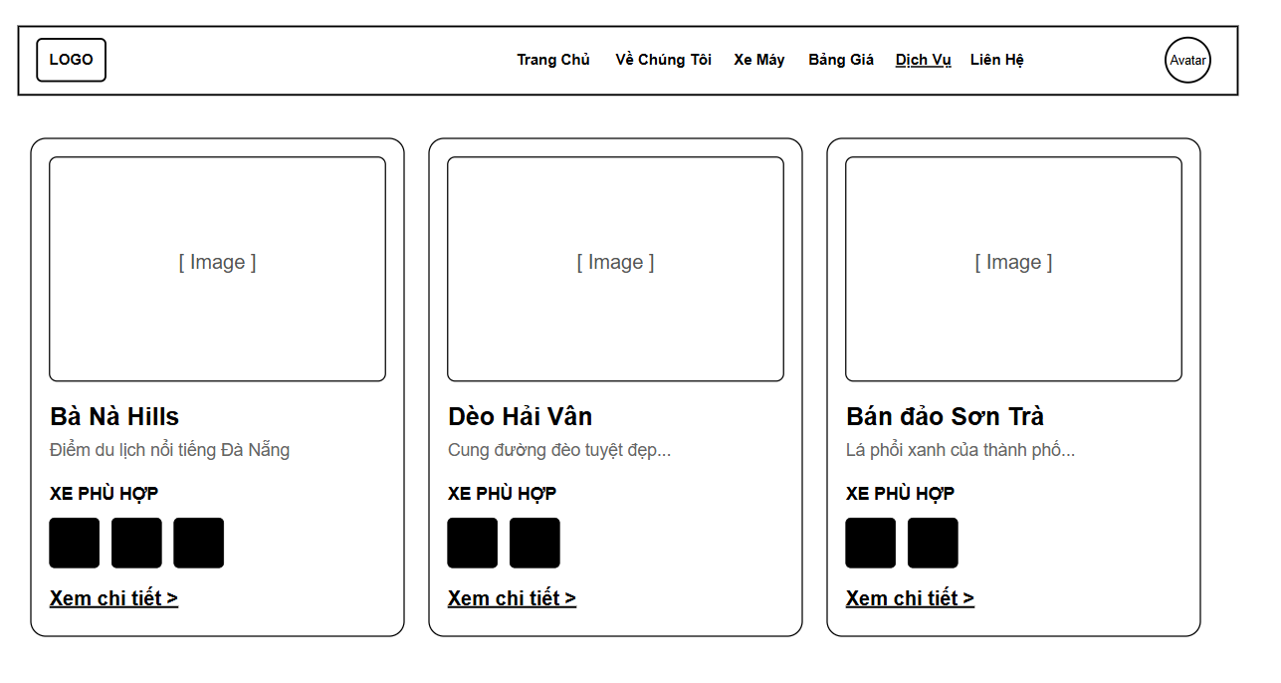

Field Name | Field Type | Description
Logo | Image | Displays the website logo.
Navigation Menu | Navigation Bar | Allows users to navigate to Home, About Us, Motorbike, Blog, Services, and Contact pages.
User Account | Hyperlink | Allows users to access account-related functions.
Destination Image | Image | Displays destination image.
Destination Name | Text | Displays destination name.
Destination Description | Text | Displays a short description of the destination.
Suitable Vehicle | Image/Icon | Displays recommended vehicle types for the destination.
View Detail | Hyperlink | Allows users to view detailed destination information.

Database Access
Table | CRUD | Description
Destination | R | Retrieve destination list.
Destination | R | Retrieve destination details.
Vehicle | R | Retrieve suitable vehicle information for destinations.
SQL Commands
1. Retrieve destination list
SELECT * FROM Destination;
2. Retrieve destination details
SELECT *
FROM Destination
WHERE DestinationID = ?;
3. Retrieve suitable vehicle information
SELECT d.*, v.VehicleName
FROM Destination d
JOIN Vehicle v ON d.VehicleID = v.VehicleID;

4.2. View Tourism Location Detail
Displays detailed information about a tourist destination and suggests suitable motorcycles based on the local terrain, helping users make informed rental choices.

UI Design
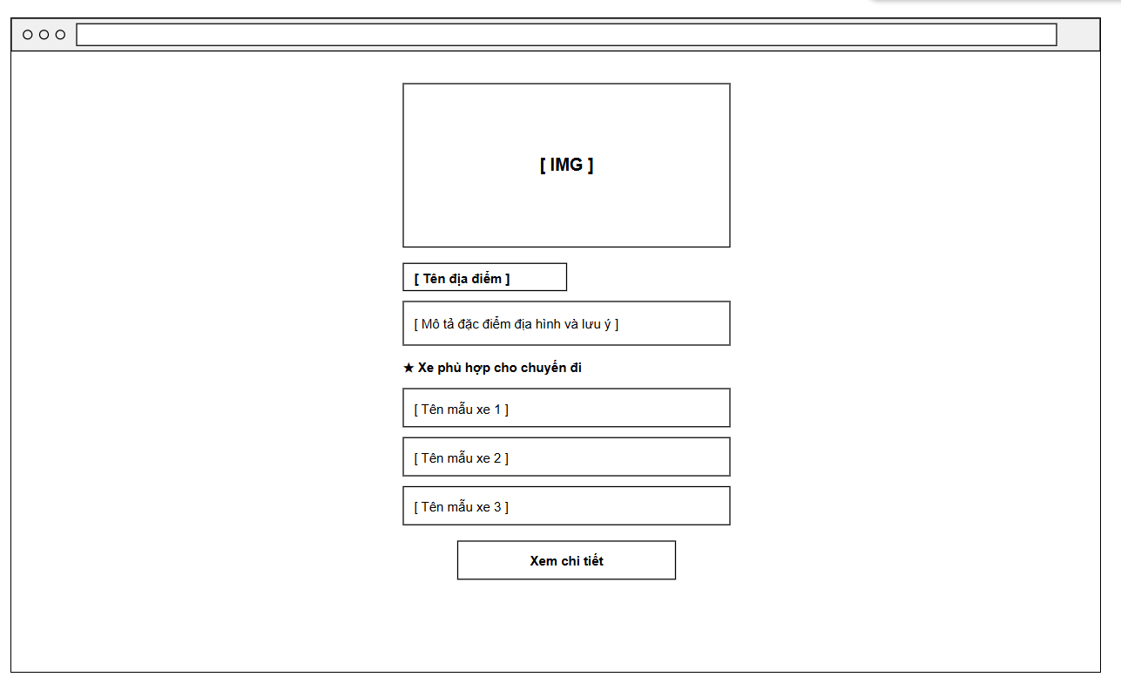

Field Name | Field Type | Description
Location Image | Image | Displays the image of the tourist destination.
Location Name | Text | Displays the name of the tourist destination.
Location Description | Text | Displays detailed information about the destination.
Suitable Motorcycles | Text | Displays recommended motorcycles for the destination.
Motorcycle 1 | Text | Displays the first recommended motorcycle.
Motorcycle 2 | Text | Displays the second recommended motorcycle.
Motorcycle 3 | Text | Displays the third recommended motorcycle.
View Detail | Button | Displays detailed information of the selected motorcycle.

Database Access
Table | CRUD | Description
TourismLocation | R | Retrieve tourism location details.
Motorcycle | R | Retrieve recommended motorcycles for the destination.
LocationMotorcycle | R | Retrieve mapping between destinations and motorcycles.
SQL Commands
1. Retrieve tourism location detail
SELECT *
FROM TourismLocation
WHERE LocationID = ?;
2. Retrieve recommended motorcycles
SELECT m.*
FROM Motorcycle m
JOIN LocationMotorcycle lm
ON m.MotorcycleID = lm.MotorcycleID
WHERE lm.LocationID = ?;
3. Retrieve destination with motorcycles
SELECT tl.LocationName,
m.MotorcycleName
FROM TourismLocation tl
JOIN LocationMotorcycle lm ON tl.LocationID = lm.LocationID
JOIN Motorcycle m ON lm.MotorcycleID = m.MotorcycleID
WHERE tl.LocationID = ?;

5. Rental Booking

5.1 Create Booking
Allows customers to create a motorcycle rental booking by selecting rental date and time, motorcycle, accessories, pickup/return location, and customer information before confirming the booking.

UI Design
Figure 5.1.1 Select Rental Date & Time
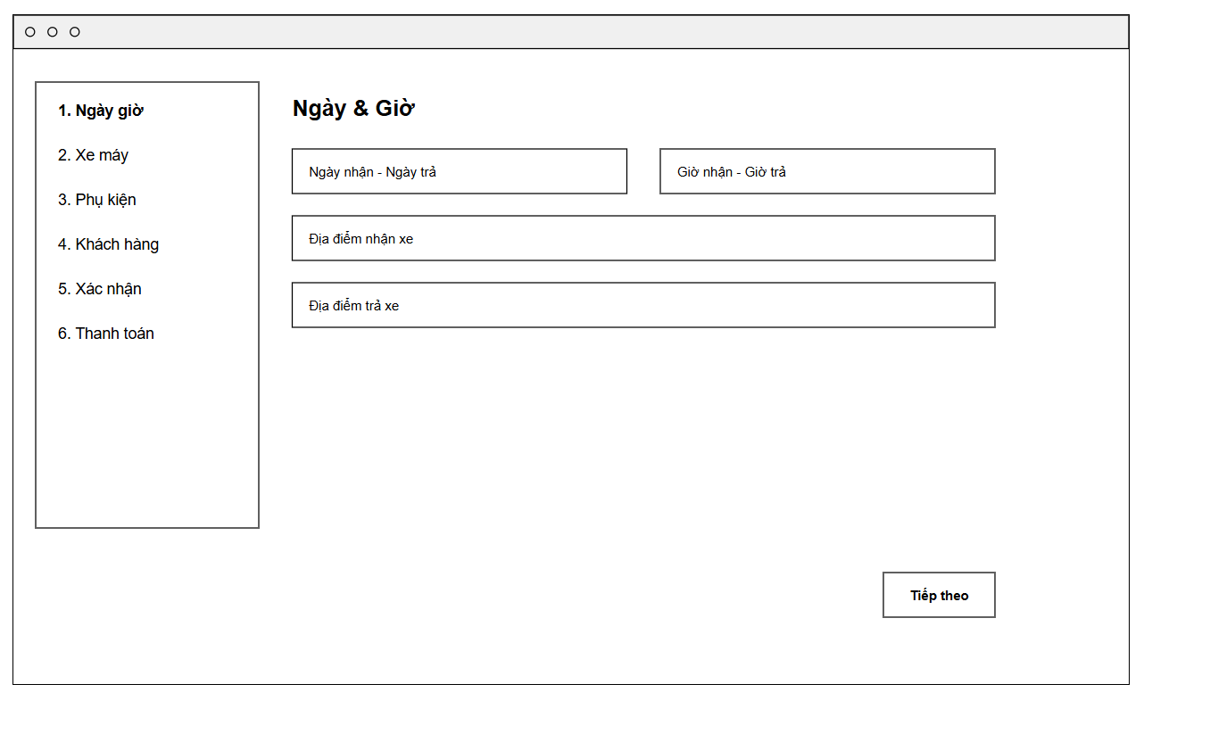

Field Name | Field Type | Description
Rental Steps | Navigation Panel | Displays the rental process steps.
Date & Time | Heading | Displays the rental date and time section.
Pickup Date - Return Date | Date Picker | Allows users to select pickup and return dates.
Pickup Time - Return Time | Time Picker | Allows users to select pickup and return times.
Pickup Location | Input Field | Allows users to enter the pickup location.
Return Location | Input Field | Allows users to enter the return location.
Next | Button | Moves users to the next rental step.

Database Access
Table | CRUD | Description
Rental | C | Create rental information draft.
Rental | R | Check rental date and time availability.
Location | R | Retrieve pickup and return location information.
SQL Commands
1. Check rental availability
SELECT *
FROM Rental
WHERE VehicleID = ?
AND (
PickupDate <= ?
AND ReturnDate >= ?
);
2. Create rental draft
INSERT INTO Rental
(PickupDate, ReturnDate, PickupLocation, ReturnLocation)
VALUES (?, ?, ?, ?);
3. Retrieve location information
SELECT *
FROM Location;

Figure 5.1.2 Select Motorcycle
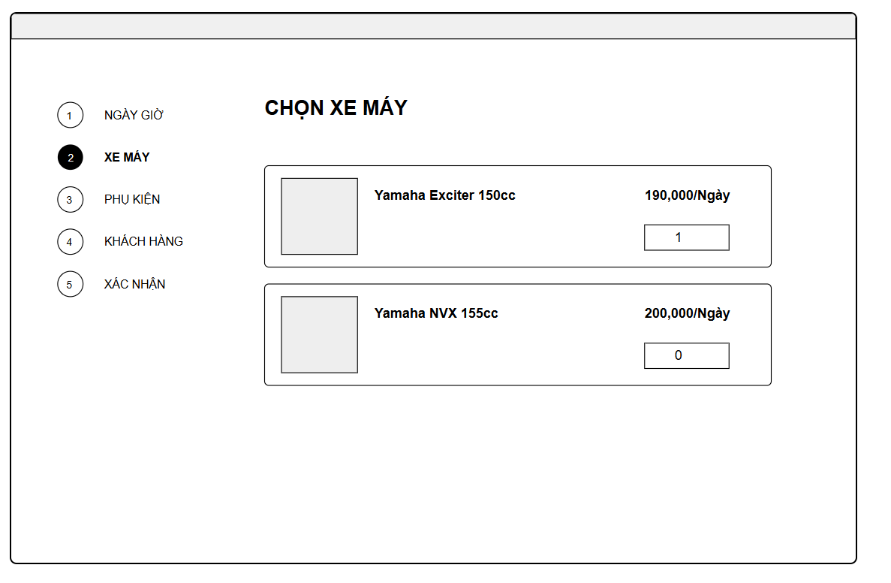

Field Name | Field Type | Description
Rental Steps | Navigation Panel | Displays the rental process steps.
Select Motorcycle | Heading | Displays the motorcycle selection section.
Motorcycle List | List View | Displays available motorcycles for rental.
Motorcycle Image | Image | Displays motorcycle image.
Motorcycle Name | Label | Displays motorcycle model name.
Rental Price | Label | Displays motorcycle rental price per day.
Quantity | Number Input | Allows users to select motorcycle quantity.
Back | Button | Returns users to the previous rental step.
Next | Button | Moves users to the next rental step.

Database Access
Table | CRUD | Description
Motorcycle | R | Retrieve motorcycle information.
Motorcycle Detail | R | Check motorcycle availability.
PriceList | R | Retrieve motorcycle rental prices.
Booking Detail | C | Store selected motorcycle information.
SQL Commands
1. Retrieve available motorcycles
SELECT
m."MotorcycleID",
m."Model",
m."Image",
m."Displacement",
p."DailyPriceForDay"
FROM "Motorcycle" m
JOIN "PriceList" p
ON m."PriceListID" = p."PriceListID"
WHERE EXISTS (
SELECT 1
FROM "Motorcycle Detail" md
WHERE md."MotorcycleID" = m."MotorcycleID"
AND md."CurrentStatus" = 'Có sẵn'
);
2. Check motorcycle availability
SELECT *
FROM "Motorcycle Detail"
WHERE "MotorcycleID" = ?
AND "CurrentStatus" = 'Có sẵn';
3. Save selected motorcycle
INSERT INTO "Booking Detail"
(
"MotorcycleDetailID",
"BookingID",
"TotalPrice"
)
VALUES
(
?, ?, ?
);

Figure 5.1.3 Select Accessories
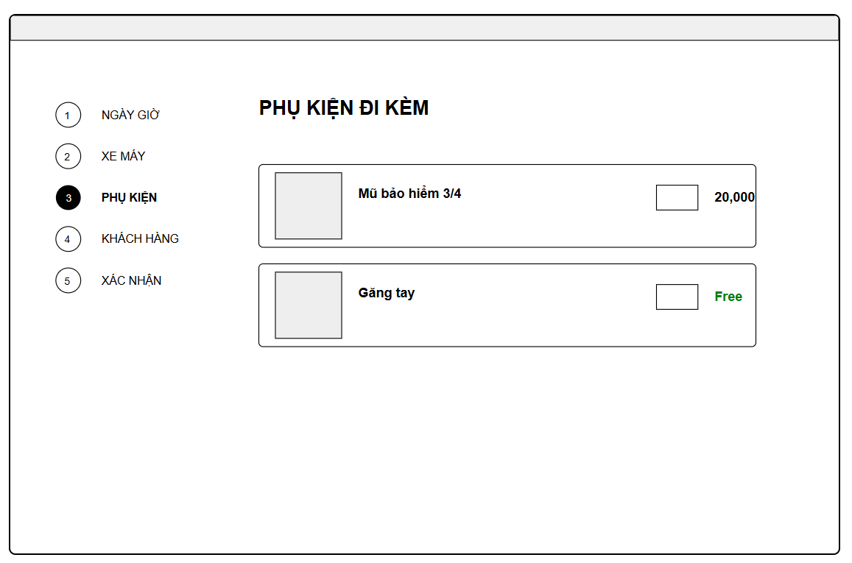

Field Name | Field Type | Description
Rental Steps | Navigation Panel | Displays the rental process steps.
Accessory Selection | Heading | Displays the accessory selection section.
Accessory List | List View | Displays available accessories.
Accessory Image | Image | Displays accessory image.
Accessory Name | Label | Displays accessory name.
Accessory Price | Label | Displays accessory rental price.
Quantity | Number Input | Allows users to select accessory quantity.
Back | Button | Returns users to the previous rental step.
Next | Button | Moves users to the next rental step.

Database Access
Table | CRUD | Description
Accessory | R | Retrieve accessory information and prices.
AccessoryDetail | C | Store selected accessories for booking.
Booking | R | Retrieve current booking information.
SQL Commands
1. Retrieve accessory information
SELECT
"AccessoryID",
"AccessoryName",
"AccessoryImage",
"Price"
FROM "Accessory";
2. Retrieve accessory detail
SELECT *
FROM "Accessory"
WHERE "AccessoryID" = ?;
3. Save selected accessory
INSERT INTO "AccessoryDetail"
(
"BookingID",
"AccessoryID",
"Quantity",
"TotalPrice"
)
VALUES
(
?, ?, ?, ?
);
4. Calculate accessory total price
SELECT
"Price" * ? AS TotalPrice
FROM "Accessory"
WHERE "AccessoryID" = ?;

Figure 5.1.4 Customer Information
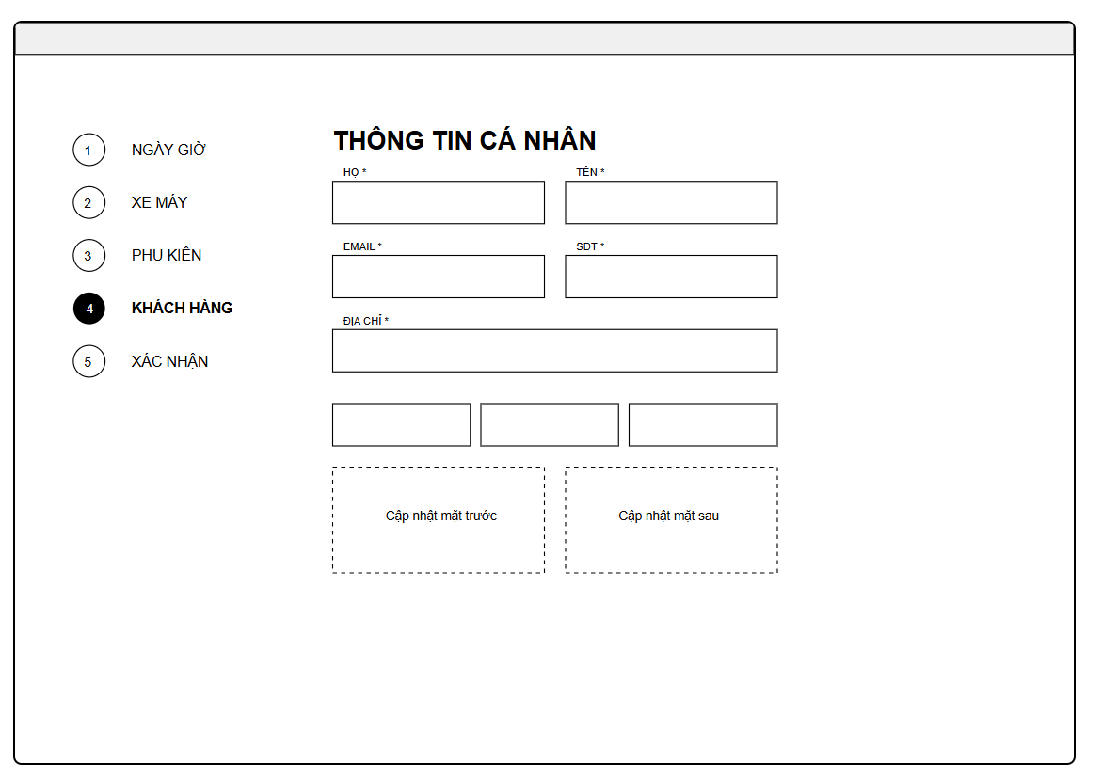

Field Name | Field Type | Description
Rental Steps | Navigation Panel | Displays the rental process steps.
Customer Information | Heading | Displays the customer information section.
First Name | Input Field | Allows users to enter first name.
Last Name | Input Field | Allows users to enter last name.
Email | Input Field | Allows users to enter email address.
Phone Number | Input Field | Allows users to enter phone number.
Address | Input Field | Allows users to enter address.
Identity Card Number | Input Field | Allows users to enter identity card number.
Issued Date | Date Picker | Allows users to select issued date.
Expiration Date | Date Picker | Allows users to select expiration date.
Front Identity Card Image | Image Upload | Allows users to upload front identity card image.
Back Identity Card Image | Image Upload | Allows users to upload back identity card image.
Back | Button | Returns users to the previous rental step.
Next | Button | Moves users to the next rental step.

Database Access
Table | CRUD | Description
Account | R | Retrieve customer account information.
Customer | C | Create customer identity information.
Customer | R | Retrieve existing customer information.
Booking | U | Update booking with customer information.
SQL Commands
1. Retrieve customer information
SELECT
a."FirstName",
a."LastName",
a."Email",
a."PhoneNumber",
a."Address",
c."IdentityCard",
c."IssuedOnDate",
c."ExpDate"
FROM "Account" a
JOIN "Customer" c
ON a."AccountID" = c."AccountID"
WHERE a."AccountID" = ?;
2. Create customer information
INSERT INTO "Customer"
(
"IdentityCard",
"IdentityCardImage",
"IssuedOnDate",
"ExpDate",
"TypeCard",
"AccountID"
)
VALUES
(
?, ?, ?, ?, ?, ?
);
3. Update booking customer
UPDATE "Booking"
SET "CustomerID" = ?
WHERE "BookingID" = ?;

Figure 5.1.5 Booking Confirmation
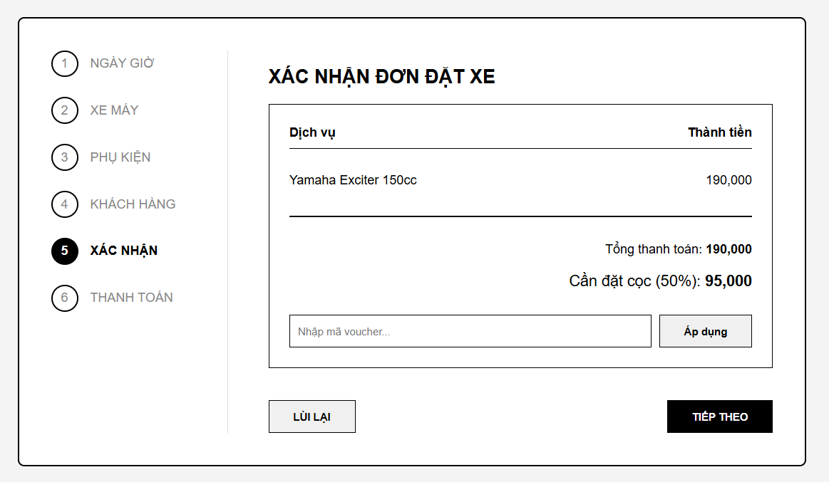

Field Name | Field Type | Description
Rental Steps | Navigation Panel | Displays the rental process steps.
Booking Confirmation | Heading | Displays booking confirmation section.
Service List | Information Table | Displays selected motorcycles and accessories.
Service Name | Label | Displays selected service information.
Total Amount | Label | Displays total rental amount.
Deposit Amount | Label | Displays required deposit amount.
Voucher Code | Input Field | Allows users to enter voucher code.
Apply Voucher | Button | Applies voucher discount to booking.
Back | Button | Returns users to the previous rental step.
Next | Button | Moves users to the payment step.

Database Access
Table | CRUD | Description
Booking | R | Retrieve booking information.
Booking Detail | R | Retrieve selected motorcycle information.
AccessoryDetail | R | Retrieve selected accessory information.
Voucher | R | Validate voucher code and discount amount.
Booking | U | Update booking with selected voucher.
SQL Commands
1. Retrieve booking summary
SELECT
b."BookingID",
m."Model",
bd."TotalPrice"
FROM "Booking" b
JOIN "Booking Detail" bd
ON b."BookingID" = bd."BookingID"
JOIN "Motorcycle Detail" md
ON bd."MotorcycleDetailID" = md."MotorcycleDetailID"
JOIN "Motorcycle" m
ON md."MotorcycleID" = m."MotorcycleID"
WHERE b."BookingID" = ?;
2. Validate voucher
SELECT *
FROM "Voucher"
WHERE "Code" = ?
AND "Status" = 'Đang hoạt động';
3. Update booking voucher
UPDATE "Booking"
SET "VoucherID" = ?
WHERE "BookingID" = ?;

Figure 5.1.6 Deposit Payment
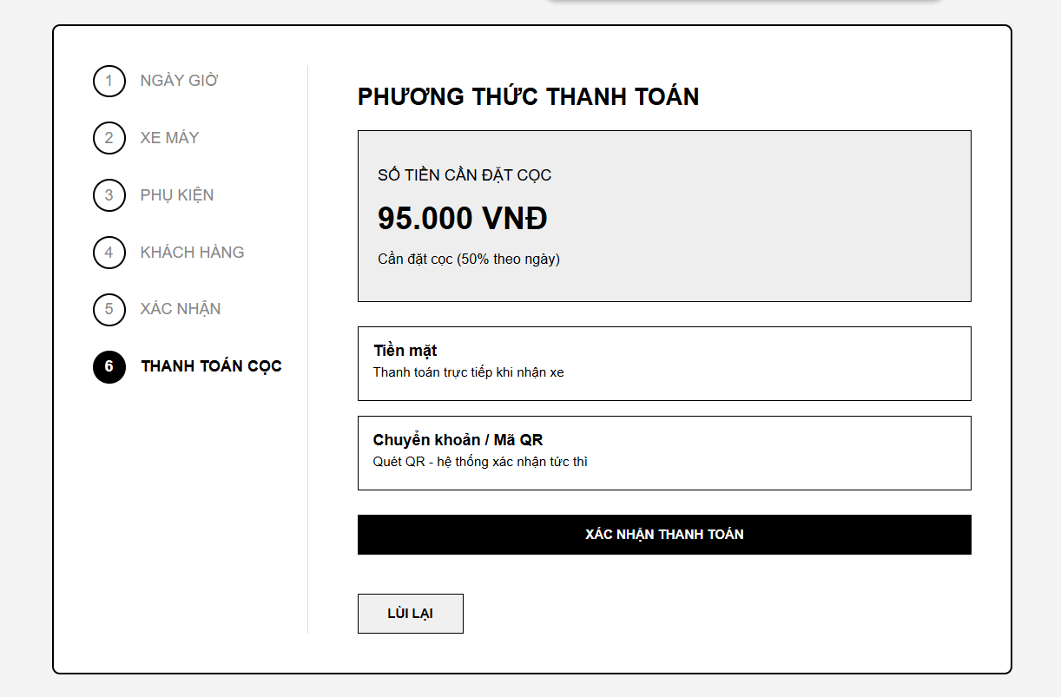

Field Name | Field Type | Description
Rental Steps | Navigation Panel | Displays the rental process steps.
Payment Method | Heading | Displays payment method section.
Deposit Amount | Information Panel | Displays required deposit amount.
Cash Payment | Radio Option | Allows users to select cash payment.
Bank Transfer / QR Code | Radio Option | Allows users to select bank transfer or QR payment.
Confirm Payment | Button | Confirms selected payment method.
Back | Button | Returns users to the previous rental step.

Database Access
Table | CRUD | Description
Booking | R | Retrieve booking and deposit information.
Payment | C | Create payment transaction.
Payment | R | Retrieve payment status.
Booking | U | Update booking payment status.
SQL Commands
1. Retrieve deposit amount
SELECT
"BookingID",
"DepositAmount",
"TotalPrice"
FROM "Booking"
WHERE "BookingID" = ?;
2. Create payment transaction
INSERT INTO "Payment"
(
"BookingID",
"Amount",
"PaymentMethod",
"PaymentStatus",
"PaymentTime"
)
VALUES
(
?, ?, ?, 'Pending', NOW()
);
3. Update payment status
UPDATE "Booking"
SET "BookingStatus" = 'Paid Deposit'
WHERE "BookingID" = ?;
4. Retrieve payment information
SELECT *
FROM "Payment"
WHERE "BookingID" = ?;

5.2 View Booking History
Allows registered users to view their past and active rental bookings, track status (Pending, Confirmed, Completed, Cancelled), and review rental details.
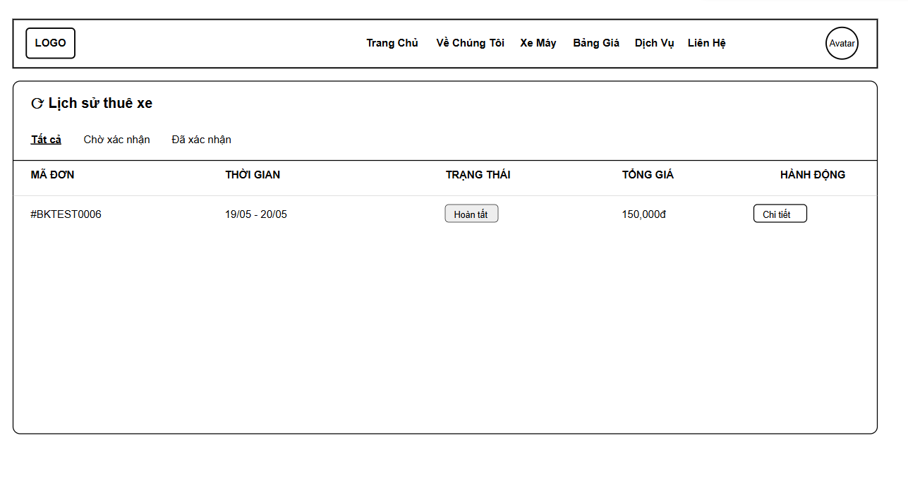
Field Name | Field Type | Description
Logo | Image | Displays the website logo.
Navigation Menu | Navigation Bar | Allows users to navigate to Home, About Us, Cars, Blog, Services, and Contact pages.
User Account | Hyperlink | Allows users to access account-related functions.
Title | Heading | Displays "Lịch sử thuê xe".
All Tab | Tab | Displays all rental orders.
Pending Tab | Tab | Displays rental orders waiting for confirmation.
Confirmed Tab | Tab | Displays confirmed rental orders.
Rental List | Table | Displays rental history information.
Order ID | Text | Displays the unique rental order identifier.
Rental Period | Text | Displays pickup and return dates.
Status | Text | Displays the current rental status.
Total Price | Text | Displays the total rental amount.
View Detail | Button | Displays detailed information of the selected rental order.
Error Message | Text | Displays system error messages if data cannot be loaded.

Database Access
Table | CRUD | Description
CarRental | R | Retrieve rental history of the customer.
Customer | R | Verify customer information.
Car | R | Retrieve vehicle information associated with rental orders.
SQL Commands
1. Retrieve rental history
SELECT *
FROM CarRental
WHERE CustomerID = ?
ORDER BY PickupDate DESC;
2. Retrieve rental history by status
SELECT *
FROM CarRental
WHERE CustomerID = ?
AND Status = ?;
3. Retrieve rental details
SELECT cr.*, c.CarName, c.RentPrice
FROM CarRental cr
JOIN Car c ON cr.CarID = c.CarID
WHERE cr.CustomerID = ?
AND cr.CarID = ?
AND cr.PickupDate = ?;

5.3 Cancel Booking
Displays full booking information and allows users to manage their orders. Users can cancel pending bookings by providing a reason, which is then recorded in the system.

UI Design
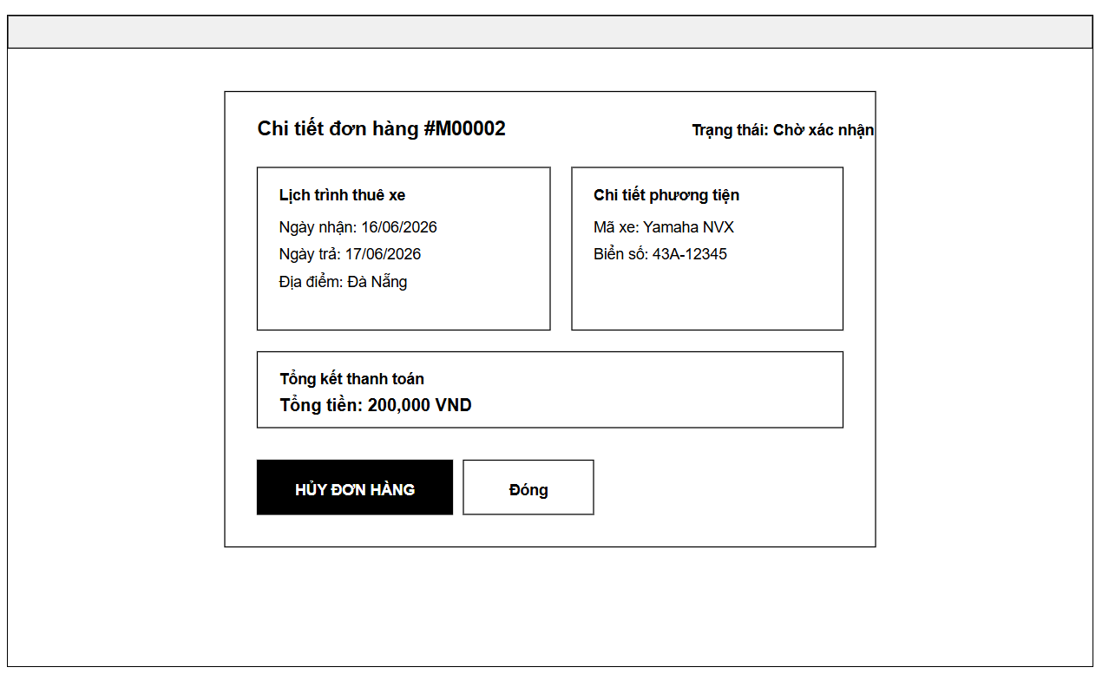

Field Name | Field Type | Description
Order Detail | Heading | Displays rental order detail information.
Order ID | Text | Displays the rental order identifier.
Rental Status | Text | Displays the current rental status.
Rental Schedule | Group Box | Displays pickup date, return date and rental location.
Pickup Date | Text | Displays vehicle pickup date.
Return Date | Text | Displays vehicle return date.
Rental Location | Text | Displays rental location.
Vehicle Detail | Group Box | Displays rented vehicle information.
Vehicle Name | Text | Displays vehicle name.
License Plate | Text | Displays vehicle license plate number.
Payment Summary | Group Box | Displays payment information.
Total Amount | Text | Displays total rental amount.
Cancel Order | Button | Allows users to cancel the rental order.
Close | Button | Closes the detail window and returns to previous page.

Database Access
Table | CRUD | Description
RentalOrder | R | Retrieve rental order details.
Vehicle | R | Retrieve rented vehicle information.
RentalOrder | U | Update rental status when order is cancelled.
SQL Commands
1. Retrieve rental order details
SELECT *
FROM RentalOrder
WHERE OrderID = ?;
2. Retrieve vehicle information
SELECT v.*
FROM Vehicle v
JOIN RentalOrder r ON v.VehicleID = r.VehicleID
WHERE r.OrderID = ?;
3. Cancel rental order
UPDATE RentalOrder
SET Status = 'Cancelled'
WHERE OrderID = ?;

5.4 Extend Booking
Allows users to extend their rental period for ongoing bookings. Users can request additional time directly through the transaction details interface, subject to vehicle availability.

UI Design

5.5 Rating & Feedback
Allows users to evaluate their rental experience after returning the motorcycle. Users provide ratings across multiple criteria and optional text comments, which are stored in the system to improve service quality.

UI Design
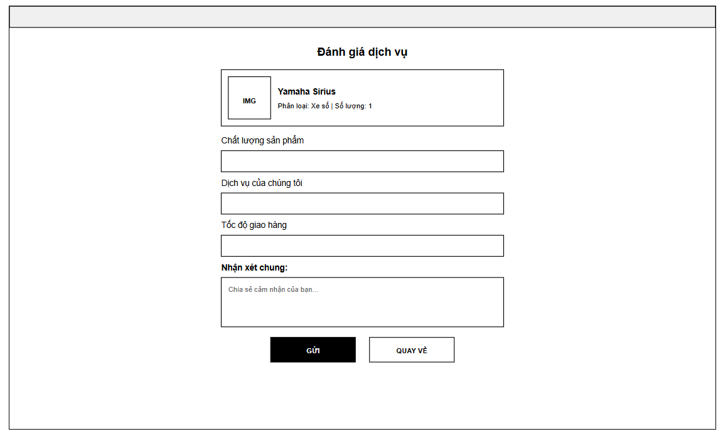

Field Name | Field Type | Description
Service Review | Heading | Displays service review title.
Vehicle Information | Information Card | Displays motorcycle image and rental information.
Product Quality Rating | Rating Input | Allows users to rate product quality.
Service Quality Rating | Rating Input | Allows users to rate service quality.
Delivery Time Rating | Rating Input | Allows users to rate delivery experience.
Comment | Text Area | Allows users to enter feedback.
Submit | Button | Submits review information.
Back | Button | Returns to previous screen.

Database Access
Table | CRUD | Description
Feedback | C | Create customer review information.
Booking | R | Retrieve booking and rental information.
Motorcycle | R | Retrieve motorcycle information.
Customer | R | Retrieve customer information.
SQL Commands
1. Retrieve review information
SELECT
b."BookingID",
m."Model",
f."productRate",
f."serviceRate",
f."deliveryRate",
f."Content"
FROM "Booking" b
LEFT JOIN "Booking Detail" bd
ON b."BookingID" = bd."BookingID"
LEFT JOIN "Motorcycle Detail" md
ON bd."MotorcycleDetailID" = md."MotorcycleDetailID"
LEFT JOIN "Motorcycle" m
ON md."MotorcycleID" = m."MotorcycleID"
LEFT JOIN "Feedback" f
ON b."BookingID" = f."BookingID"
WHERE b."BookingID" = ?;
2. Submit review
INSERT INTO "Feedback"
("Content","productRate","serviceRate","deliveryRate","feedbackTime","CustomerID","BookingID")
VALUES
(?,?,?, ?, NOW(), ?, ?);
3. Check existing review
SELECT *
FROM "Feedback"
WHERE "BookingID" = ?;

6. Customer Support

6.1 View FAQ
Provides a dedicated interface for users to quickly access answers to frequently asked questions regarding the rental process, policies, and common inquiries.

UI Design
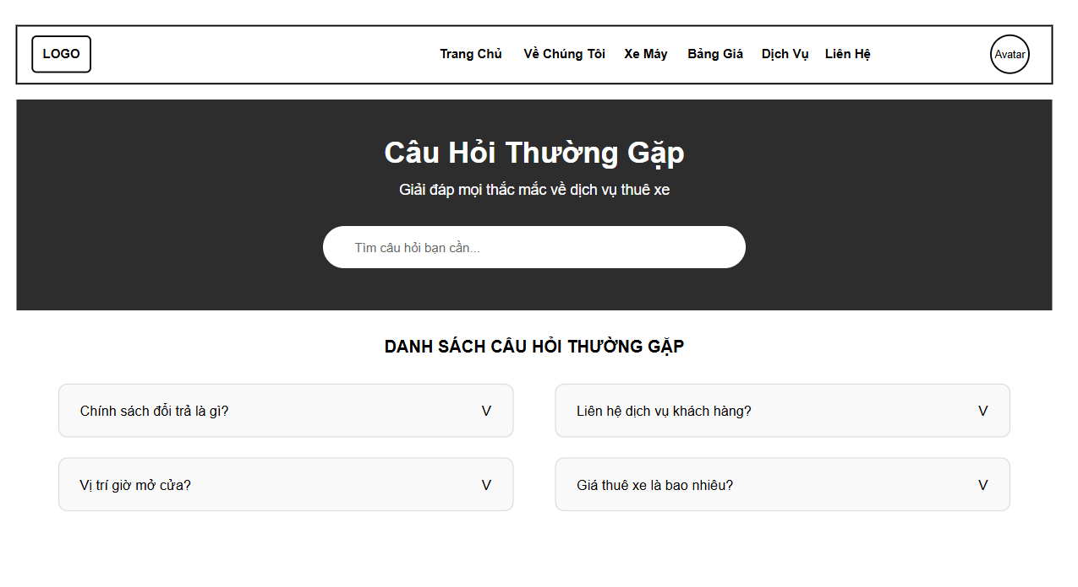

Field Name | Field Type | Description
Navigation Menu | Navigation Bar | Displays website navigation links.
User Profile | Avatar | Displays customer account information.
FAQ Heading | Heading | Displays FAQ page title.
Search FAQ | Search Box | Allows users to search frequently asked questions.
FAQ List | Accordion List | Displays frequently asked questions and answers.
Question Item | Accordion Item | Displays a frequently asked question.
Answer Content | Expandable Content | Displays the answer when a question is expanded.

Database Access
Table | CRUD | Description
FAQ | R | Retrieve frequently asked questions and answers.
FAQ Category | R | Retrieve FAQ category information.
SQL Commands
1. Retrieve all FAQs
SELECT
"FAQID",
"Question",
"Answer"
FROM "FAQ";
2. Search FAQ
SELECT
"FAQID",
"Question",
"Answer"
FROM "FAQ"
WHERE "Question" ILIKE '%' || ? || '%';
3. Retrieve FAQ by category
SELECT f.*
FROM "FAQ" f
JOIN "FAQ Category" fc
ON f."CategoryID" = fc."CategoryID"
WHERE fc."CategoryID" = ?;

6.2 View Rental Policy
Provides a dedicated interface where users can access and review the official rental terms, conditions, and regulations governing the use of the motorcycle rental service.

UI Design

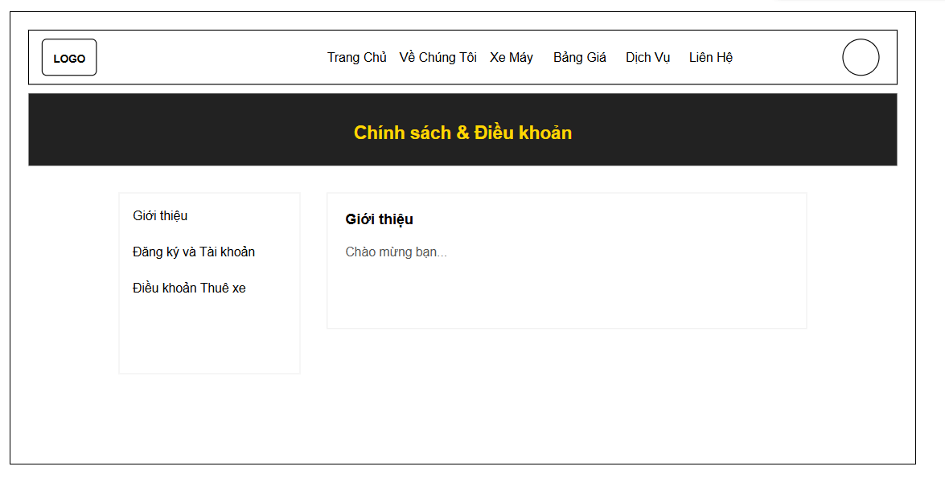UI Design
Field Name | Field Type | Description
Navigation Menu | Navigation Bar | Displays website navigation links.
User Profile | Avatar | Displays customer account information.
FAQ Heading | Heading | Displays FAQ page title.
Search FAQ | Search Box | Allows users to search frequently asked questions.
FAQ List | Accordion List | Displays frequently asked questions and answers.
Question Item | Accordion Item | Displays a frequently asked question.
Answer Content | Expandable Content | Displays the answer when a question is expanded.

Database Access
Table | CRUD | Description
FAQ | R | Retrieve frequently asked questions and answers.
FAQ Category | R | Retrieve FAQ category information.
SQL Commands
1. Retrieve all FAQs
SELECT
"FAQID",
"Question",
"Answer"
FROM "FAQ";
2. Search FAQ
SELECT
"FAQID",
"Question",
"Answer"
FROM "FAQ"
WHERE "Question" ILIKE '%' || ? || '%';
3. Retrieve FAQ by category
SELECT f.*
FROM "FAQ" f
JOIN "FAQ Category" fc
ON f."CategoryID" = fc."CategoryID"
WHERE fc."CategoryID" = ?;

6.3 Contact Us
Provides a dedicated interface for users to get in touch with the support team or service providers for inquiries, assistance, or feedback.
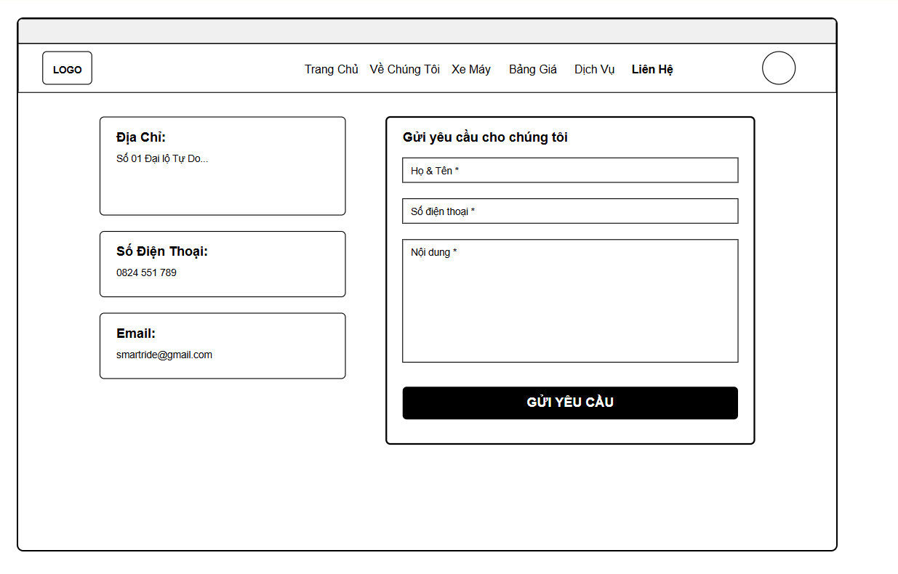

Field Name | Field Type | Description
Navigation Menu | Navigation Bar | Displays admin/website navigation links.
User Profile | Avatar | Displays user account status information.
Policies Heading | Heading | Displays the page title: 'CHÍNH SÁCH SMART RIDE'.
Policy List Block | Vertical Layout | Displays a stacked list of all company policies and rental regulations.
Policy Title | Heading / Text Block | Displays the specific title of each policy item (e.g., '1. Quy định nhận xe', '2. Trách nhiệm người thuê'...).
Policy Content | Text Paragraph | Displays the detailed terms, rules, clauses, and text content under each policy heading.

Database Access
Table | CRUD | Description
Policies | R | Retrieve lists of rental terms, conditions, regulations, and content from the database.
SQL Commands
1. Retrieve all active system policies
SELECT
"PolicyID",
"PolicyName",
"Content"
FROM "Policies"
ORDER BY "PolicyID" ASC;

6.4 AI Chatbot Support
Integrates an intelligent AI assistant, "Trợ Lý AI " directly into the platform to provide users with immediate, 24/7 automated support.
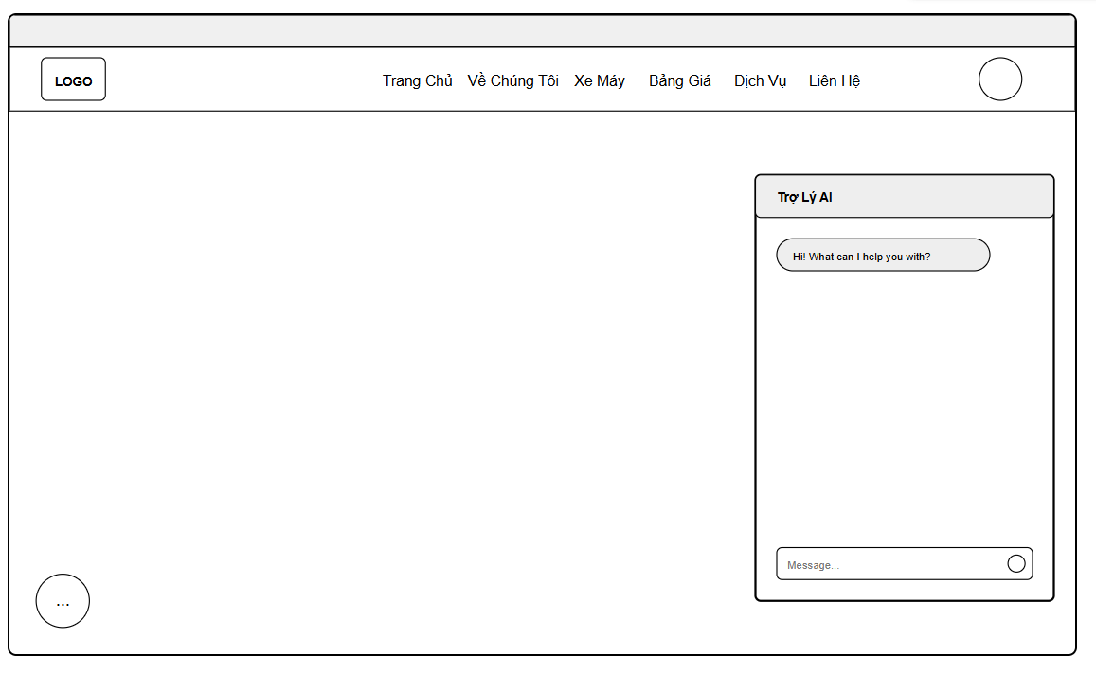

Field Name | Field Type | Description
Navigation Menu | Navigation Bar | Displays website/admin panel navigation links.
User Profile | Avatar | Displays user account profile and status details.
Voucher Heading | Heading | Displays page title: 'ƯU ĐÃI KHÁCH HÀNG'.
Voucher List Grid | Grid Layout | Displays rows/columns of available coupon and promotional codes.
Voucher Item Block | Container | Individual block housing discount details, percentage, criteria, and terms.
Discount Value | Heading / Large Text | Displays specific percentage/value reduction (e.g., 'Giảm 10%', 'Giảm 5%').
Voucher Name | Text Block | Displays title/purpose of promo code (e.g., 'Ưu đãi hè rực rỡ', 'Chào mừng thành viên mới').
Minimum Spend Condition | Text Paragraph | Displays minimum requirement details (e.g., 'Đơn tối thiểu 500k', 'Đơn tối thiểu 200k').
Voucher Code | Badge / Highlighted Text | Displays actual code to string copy/input (e.g., 'SUMMER10', 'WELCOME5').

Database Access
Table | CRUD | Description
Voucher | R | Retrieve available active promotion codes, descriptions, and rules for client selection.
SQL Commands
1. Retrieve all active and valid vouchers
SELECT
"VoucherID",
"Code",
"Discount",
"Condition",
"Quantity"
FROM "Voucher"
WHERE "Quantity" > 0
ORDER BY "Discount" DESC;

7. Rental Management

7.1 View Booking List
Provides an administrative interface to view and manage all motorcycle rental bookings.
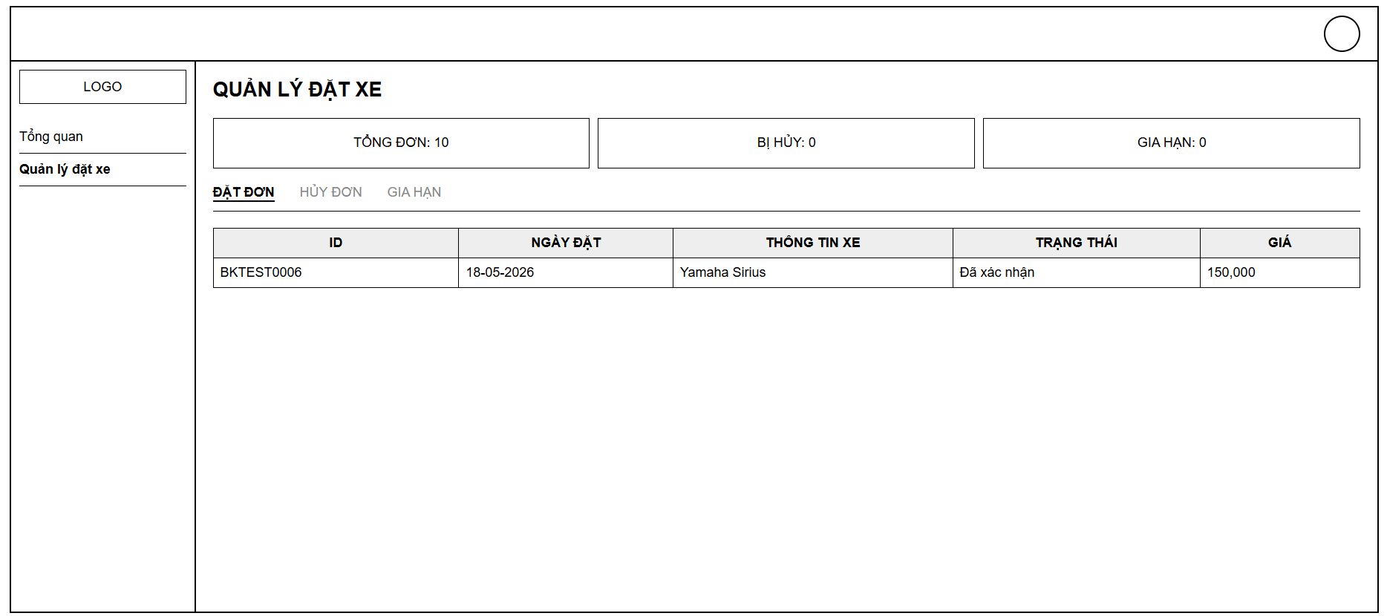

Field Name | Field Type | Description
Navigation Menu | Navigation Bar | Displays admin panel navigation links (Tổng quan, Quản lý đặt xe, Quản lý khách hàng).
Total Bookings Card | Stat Box | Displays the total number of bookings in the system: 'TỔNG ĐƠN: 10'.
Cancelled Bookings Card | Stat Box | Displays the total number of cancelled bookings: 'BỊ HỦY: 0'.
Extended Bookings Card | Stat Box | Displays the total number of extended bookings: 'GIA HẠN: 0'.
Tabs Navigation | Tab Bar | Allows switching between booking lists: 'ĐẶT ĐƠN', 'HỦY ĐƠN', and 'GIA HẠN'.
Booking List Table (Đặt Đơn) | Table | Displays active bookings including: ID, Ngày Đặt, Thông Tin Xe, Trạng Thái, Giá.
Delivery Status Dropdown | Dropdown | Allows updating delivery status directly in the list (Đang thuê, Đã trả xe, Chờ nhận xe).
Delivery Status Update Button | Button | Triggers the status update action ('Cập nhật').
Cancellation List Table (Hủy Đơn) | Table | Displays cancelled bookings: #, Mã Đơn, Ngày Hủy, Lý Do, Thao Tác (Xem button).
Extension List Table (Gia Hạn) | Table | Displays extended bookings: Mã Đơn, Ngày Hạn Trước, Ngày Hạn Mới, Phí Gia Hạn.

Database Access
Table | CRUD | Description
Booking | R | Retrieve list of bookings for grid view.
Booking | U | Update status and delivery status of bookings.
Cancellation | R | Retrieve cancelled booking logs and cancellation reasons.
Extension | R | Retrieve details of extended booking transactions.
SQL Commands
1.1 Retrieve active booking list with details
SELECT
b."BookingID" AS "ID",
b."BookingDate" AS "Ngày Đặt",
m."Model" AS "Thông Tin Xe",
b."StatusBooking" AS "Trạng Thái",
p."PaymentAmount" AS "Giá"
FROM "Booking" b
LEFT JOIN "Booking Detail" bd ON b."BookingID" = bd."BookingID"
LEFT JOIN "Motorcycle Detail" md ON bd."MotorcycleDetailID" = md."MotorcycleDetailID"
LEFT JOIN "Motorcycle" m ON md."MotorcycleID" = m."MotorcycleID"
LEFT JOIN "Payment" p ON b."BookingID" = p."BookingID";
1.2 Update delivery status
UPDATE "Booking"
SET "DeliveryStatus" = ?
WHERE "BookingID" = ?;
1.3 Retrieve cancelled bookings
SELECT
c."CancellationID" AS "STT",
c."BookingID" AS "Mã Đơn",
c."CancellationDate" AS "Ngày Hủy",
c."Note" AS "Lý Do"
FROM "Cancellation" c;
1.4 Retrieve extended bookings
SELECT
e."BookingID" AS "Mã Đơn",
e."PreviousEndDate" AS "Ngày Hạn Trước",
e."NewEndDate" AS "Ngày Hạn Mới",
e."ExtenstionFee" AS "Phí Gia Hạn"
FROM "Extension" e;

7.2 Confirm Booking

7.3 Update Booking Status
Allows administrators or staff to update the "TRẠNG THÁI GIAO" (Delivery Status) of a booking directly within the management table.
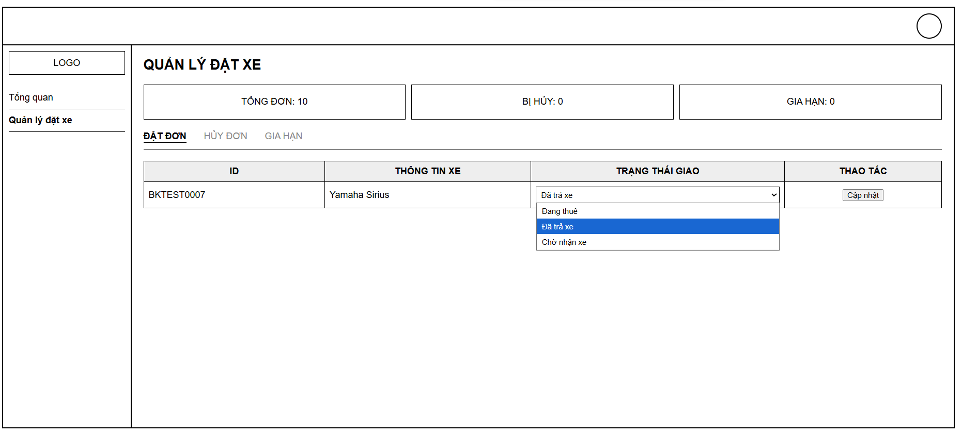

Field Name | Field Type | Description
Navigation Menu | Navigation Bar | Displays website/admin navigation links.
User Profile | Avatar | Displays customer account information.
Event Heading | Heading | Displays page title: 'SỰ KIỆN NỔI BẬT'.
Event List Grid | Grid Layout | Displays rows and columns of ongoing and upcoming promotional events.
Event Card Item | Container | Individual block housing specific event details, images, and content.
Event Image Banner | Image Component | Displays promotional banner graphic related to the event.
Event Title | Heading / Text Block | Displays title of the promotion (e.g., 'Sự Kiện Lễ Hội Trực Tuyến 2024', 'Sự Kiện Đồng Giá 12.12').
Event Content Snippet | Text Paragraph | Displays promotional description, sub-text, and detailed event program summaries.

Database Access
Table | CRUD | Description
Event | R | Retrieve list of valid promotional campaigns, events, headings, images, and descriptions from database.
SQL Commands
1. Retrieve all active and upcoming promotional events
SELECT
"EventID",
"EventName",
"Content",
"Image",
"StartDate",
"EndDate"
FROM "Event"
WHERE CURRENT_TIMESTAMP BETWEEN "StartDate" AND "EndDate"
ORDER BY "StartDate" DESC;

7.4 Handle Cancellation Request
Allows administrators to view and manage all cancelled rental bookings, providing visibility into the reasons for cancellation to improve service quality.
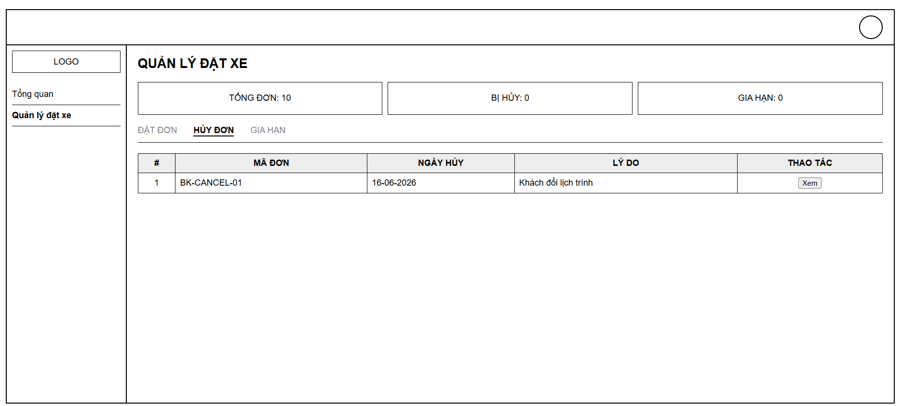

Field Name | Field Type | Description
Title | Heading | This field display "Xử Lý Yêu Cầu Hủy Lịch".
Mã đặt xe | Text field | Displays the booking ID requested for cancellation.
Lý do hủy | Text area | Displays the customer's reason for cancelling the booking.
Ghi chú của Admin | Input field | Field for the administrator to enter review notes or reasons for approval/rejection.
XÁC NHẬN HỦY | Button | Button to approve the cancellation request and update the status.
TỪ CHỐI HỦY | Button | Button to reject the cancellation request and keep the booking active.
Error Message | Text | Displays error messages "Yêu cầu đã được xử lý trước đó" hoặc "Nội dung ghi chú không hợp lệ".
Success Message | Text | Displays "Xử lý yêu cầu hủy thành công" and refreshes the dashboard list.

Database Access

Table | CRUD | Description
Booking | R | Check if the booking exists and verify its current cancellation status.
Booking | U | Update the booking status to 'Cancelled' or 'Active' depending on the admin's decision.
Cancellation | U | Record the administrative handling details, notes, and timestamp.
SQL Commands
1. View all pending cancellation requests
SELECT * FROM "Booking" b JOIN "Account" a ON b."CustomerID" = a."AccountID" JOIN "Cancellation" c ON b."BookingID" = c."BookingID" WHERE b."BookingStatus" = 'Pending Cancellation';
2. Update booking status upon request handling
UPDATE "Booking" SET "BookingStatus" = ?, "UpdatedAt" = NOW() WHERE "BookingID" = ?;
3. Update administrative confirmation details
UPDATE "Cancellation" SET "AdminID" = ?, "Note" = ?, "Status" = ?, "CancellationDate" = NOW() WHERE "BookingID" = ?;

7.5 Handle Extension Request
Allows administrators to manage requests from customers to extend their rental period, ensuring accurate scheduling and revenue tracking.

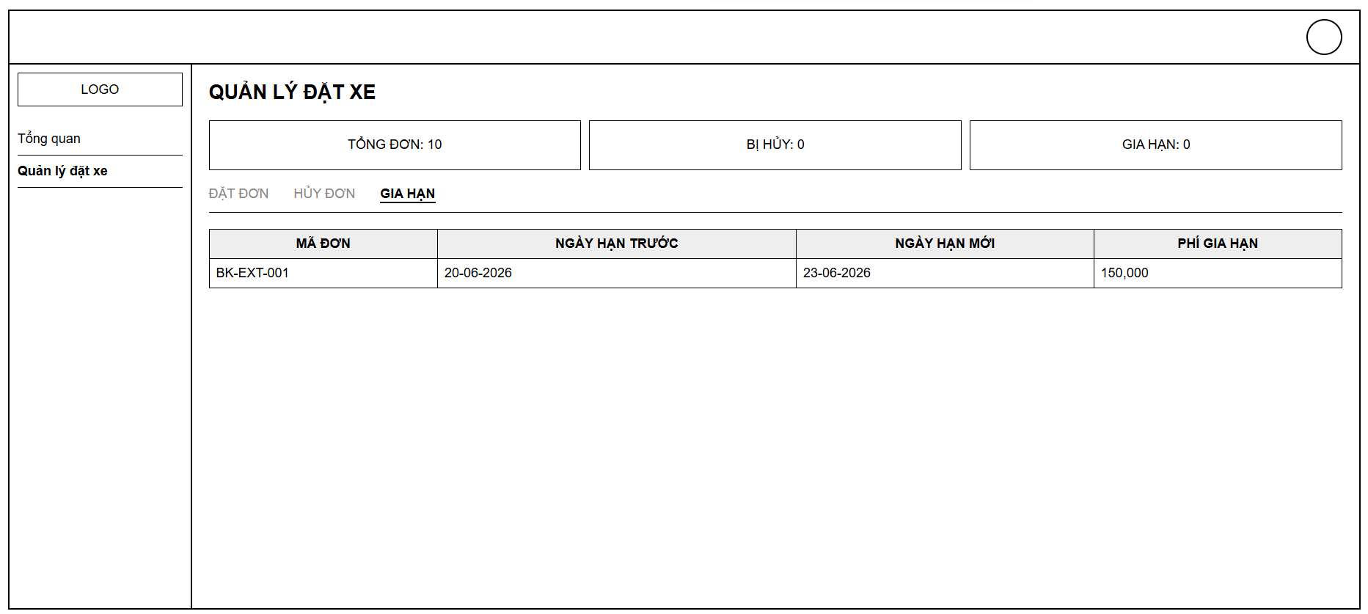

Field Name | Field Type | Description
Title | Heading | This field display "Xử Lý Yêu Cầu Gia Hạn".
Mã đặt xe | Text field | Displays the booking ID associated with the extension request.
Ngày gia hạn mới | Date picker | Displays the new return date requested by the customer.
Phí gia hạn | Text field | Displays the calculated additional cost for the extra rental days.
Ghi chú của Admin | Input field | Field for the administrator to enter notes for approval or rejection.
CHẤP NHẬN GIA HẠN | Button | Button to approve the request, update the rental schedule, and apply fees.
TỪ CHỐI GIA HẠN | Button | Button to reject the extension request and maintain the original schedule.
Error Message | Text | Displays error messages "Yêu cầu đã quá hạn xử lý" hoặc "Xe đã có lịch đặt tiếp theo, không thể gia hạn".
Success Message | Text | Displays "Xử lý gia hạn lịch thuê thành công" and updates the booking state.

Database Access

Table | CRUD | Description
Booking | R | Check the current booking status and verify that the vehicle is available for the extended period.
Booking | U | Update the original return date, total price, and booking status based on admin decision.
Extension | U | Record the administrator's review status, notes, and handling timestamp.
SQL Commands
1. View all pending extension requests
SELECT * FROM "Booking" b JOIN "Account" a ON b."CustomerID" = a."AccountID" JOIN "Extension" e ON b."BookingID" = e."BookingID" WHERE b."BookingStatus" = 'Pending Extension';
2. Update booking duration upon approval
UPDATE "Booking" SET "ReturnDate" = ?, "BookingStatus" = 'Active', "UpdatedAt" = NOW() WHERE "BookingID" = ?;
3. Update administrative confirmation details on extension record
UPDATE "Extension" SET "AdminID" = ?, "Note" = ?, "Status" = ?, "HandledAt" = NOW() WHERE "BookingID" = ?;

7.6 View Customer Information
Provides an administrative interface for managing the customer database, allowing staff to view personal details and monitor the status of user accounts.
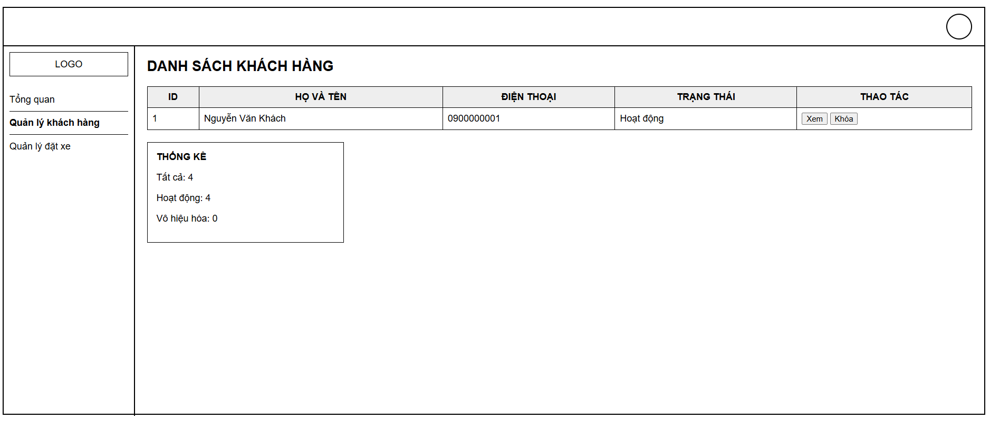

Field Name | Field Type | Description
Title | Heading | This field display "Thông Tin Khách Hàng".
Từ khóa tìm kiếm | Input field | Field to search for a customer by name, email, or phone number.
Họ và tên | Text field | Displays the full name of the selected customer.
Số điện thoại | Text field | Displays the customer's active phone number.
Email | Text field | Displays the registered email address of the customer.
Trạng thái tài khoản | Text field | Displays whether the account is 'Active', 'Suspended', or 'Unverified'.
TÌM KIẾM | Button | Button to trigger the search query based on input keywords.
Error Message | Text | Displays error messages "Không tìm thấy khách hàng phù hợp" hoặc "Từ khóa tìm kiếm không hợp lệ".
Success Message | Text | Displays customer profile details successfully on the admin screen.

Database Access

Table | CRUD | Description
Account | R | Search for account records matching the administrative search filters.
Booking | R | Retrieve the booking history summaries associated with the specific customer ID.
SQL Commands
1. Search customer accounts by multiple keywords
SELECT * FROM "Account" WHERE ("Username" LIKE ? OR "Email" LIKE ? OR "PhoneNumber" LIKE ?) AND "RoleID" = 1;
2. View detailed profile for a specific customer ID
SELECT * FROM "Account" WHERE "AccountID" = ? AND "RoleID" = 1;
3. Fetch total summary of rental bookings done by the customer
SELECT COUNT(*), SUM("TotalPrice") FROM "Booking" WHERE "CustomerID" = ?;

8. Administration

8.1 Motorcycle Management
Allows administrators to manage motorcycle information, availability, and rental details.

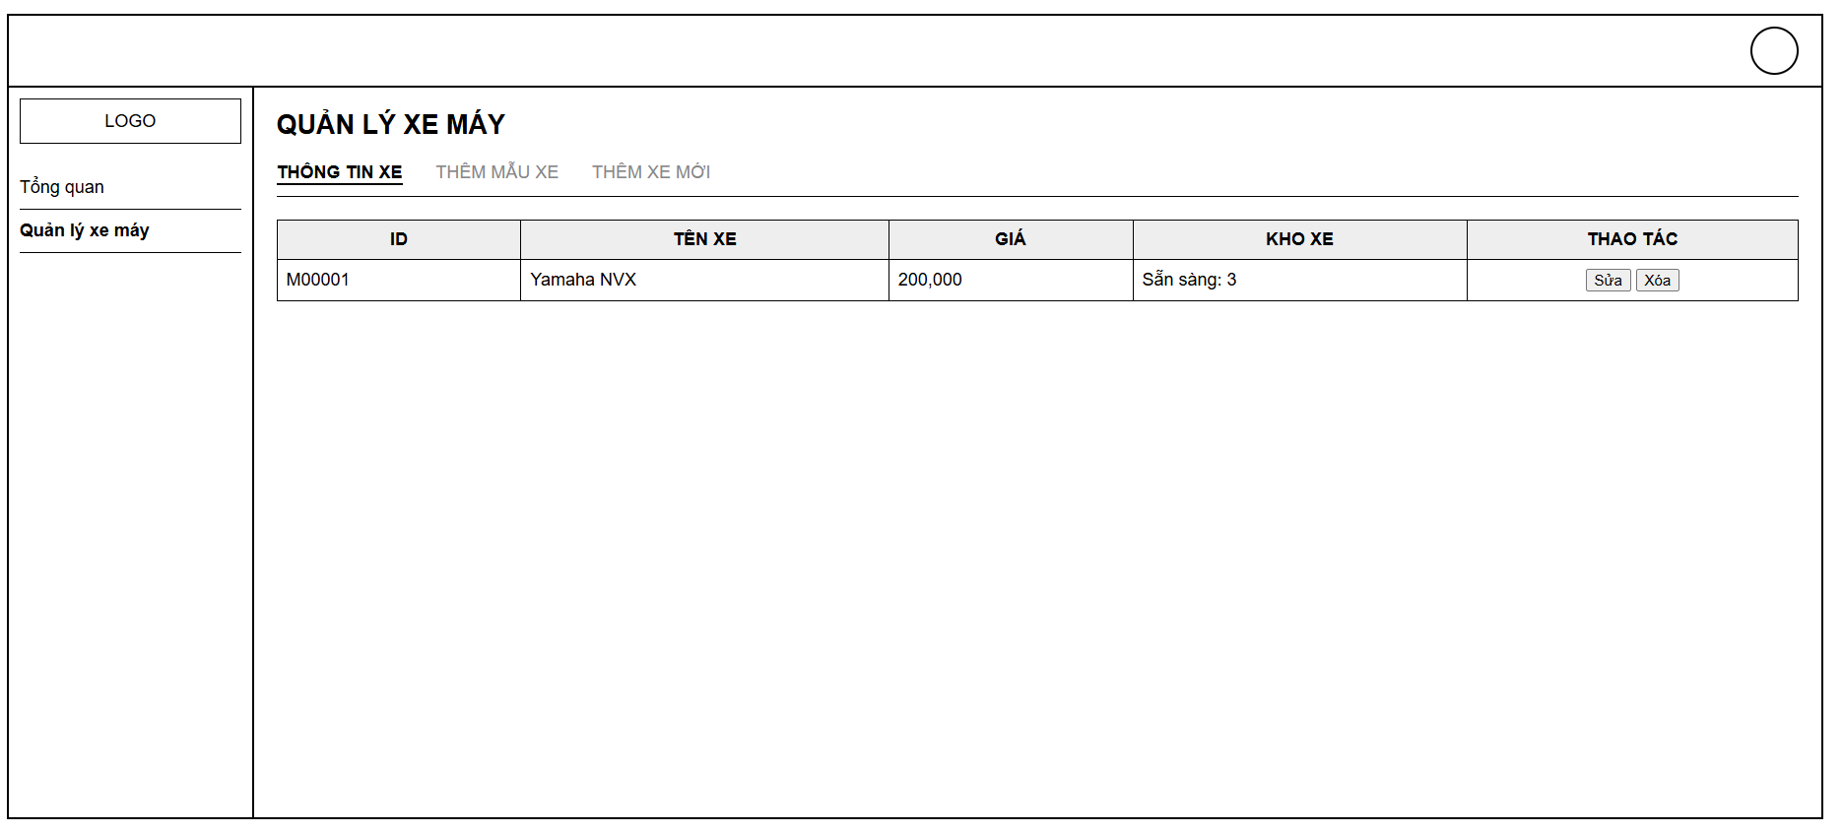

Field Name | Field Type | Description
Title | Heading | This field display "QUẢN LÝ XE MÁY".
THÔNG TIN XE | Tab | Tab to view the list of existing motorcycles.
THÊM MẪU XE | Tab | Tab to add a new motorcycle model to the system.
THÊM XE MỚI | Tab | Tab to input individual vehicle details like license plate.
ID | Text field | Displays the unique identifier of the motorcycle (e.g., M00001).
TÊN XE | Text field | Displays the name/model of the motorcycle (e.g., Yamaha NVX).
GIÁ | Text field | Displays the rental price per day (e.g., 200,000).
KHO XE | Text field | Displays the current stock status (e.g., Sẵn sàng: 3).
Sửa | Button | Button to edit the details of the selected motorcycle.
Xóa | Button | Button to delete or deactivate the selected motorcycle from the list.

Database Access

Table | CRUD | Description
Vehicle | R | Retrieve the list of all motorcycles, including their ID, name, price, and current stock status.
Vehicle | U | Update motorcycle details when the admin clicks the "Sửa" button.
Vehicle | D | Delete or change the active status of a vehicle when the admin clicks the "Xóa" button.
SQL Commands
1. View all motorcycle records with their status
SELECT * FROM "Vehicle" ORDER BY "VehicleID" ASC;
2. Update motorcycle information
UPDATE "Vehicle" SET "VehicleName" = ?, "Price" = ?, "Status" = ?, "UpdatedAt" = NOW() WHERE "VehicleID" = ?;
3. Delete a motorcycle record from the system
DELETE FROM "Vehicle" WHERE "VehicleID" = ?;

8.2 Tourism Location Management
Allows administrators to add, update, and remove tourism destinations displayed on the platform.
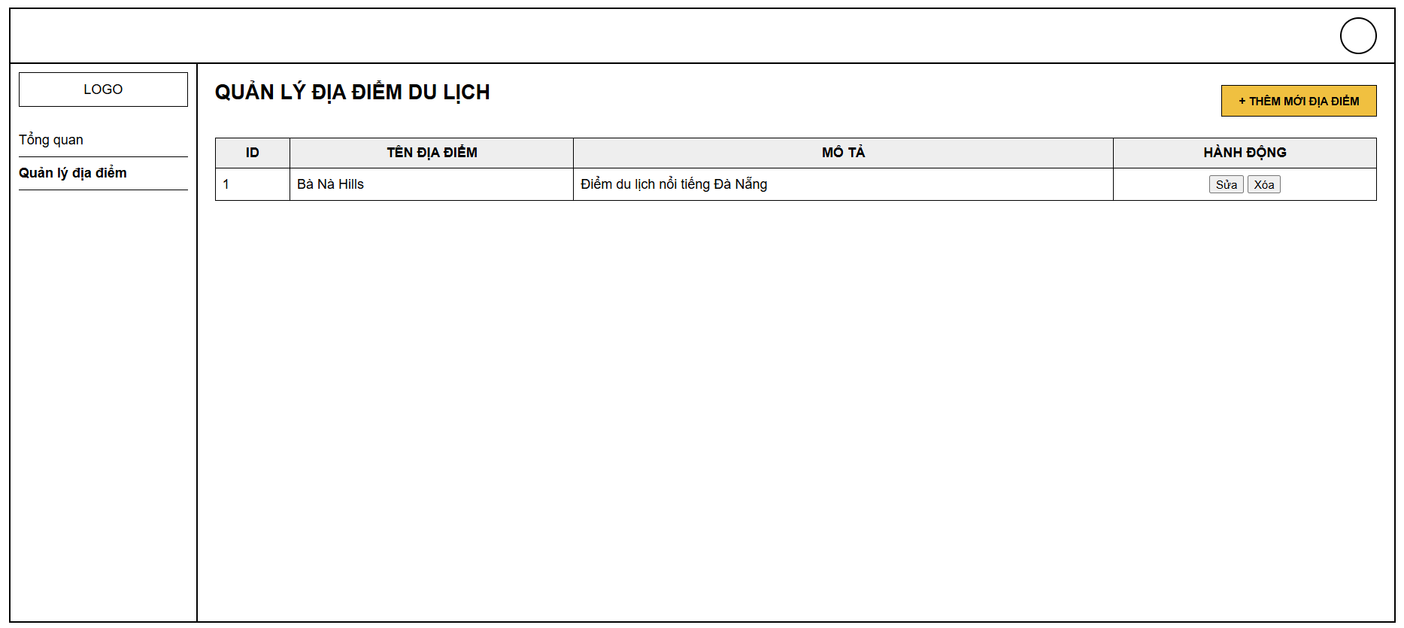

Field Name | Field Type | Description
Title | Heading | This field display "QUẢN LÝ ĐỊA ĐIỂM DU LỊCH".
+ THÊM MỚI ĐỊA ĐIỂM | Button | Button to open the form for adding a new tourism destination.
ID | Text field | Displays the unique identifier of the tourism location .
TÊN ĐỊA ĐIỂM | Text field | Displays the name of the destination.
MÔ TẢ | Text area | Displays a brief description of the tourism location.
Sửa | Button | Button to edit the details of the selected tourism location.
Xóa | Button | Button to delete or deactivate the selected tourism location from the platform.

Database Access

Table | CRUD | Description
TourismLocation | R | Retrieve the list of all tourism destinations including their ID, name, and description.
TourismLocation | C | Insert a new tourism destination record when the admin submits the add form.
TourismLocation | U | Update the name or description of a destination when the admin clicks the "Sửa" button.
TourismLocation | D | Delete a tourism location from the system when the admin clicks the "Xóa" button.
SQL Commands
1. View all tourism locations
SELECT * FROM "TourismLocation" ORDER BY "LocationID" ASC;
2. Insert a new tourism location
INSERT INTO "TourismLocation" ("LocationName", "Description", "CreatedAt") VALUES (?, ?, NOW());
3. Update tourism location details
UPDATE "TourismLocation" SET "LocationName" = ?, "Description" = ?, "UpdatedAt" = NOW() WHERE "LocationID" = ?;
4. Delete a tourism location record
DELETE FROM "TourismLocation" WHERE "LocationID" = ?;

8.3 Promotion Management
Allows administrators to create, update, and monitor promotional vouchers and discount campaigns.

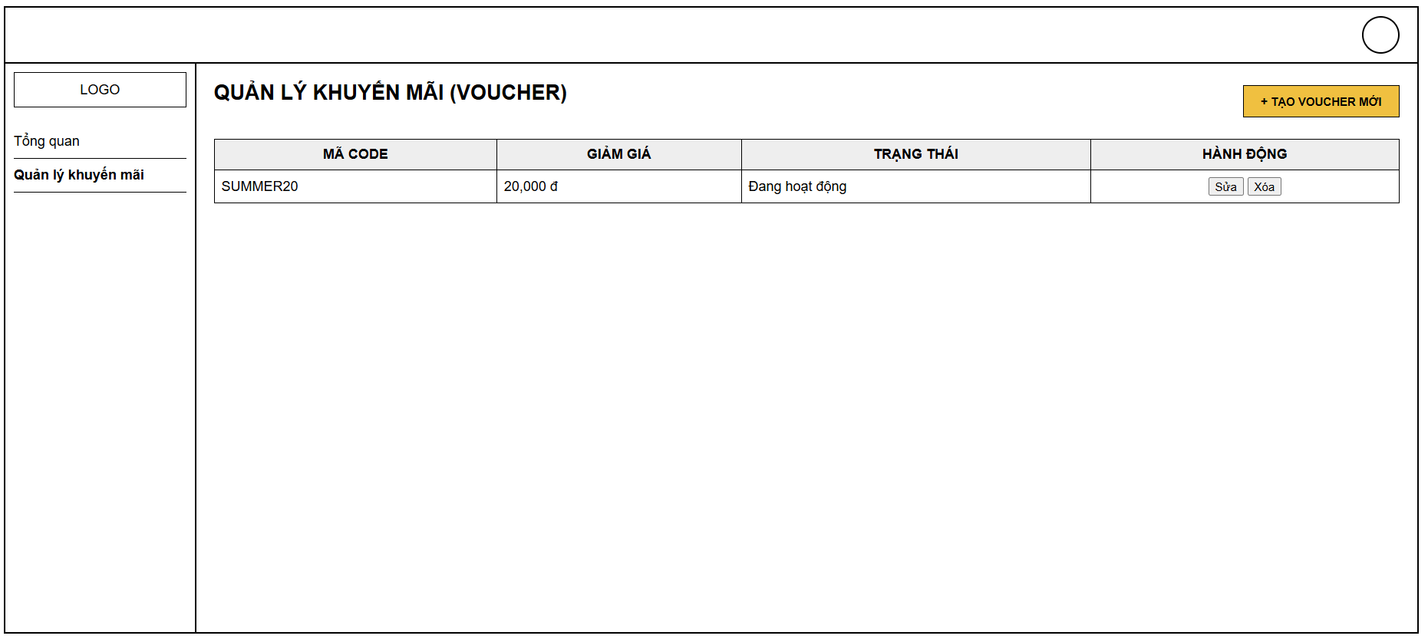

Field Name | Field Type | Description
Title | Heading | This field display "QUẢN LÝ KHUYẾN MÃI (VOUCHER)".
+ TẠO VOUCHER | Button | Button to open the form for creating a new promotional voucher.
MÃ CODE | Text field | Displays the unique code identifier for the voucher .
GIẢM GIÁ | Text field | Displays the discount value applied by the voucher
TRẠNG THÁI | Text field | Displays the operational status of the voucher.
Sửa | Button | Button to edit the rules, discount amount, or expiry of the voucher .
Xóa | Button | Button to delete or deactivate the promotional voucher from the system .

Database Access

Table | CRUD | Description
Promotion | R | Retrieve the list of all available vouchers including their code, discount values, and current status.
Promotion | C | Insert a new voucher campaign record when the admin clicks "+ TẠO VOUCHER" and submits.
Promotion | U | Update the status, code, or discount rates when the admin clicks the "Sửa" button.
Promotion | D | Remove or deactivate a voucher from the active list when the admin clicks the "Xóa" button.

SQL Commands
1. View all promotional vouchers and campaigns
SELECT * FROM "Promotion" ORDER BY "PromotionID" ASC;
2. Insert a new promotional voucher
INSERT INTO "Promotion" ("Code", "DiscountValue", "Status", "CreatedAt") VALUES (?, ?, 'Active', NOW());
3. Update voucher or promotion details
UPDATE "Promotion" SET "Code" = ?, "DiscountValue" = ?, "Status" = ?, "UpdatedAt" = NOW() WHERE "PromotionID" = ?;
4. Delete a promotional voucher from the system
DELETE FROM "Promotion" WHERE "PromotionID" = ?;

8.4 FAQ Management
Allows administrators to add, update, and remove frequently asked questions and answers.

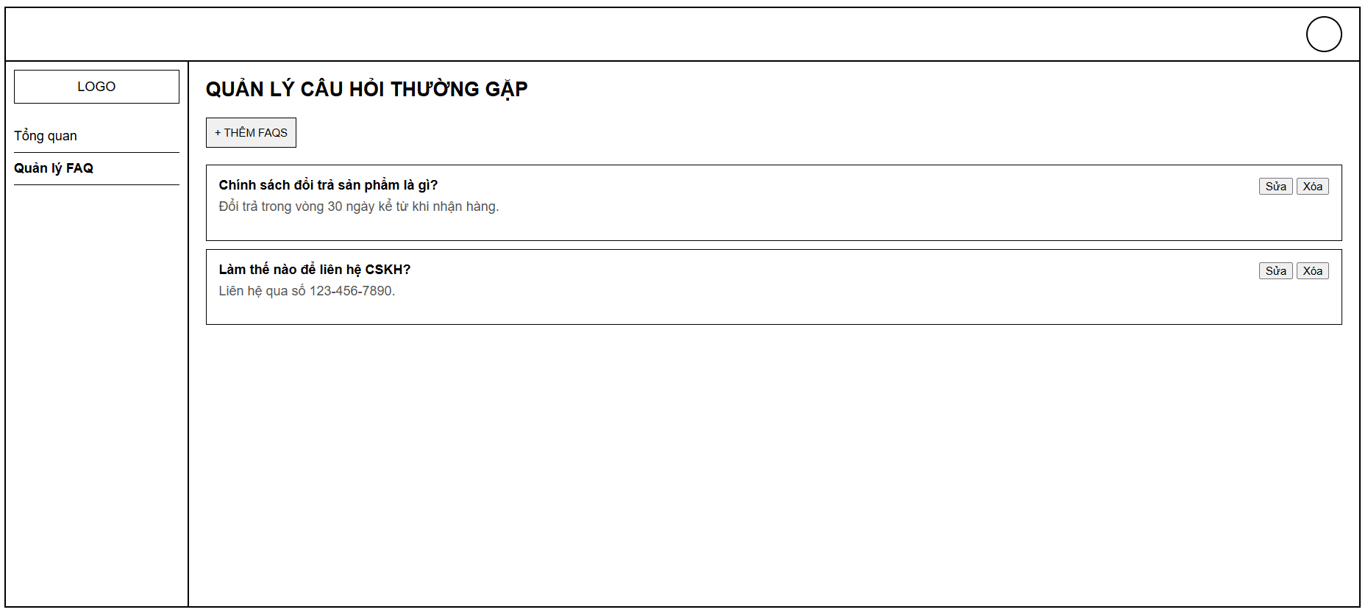

Field Name | Field Type | Description
Title | Heading | This field display "QUẢN LÝ CÂU HỎI THƯỜNG GẶP (FAQ)".
+ THÊM CÂU HỎI | Button | Button to open the form for creating a new FAQ entry.
ID | Text field | Displays the unique identifier of the FAQ.
CÂU HỎI | Text area | Displays the frequently asked question text.
CÂU TRẢ LỜI | Text area | Displays the corresponding answer text for the question.
Sửa | Button | Button to edit the question or answer content of the selected FAQ.
Xóa | Button | Button to delete the FAQ entry from the system.

Database Access

Table | CRUD | Description
FAQ | R | Retrieve the list of all frequently asked questions and answers.
FAQ | C | Retrieve the list of all frequently asked questions and answers.
FAQ | U | Update the question or answer content when the admin clicks the "Sửa" button.
FAQ | D | Delete an FAQ record from the system when the admin clicks the "Xóa" button.

SQL Commands
1. View all frequently asked questions and answers
SELECT * FROM "FAQ" ORDER BY "FAQID" ASC;
2. Insert a new FAQ record
INSERT INTO "FAQ" ("Question", "Answer", "CreatedAt") VALUES (?, ?, NOW());
3. Update FAQ details
UPDATE "FAQ" SET "Question" = ?, "Answer" = ?, "UpdatedAt" = NOW() WHERE "FAQID" = ?;
4. Delete an FAQ record from the system
DELETE FROM "FAQ" WHERE "FAQID" = ?;

8.5 Price Management
Allows administrators to configure rental rates for different motorcycle types and rental durations.

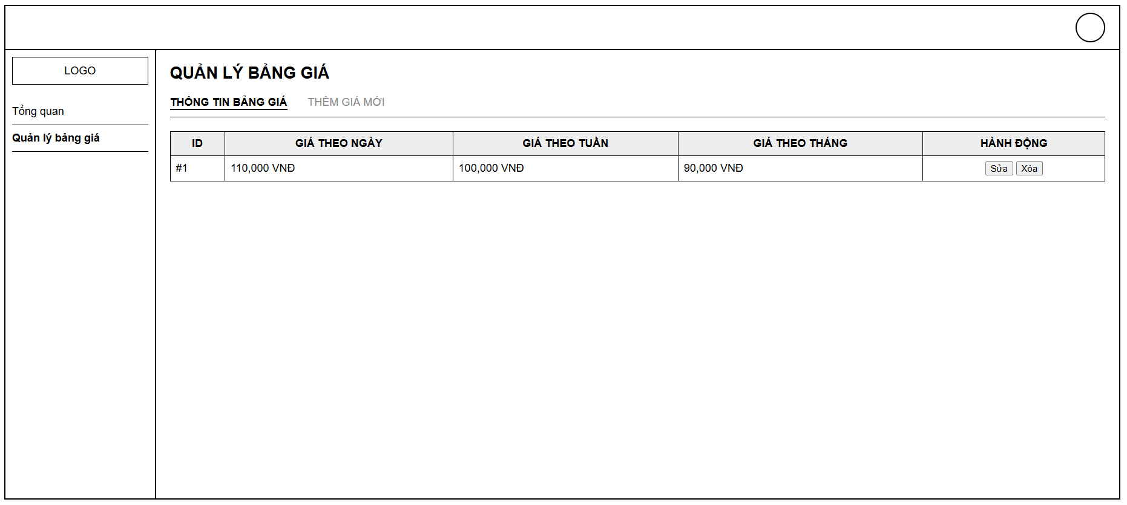

Field Name | Field Type | Description
Title | Heading | This field display "QUẢN LÝ BẢNG GIÁ".
THÔNG TIN BẢNG GIÁ | Tab | Tab to view the existing rental pricing structure.
THÊM GIÁ MỚI | Tab | Tab to open the form for configuring a new pricing tier.
ID | Text field | Displays the unique identifier of the price configuration.
GIÁ THEO NGÀY | Text field | Displays the rental rate charged per day.
GIÁ THEO TUẦN | Text field | Displays the discounted rental rate charged per week.
GIÁ THEO THÁNG | Text field | Displays the discounted rental rate charged per month.
Sửa | Button | Button to edit the daily, weekly, or monthly rates for a pricing tier.
Xóa | Button | Button to delete a price configuration from the system.

Database Access

Table | CRUD | Description
PriceConfig | R | Retrieve all configured rental rates including daily, weekly, and monthly pricing records.
PriceConfig | C | Insert a new pricing structure into the database when the admin submits the creation form.
PriceConfig | U | Update the specific pricing details when the admin clicks the "Sửa" button.
PriceConfig | D | Delete a pricing tier from the active management list when the admin clicks the "Xóa" button.

SQL Commands
1. View all rental price configurations
SELECT * FROM "PriceConfig" ORDER BY "PriceConfigID" ASC;
2. Insert a new rental price configuration
INSERT INTO "PriceConfig" ("DailyRate", "WeeklyRate", "MonthlyRate", "CreatedAt") VALUES (?, ?, ?, NOW());
3. Update existing rental pricing rates
UPDATE "PriceConfig" SET "DailyRate" = ?, "WeeklyRate" = ?, "MonthlyRate" = ?, "UpdatedAt" = NOW() WHERE "PriceConfigID" = ?;
4. Delete a price configuration record
DELETE FROM "PriceConfig" WHERE "PriceConfigID" = ?;

8.6 Accessory Management
Allows administrators to add, update, and remove rental accessories available for customers.

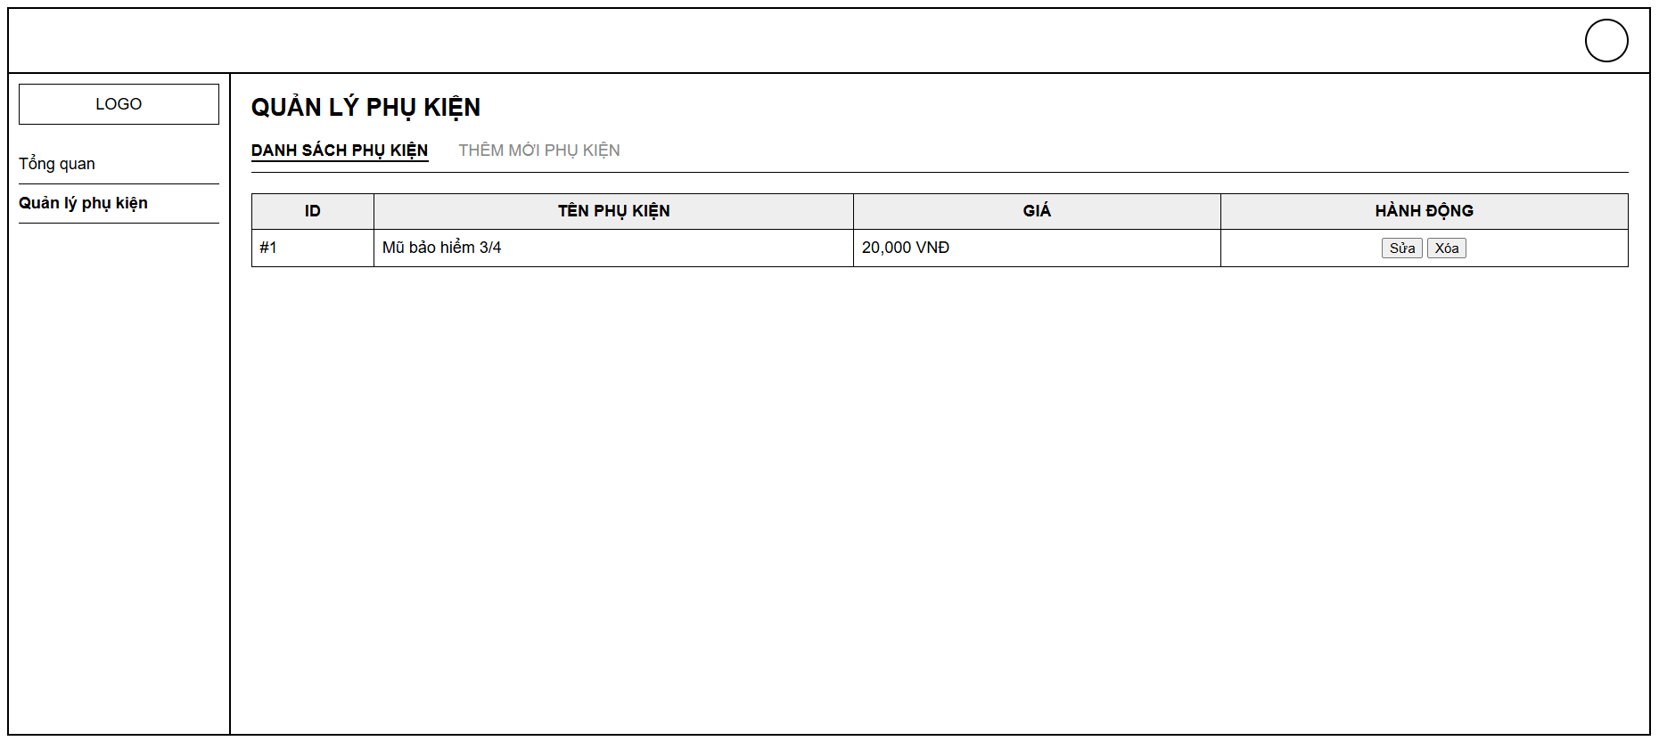

Field Name | Field Type | Description
Title | Heading | This field display "QUẢN LÝ PHỤ KIỆN".
DANH SÁCH PHỤ KIỆN | Tab | Tab to view the list of currently available rental accessories.
THÊM MỚI PHỤ KIỆN | Tab | Tab to open the input form for adding a new rental accessory .
ID | Text field | Displays the unique identifier of the accessory.
TÊN PHỤ KIỆN | Text field | Displays the name of the rental accessory.
GIÁ | Text field | Displays the rental price or penalty fee for the accessory.
Sửa | Button | Button to edit the name or price details of the selected accessory.
Xóa | Button | Button to delete or remove the accessory from the active system database.

Database Access

Table | CRUD | Description
Accessory | R | Retrieve the list of all rental accessories including their ID, name, and price details.
Accessory | C | Insert a new rental accessory record when the admin fills out the creation form.
Accessory | U | Update the name or pricing metrics when the admin clicks the "Sửa" button.
Accessory | D | Delete an accessory record from the active list when the admin clicks the "Xóa" button.

SQL Commands
1. View all rental accessories
SELECT * FROM "Accessory" ORDER BY "AccessoryID" ASC;
2. Insert a new rental accessory record
INSERT INTO "Accessory" ("AccessoryName", "Price", "CreatedAt") VALUES (?, ?, NOW());
3. Update accessory specifications or price rates
UPDATE "Accessory" SET "AccessoryName" = ?, "Price" = ?, "UpdatedAt" = NOW() WHERE "AccessoryID" = ?;
4. Delete an accessory from the database
DELETE FROM "Accessory" WHERE "AccessoryID" = ?;

8.7 User Management
Allows administrators to view user accounts, update account status, and manage user permissions.

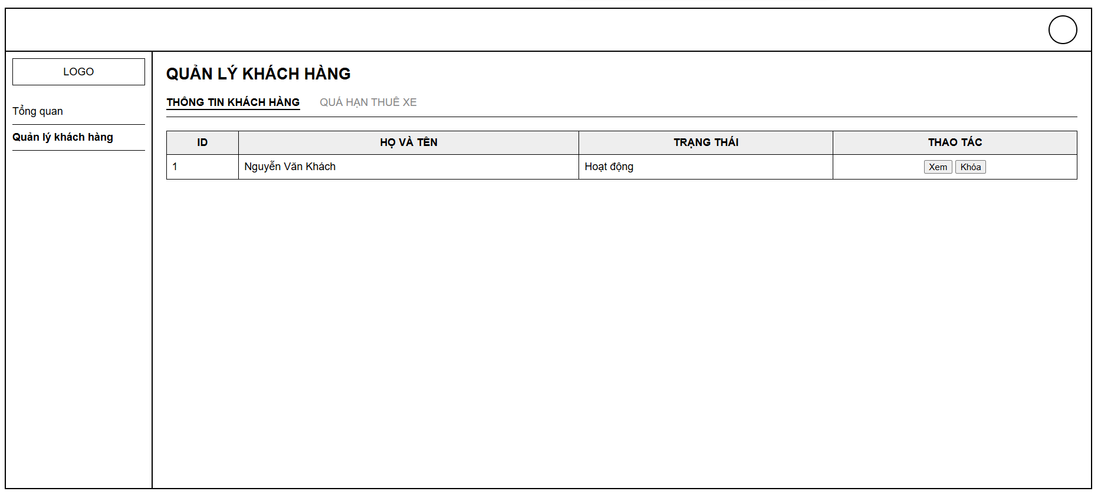

Field Name | Field Type | Description
Title | Heading | This field displays "QUẢN LÝ NGƯỜI DÙNG".
Tìm kiếm người dùng | Input field | Field to search for a user by username, email, or phone number.
ID | Text field | Displays the unique identifier of the user account.
TÊN ĐĂNG NHẬP | Text field | Displays the username of the account.
EMAIL | Text field | Displays the registered email address.
SỐ ĐIỆN THOẠI | Text field | Displays the phone number of the user.
VAI TRÒ | Dropdown | Displays and allows modification of the user's role.
TRẠNG THÁI | Text field | Displays the current account status.
Sửa | Button | Button to edit user details and permissions.
Khóa/Mở khóa | Button | Button to toggle the active/blocked status of the account.

Database Access

Table | CRUD | Description
Account | C | Retrieve the list of all user accounts or search for specific accounts based on administrative filters.
Account | U | Update user account details, roles, or status (active/blocked) when modified by the admin.

SQL Commands
1. View all registered users with their roles
SELECT a.*, r."RoleName" FROM "Account" a JOIN "Role" r ON a."RoleID" = r."RoleID" ORDER BY a."AccountID" ASC;
2. Search users by multiple keywords
SELECT * FROM "Account" WHERE "Username" LIKE ? OR "Email" LIKE ? OR "PhoneNumber" LIKE ?;
3. Update user role and account status
UPDATE "Account" SET "RoleID" = ?, "Status" = ?, "UpdatedAt" = NOW() WHERE "AccountID" = ?;

